**Middy Report 3 June 2018.**

**HARRIERS SCOOP MEDALS AT SUSSEX MASTERS TRACK & FIELD CHAMPIONSHIPS AT EWELL.**

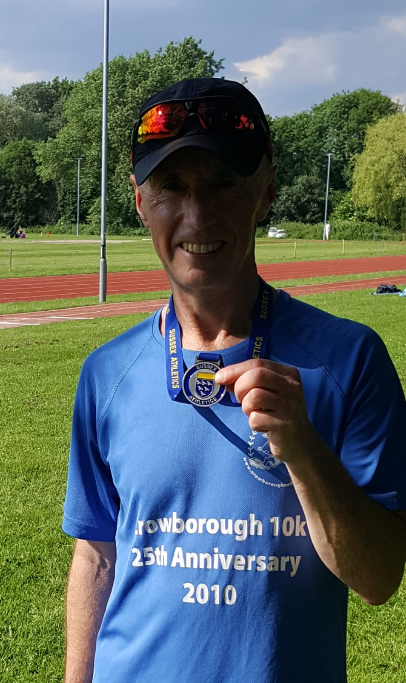

**Carl Bicknell with his silver medal.**

Haywards Heath Harriers were busy during the last weekend. On Sunday at the **Sussex Masters Track and Field Championships at Ewell** where a large number of veteran athletes form Haywards Heath Harriers took part in what is now becoming a bigger event for the club. The championships are held in conjunction with Surrey Athletics. The veteran age groups start at 35 years old for both men and women and go up in 5 year age groups.

Top results on the day were Jenny Denyer with 5 golds and Mile Bale with 4 golds – both in the throws events. James Skinner won the Vet Men’s 45 age categories for the 1500 metres and in the 5000 metres races. James was just outside of Rodney BurrowsV40 record of 4:15.3 secs set back in 1985. With the form that James is in surely this historic record is in jeopardy. Meanwhile, Carl Bicknell also won his first Sussex county medal in the V55 age category.

Results in full:

Jenny Denyer W60: Discus 15.56m; H/Hammer 8.67m (club record and pb) (1st); Hammer 22.64m (1st); Shot Putt 6.49m (1st); Triple Jump 5.47m (1st).

Mike Bale M60: Discus 28.69m; H/Hammer 13.40 (1st); Hammer 32.93m (1st); Shot Putt 8.08m (1st).

Helen Diack W35: Triple Jump 8.53m (1st).

James Skinner M45: 1500m 4:18.48 (1st); 5000m 16:02.08 (1st).

Ben Duncan M40: 5000m 17:33.21 (2nd) (pb).

Julian Boyer M50: 5000m 19:03.31 (1st) (pb).

Barry Tullett M50: 5000m 19:31.29 (2nd).

Carl Bicknell V55: 5000m 21:56.87 (2nd).

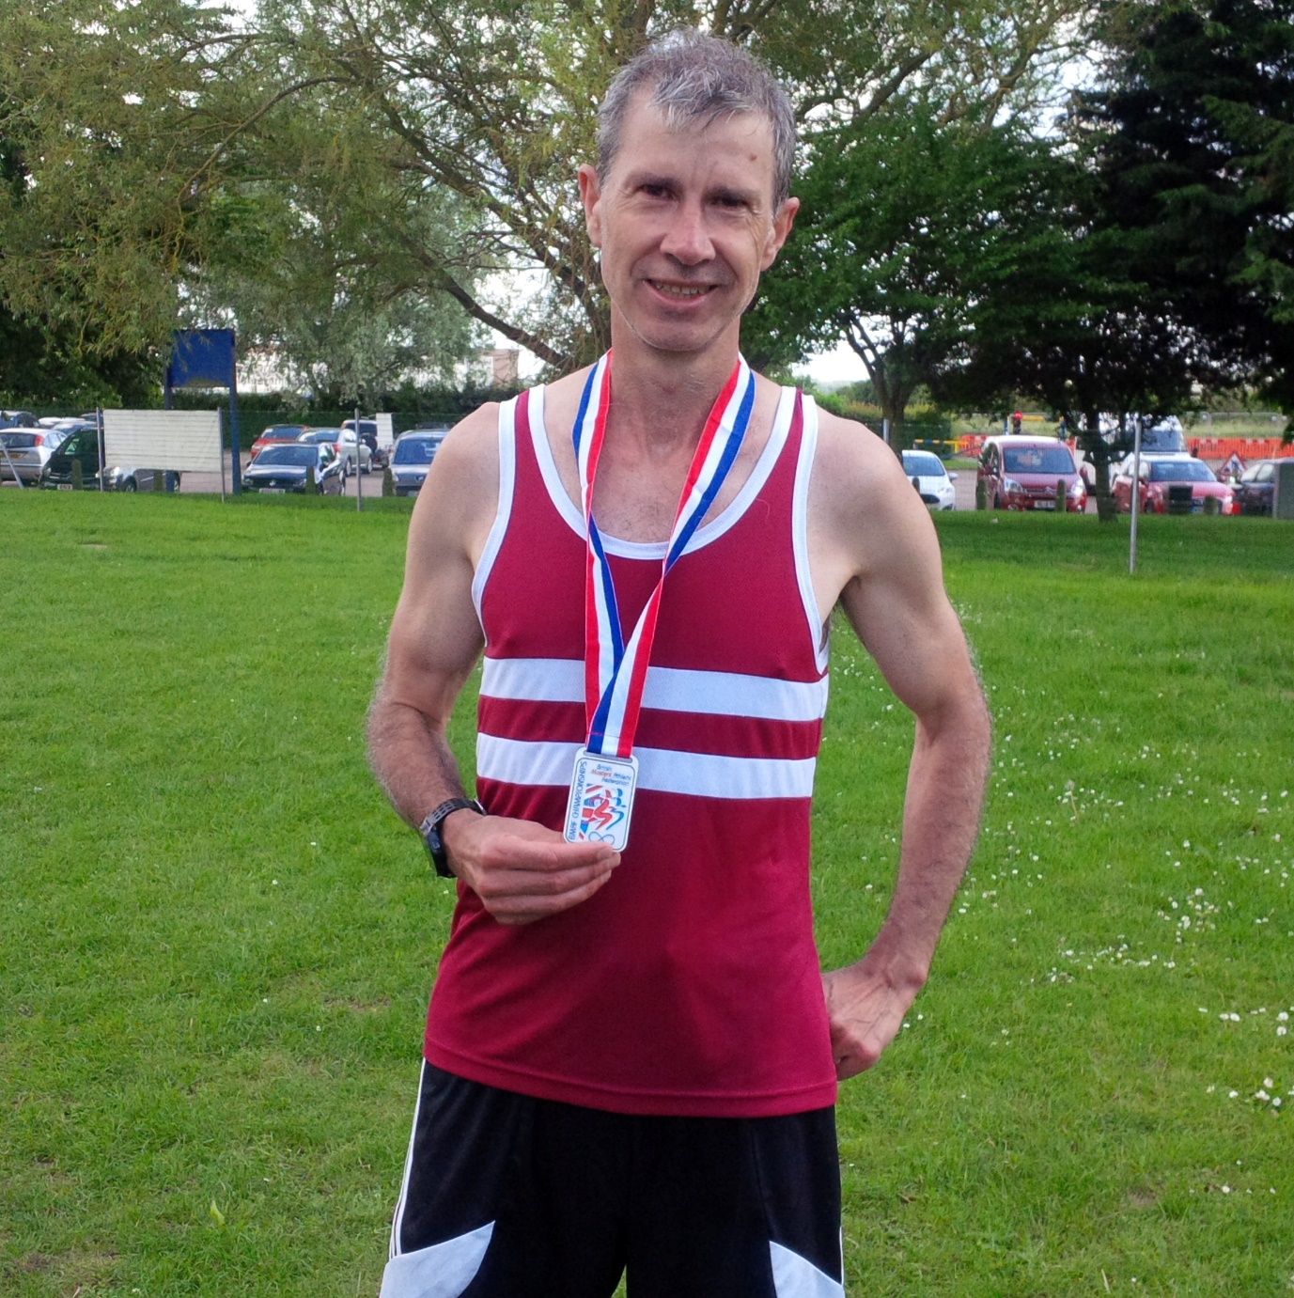

**Mr Cousins with his silver BMAF medal.**

Also, on 3rd June was the **British Masters Athletics Federation Track 10,000m Championships at Oxford**. In hot conditions (as also at the Sussex Vets Championships at Ewell) where water was provided trackside for the athletes as they ran the 25 laps of the track at Horspath. Local Harrier, Paul Cousins came second place in the Vet Men’s 55 age category in 38 minutes and 14 seconds.

Last Friday, the **Sussex Under 15 Track and Field League** was held at Horsham.

Results were as follows:

Girls results:

Millie Francis: 100m 16.3 secs; Long Jump 3m21; Shot Putt 5m71.

Emma Vince: 300m 48.7 secs; Javelin 6m16.

Harriet Dray: 800m 2:43.8 secs (pb).

Lilly Bliss-Tomlinson: 1500m 6:05.3 secs.

4 x 100m Relay: Haywards Heath: 61.7 secs.

Boys results:

Ethan Lambert: 100m 13.4 secs (pb); 200m 27.6 secs (pb).

Alfie Geere: 100m 14.3 secs; 200m 30.9 secs (pb); Long Jump 4m11 (pb).

Harry Pulham: 800m 2:44.1 secs (pb).

Louis Henry: 800m 3:14.2 secs (pb); Shot Putt 4m47.

Lio Robinson: Long Jump 3m60; Shot Putt 6m31 (pb); Javelin 23m74.

4 x 100m Relay: Haywards Heath 58.8 secs.

On Wednesday May 30th was the **Brighton Phoenix Open Meeting** at the Withdean Stadium. Russ Mullen ran in the 3000m and finished in 9 minutes 57.69 seconds.

Emma Navesey ran in her first ever 3000m and finished in 10 minutes 29.77 seconds.

Adam Dray ran a pb in the 1500m in 4 minutes and 13.74 seconds.

On road racing, nine Harriers ventured down to Worthing for the **Worthing 10km**. First Harrier home was Jack Chivers in 60th place. Other results were as follows:

60th Jack Chivers 39:07; 96th Rob English 40:22 (pb); 117th Matt Quinton 41:39; 267th Matt Howells 45:39; 400th Graham Jenner 47:09; 422nd Chris Glanfield 48:10; 535th Isobel Russell 49:42; 538th Jason Russell 49:43; 696th Marion Hemsworth 51:55.