Sussex Cross Country Gold for the under 13’s
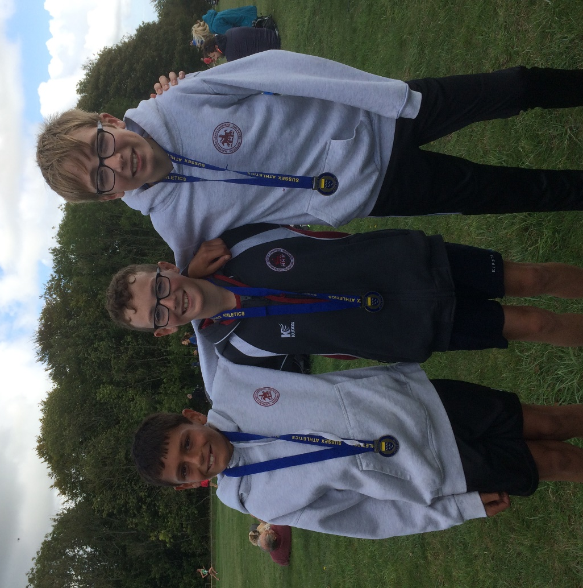
Victorious Under 13 Boys:

The Cross Country season has begun with the Sussex County Cross Country Relay Championships which were held next to Goodwood race course on the 28 September. The Under 13 Boys had a tremendous first place in the team event and were awarded the gold medal. The team consisting of Arun Khursheed (9:50), Jacob Roderick (10:39) and Jonathan Beckett (10:42) came home first place in a time of 31 minutes and 11 seconds. Arun Khursheed ran fastest leg out of all the runners.

In the Men’s Vet 40 race, the Harriers finished in third place getting the bronze medal. The team consisting of John Kettle (13:31), Michael Burke (14:33), Andy Dray 16:27) and Marcus Kimmins (13:58) finished in a time of 58 minutes and 29 seconds.

Tim Hicks was third fastest vet 60 in 16:02 and in the women’s race, Darja Knotkova-Hanley was the third fastest Senior lady with an amazing time of 14:56.

At the Eastbourne 10 kilometres race on 29 September, Ben Gibson finished in first place in a time of 35 minutes and 55 seconds.

(Full results next week).
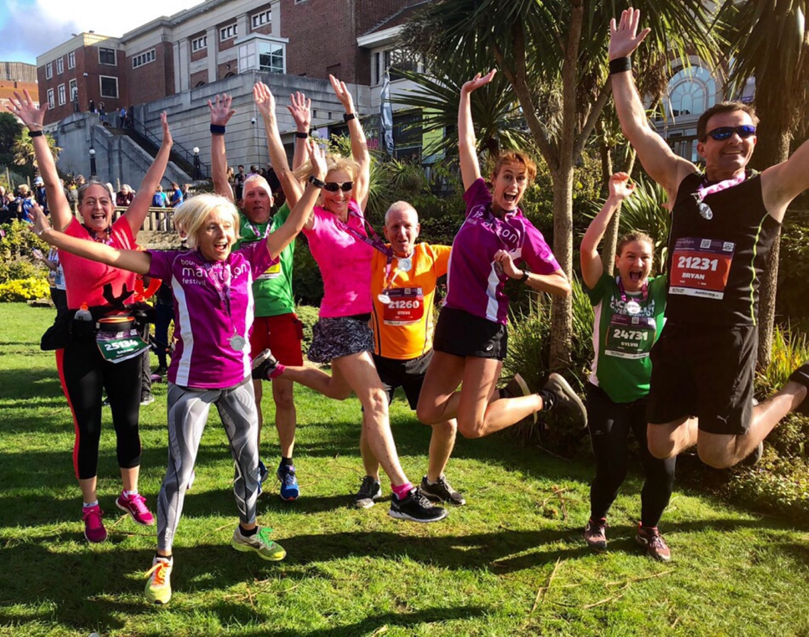
Haywards Heath Harriers (Sarah Banks, Bryan Tiller, Gary Johnson and Sam Ridley) and St Francis Running Club (Lins Blain, Sarah and Steve Harper, Silvie Favier) get warmed up together for the Bournemouth Half Marathon.

The Bournemouth Half Marathon took place last Sunday, finishing next to the sea front.
Harriers results were: 77th Paul Cousins 1:25.48 seconds, 550th Sam Ridley 1:43.04, 1153rd Clare Kenward 1:53.22, 1156th Graham Kenward 1 hour 53.25, 1353 Bryan Tiller 1:55.54, 1354th Sarah Banks 1:55.55 and Gary Johnson 1:58.04.

Tweed Valley Tunnel Trail Run which is a 20 kilometres race, both Phil Payne and Kim Lo ran and Phil finished in third place in one hour and thirty minutes and thirty nine seconds. Kim finished in 51st place in one hour forty five minutes and twenty seconds.

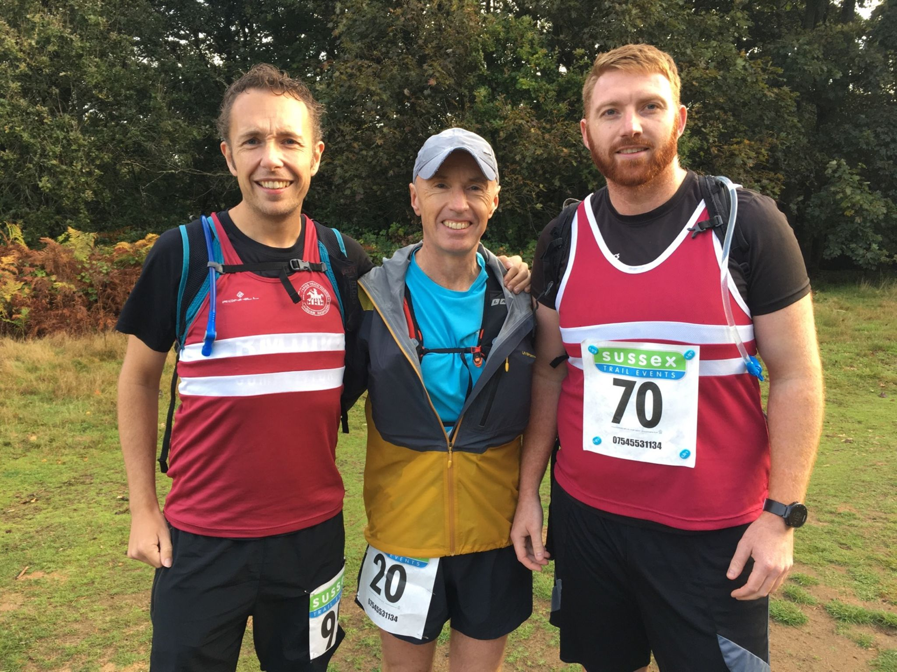
Greg Hilton, Carl Bicknell and Oli Farr at the Downslink Ultra.

Greg Hilton ran in the Downslink Ultra 60 km race (37.59 miles) in finishes in an amazing 6 hours 10 minutes. Young harriers, Kai Robinson and James Yule were running as a team and had to drop out of the event after their third team member had to drop out due to blisters. They got to a respectable 33 miles. Other harriers Carl Bicknell and Oli Farr both finished the course.

On Sunday 22 September Oli Farr finished his 42nd marathon at the Green Chain Marathon in 4 hours 20 mins.

