Middy Report 08.04.18

Harriers Success at the Sussex Relays:

At the Sussex Road Relays last Saturday at Christ’s Hospital near Horsham, Haywards Heath Harriers sent many teams comprising of young and old from junior athletes to the senior men and senior women and also the vet men and vet women age groups.
Top results were Darja Knotkova-Hanley was the fastest Under 17 Woman, and Adam Dray was the second fastest Under 15 Boy. Also, the Harriers men won bronze in the Vet Men’s Over 50 relay. Full results in next week’s Middy report.

This week’s report focuses on the beginning of the marathon season with Harriers taking part last weekend at the Rotterdam and Manchester marathons. Next weekend will be the Brighton Marathon and the following week, the London Marathon. Many local runners from the many running clubs up and down Mid Sussex and the many other runners who do not belong to a running club who will be travelling to one of these two cities in the next 2 weeks after many weeks and months of hard training to run their marathon and hopefully accomplish their goal: some just to finish while others trying to get their best time.

Results roundup:

Last weekend, Kim Lo ran at the Rotterdam Marathon in a time of 3:24:54.

At the West Sussex Fun Run League at Lewes on Bank Holiday Monday over a multi-terrain course of 10 kilometres around the locality of Lewes. The Harriers had a strong team out in force.
In the Juniors race, Ryan Armstrong finished in 6th place in 6 mins 09 secs.
In the adult race, the results were as follows:
1st Ben Gibson 37 mins 39 secs, 3rd Josh Pewter 38 mins 19 secs, 9th Phil Payne 39 mins 22 secs, 19th Jamie Gibson 41 mis 37 secs, 28th Oli Gibson 43 mins 42 secs, 32nd Jack Chivers 44 mins 02 secs, 70th Barry Tullett 47 mins 36 secs, 71st Julian Boyer 47 mins 36 secs, 164th Phil Scott 54 mins 13 secs, 247th Gemma Morgan 59 mins 28 secs, 298th Marion Hemsworth 64 mins 11 secs, 326th Richard Bates 68 mins 07 secs.

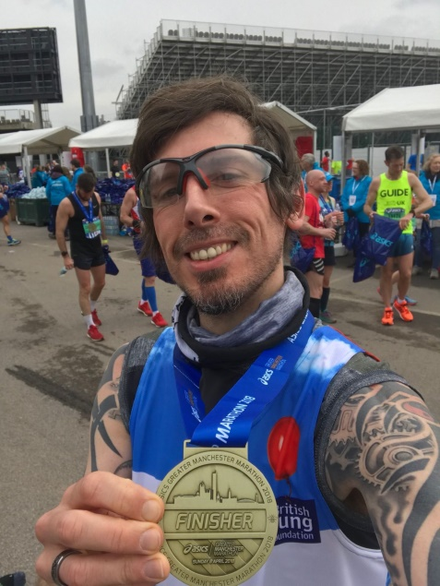
Andy Hind at the Manchester Marathon.
At the Manchester Marathon, Andy Hind got a pb. His time of 3:20.42. was a personal best by more than 5 minutes! Also running Manchester was Bryan Tiller who finished his first marathon in a super 4:04.43.
At the Paddock Wood Half Marathon on Sunday, James Skinner ran a super pb of 1 hr 13 mins and 41 secs. Mike Scholes (Men Vet 60) also finished in 1 hr 39 mins 55 secs.

At the Berlin ½ Marathon, Emma Navesey ran a pb in 1 hr 27 mins and 6 secs. Her mum, Beverly also ran the same marathon and finished in 2 hrs 31 mins and 29 secs. Emma was 52nd out of 10,140 women finishers!

At the Crawley Open Meeting on 1st April, young Harriers Charlie Bonwick-Adams and his brother George both ran in the 1500m. Charlie came in first in 5 mins 13.98 secs and George not far behind George finished in a time of 5 mins 33.33 secs.

At the Wings Coventry Half Marathon, Harriers Richard Haynes and Maresa Pitt both took part. Richard was first Vet Man 60 in a time of 1 hr 36 mins 08 secs and Maresa Maresa was first Vet Lady 45 and finished in a time of 1 hr 42 mins 48 secs. 60.

At the Hartfield 10km last Sunday Harriers Katie Morgan and Phil Payne and both respectively won their races.

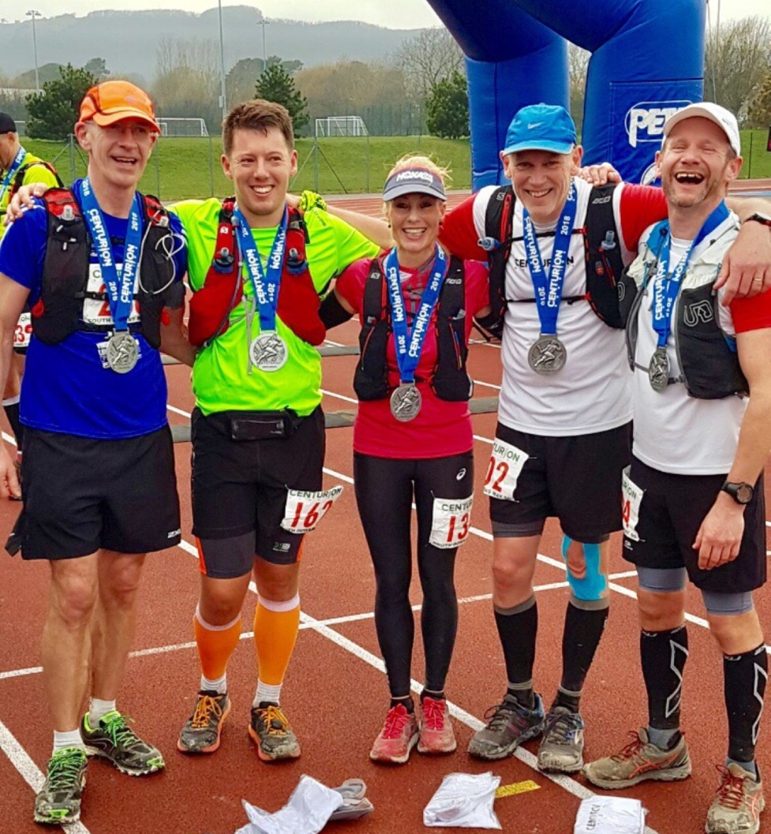
Sam Ridley at the South Downs Way 50.

On Saturday, Sam Ridley ran in the South Downs Way 50 miles race from Worthing to Eastbourne. She finished first in her age category in a time of 9 hours and 49 minutes. Shelagh Robinson also ran and finished in 11 hrs 41 mins and 20 secs.
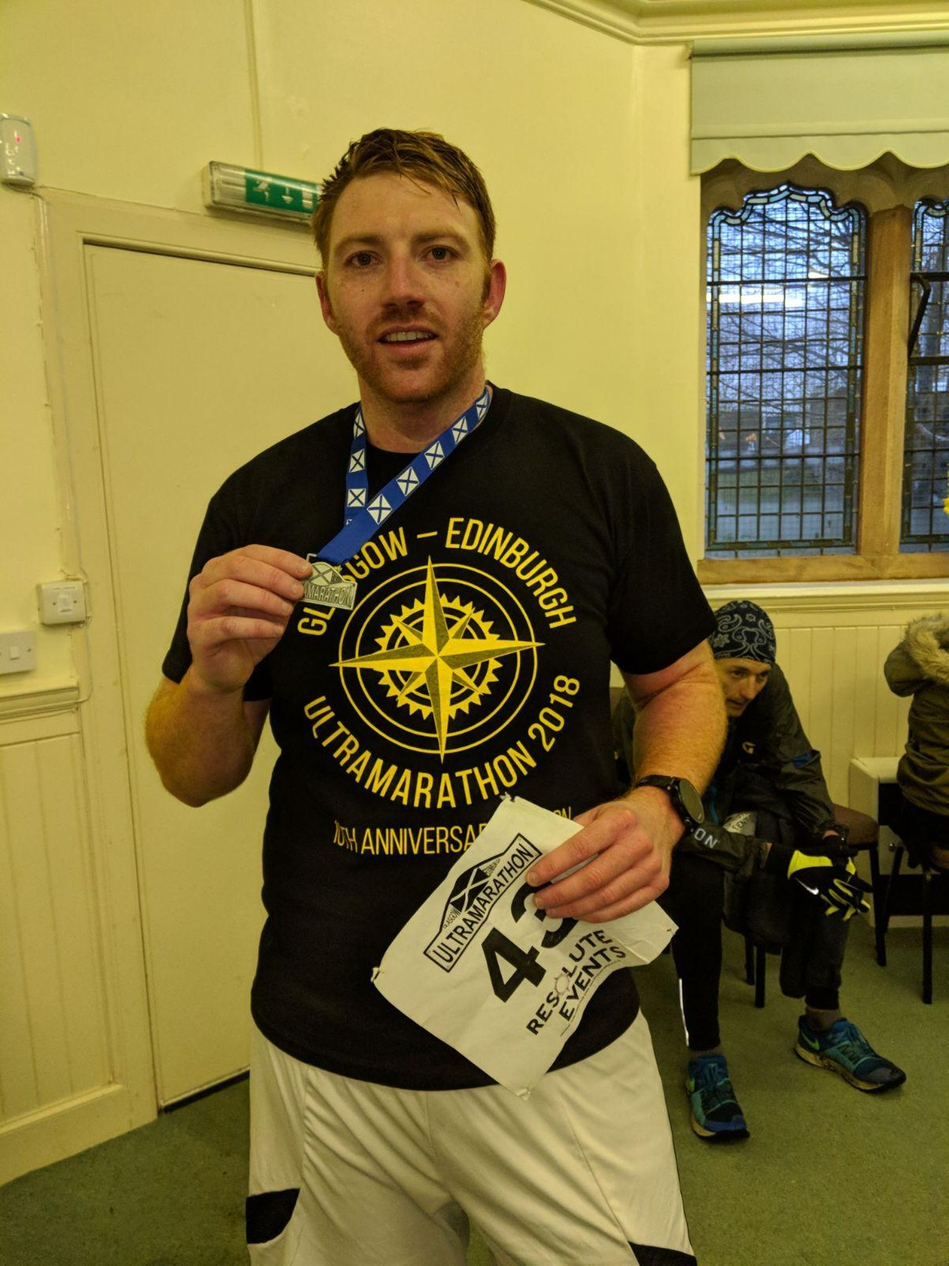
Oliver Farr at the Glasgow to Edinburgh Ultra last weekend.

At the Glasgow to Edinburgh Ultra last weekend, Oliver Farr took part in this running Ultra trail event and completed the 54 mile course in a super time of 10 hours 15 mins and 30 seconds. He finished in 45th position out of a field of 117.There were 83 finishers and 34 non-finishers.

