SILVER SUCCESS FOR PAUL
By Barry Tullett

At the Southern Masters Cross Country Championships 2018, Paul Cousins produced a stunning run to finish second in the Men’s V55 category. This silver medal winning performance from Paul was one of his finest achievements in a Haywards Heath Harriers vest.

Paul with his Medal
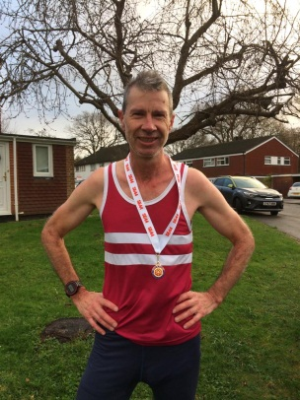
Overcast and damp conditions greeted the athletes at this prestigious event held at Horspath Sports Ground, Oxford on Saturday 8th December and organised by the South of England Athletics Association (SEAA).

Paul finished in a lightening quick time of 35:08 as he breezed around the 2 lap undulating course, which consisted of a mixture of hills, woodland, grass and mud! Over 220 runners took part in this 10k event. Paul has been one of the top Sussex Veteran cross country runners for a number of years now, and it is great to see him flourishing at a regional event. His achievements inspire fellow Haywards Heath Harrier members and his recent success is down to extra cross country training sessions held by the club’s endurance coach, Martin Delbridge. Also competing at this event was Barry Tullett (38:53) and Tim Hicks (42:02) with the HHH team finishing in 9th position.

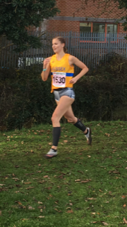
This event is combined with the Inter Counties Cross Country Championships for age groups from U13 Girls up to Senior Ladies and U13 Boys to U17 Men. Haywards Heath Harriers were represented by Sam Fernley in the U13 Boys 3k race who finished 104th in a time of 12:34, Darja Knotkova-Hanley, 30th in the U20 Ladies 6k race with a time of 26:27 (2nd Sussex finisher and team 5th overall) and Emma Navesey 54th in the Senior Ladies 6k race with a time of 25:39 (4th Sussex finisher and team finished 7th overall). All three of these athletes were selected to run for Sussex at this event following impressive performances at recent Sussex Cross Country races, and representing the County gives them the coveted ‘golden’ Sussex vest.

Emma Navesey in action.

