West Sussex Fun Run League
WSFRL Round Hill Romp

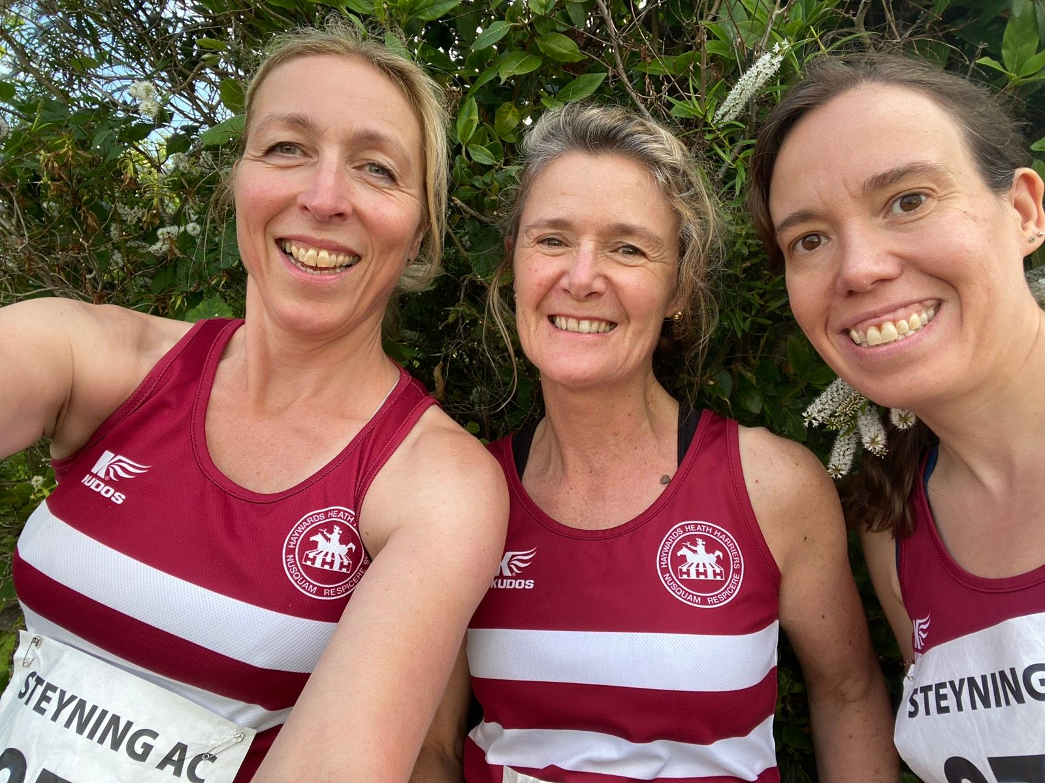
Sarah Hamilton, Caroline Gumm and Katherine Woolhouse at the Round Hill Romp.

On Wednesday 5th July at Steyning, was the Round Hill Romp. This six mile fun run race started in the High Street in Steyning by the Clock Tower and included a steep climb of around seven hundred feet of climb over the whole race!

Harriers results were:
162nd Abigail Redd 51:58; 163rd Phil Scott 51:59; 194th James Smyth 54:39; 279th Sarah Hamilton 63:51; 294th Katherine Woolhouse 66:34; 303rd Caroline Gumm 67:45; 351st Richard Bates 78:59.

There were over four hundred and thirty finishers in this fun run event. With a low club turnout, the Harriers finished in sixteenth place.

WSFRL Downland Dash

The Downland Dash held on 24th June at Hassocks School. There were two hundred and seventy six finishers over the four and a half mile course through the fields and footpaths, starting and finishing by the running track.

The combined team of men and women finished in ninth place out of eighteen teams that took part.

Results were:
19th Andy Hind 30:02; 20th Julian Boyer 30:05; 31st Patrick Kenward 31:08; 51st Paul Cousins 33:27; 81st Jason Robinson 35:54; 110th Phil Scott 38:38; 122nd Eric Hepburn 39:27; 145th Richard Jobling 41:42; 153rd James Smyth 42:34; 165th Shelagh Robinson 43:35; 185th Michael Parish 46:11; 186th Graham Kenward 46:22; 190th Sarah Hamilton 47:49; 206th Caroline Gumm 50:01; 245th Richard Bates 58:42; 247th Rupert Purchase 60:27.

Haywards Heath Harriers BlackCap Handicap

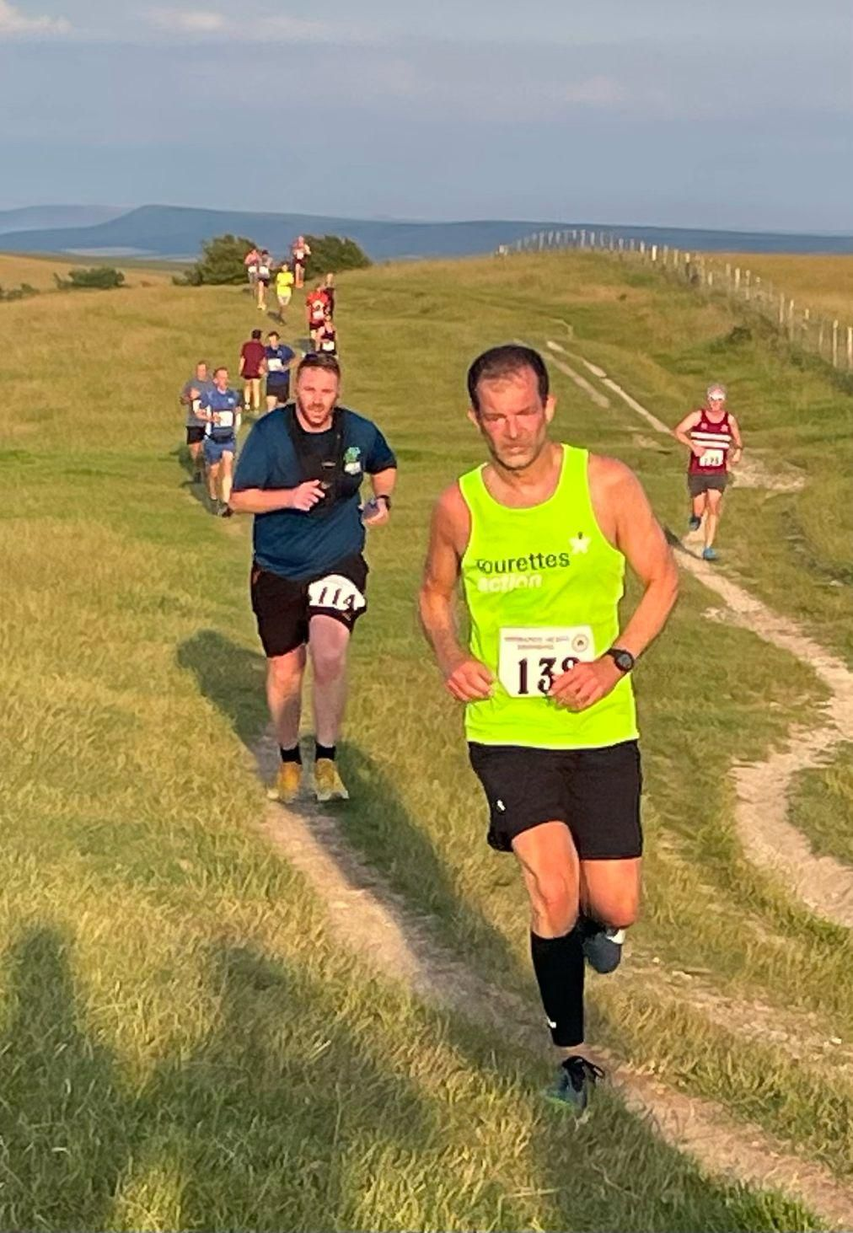
The Blackcap Handicap 2023

On a hot and balmy Thursday evening on the 29 June was the annual club handicap that was held on an out-and-back course on the South Downs.

Starting from Ditchling Beacon and going out to the Trig Point near Lewes and returning to Ditchling Beacon.
The handicap was based on the recent parkrun times: the slowest runner setting off first towards the trig point, then other runners following shortly afterwards. The theory being that all the runners would finish within a few minutes of each other. The winner being the first runner back home to Ditchling Beacon.
This annual event was unusual for two reasons - the large number of finishers (forty-two) and the fact that we had some sunshine!

Jacqueline Barnes was first home followed by a fast-paced Ben Gibson about a minute and a half later in second place who was the fastest on the day. Siobhan Amer ran hard to be fastest competitive lady.

The Handicapping Accuracy award (which runners have no knowledge of) was shared between Greg Hilton and club Co-Chair Andy Hind.

Marion, Bob and Kath acted as Turn and Gate Marshalls, while Sam, Lins and visitor Katie Morgan shared finish line duties with Mark.

Results of Haywards Heath Harriers BlackCap Handicap June 29 2023

Finish Time Runner Handicap Handicap Gap to Gap
Of Day Run Time Target H/Cap Rank
19:56:19 1 Jacqueline Barnes 45:34 48:43 03:09 37 Winner
19:57:53 2 Ben Gibson 29:08 30:38 01:30 22 Fastest
19:58.21 3 Rachael & Luke Overton 37:51 38:55 01:04 14
19:58:37 4 James Bennett 33:52 34:45 00:53 12
19:58:52 5 Sarah Hamilton 47:52 48:23 00:31 10
19:59:07 6 Jayne Brewer 43:07 43:28 00:21 8
19:59:08 7 Russ Mullen 30:23 30:38 00:15 5
19:59:10 8 Andy Dray 36:55 37:16 00:21 6
19:59:29 9 James Booth 35:14 35:06 00:08 3
19:59:30 10 Andy Hind 32:30 32:34 00:04 1 Closest Target
19:59:38 11 Greg Hilton 34:08 34:04 00:04 1 Closest Target
19:59:41 12 Sim Wishlade 35:56 35:46 00:10 4
19:59:47 13 Kai Robinson 36:47 36:26 00:21 7
19:59:55 14 Chris Faulkner 37:10 36:46 00:24 9
20:00:21 15 Gray Wilkinson 40:51 39:56 00:55 13
20:00:29 16 Hanne Boggon 42:29 41:24 01:05 15
20:00:43 17 Steven Heath 36:13 35:03 01:10 16
20:00:45 18 Oli Farr 41:00 39:45 01:15 17
20:00:52 19 Simon Robinson 37:52 36:31 01:21 18
20:00:54 20 Andrew Wilson 41:39 40:18 01:21 19
20:00:57 21 Phil Scott 40:57 39:28 01:29 21
20:00:59 22 James Moffatt 32:59 31:31 01:28 20
20:01:07 23 Clare Hilton 41:22 39:45 01:37 24
20:01:08 24 Tim Hicks 37:53 36:21 01:32 23
20:01:09 25 George Adams 34:39 33:57 00:42 11
20:01:11 26 Will Axell 34:56 33:17 01:39 25
20:01:19 27 Matt King 33:04 31:20 01:44 26
20:01:28 28 Claire Reyner 41:43 39:43 02:00 27
20:01:39 29 Ian Dumbrell 41:39 39:33 02:06 28
20:01:45 30 Siobhan Amer 38:45 36:26 02:19 29 Fastest F
20:01:54 31 Carl Bicknell 43:09 40:39 02:30 31
20:02:02 32 Pete Francis 35:02 32:34 02:28 30
20:02:16 33 Jason Robinson 40:46 38:05 02:41 32
20:02:22 34 Shelagh Robinson 47:37 44:43 02:54 33
20:02:29 35 Gem Catterall 50:59 48:01 02:58 34
20:02:31 36 Simon Fitzpatrick 44:01 40:59 03:02 35
20:02:40 37 Eric Hepburn 42:25 39:16 03:09 36
20:02:44 38 Rupert Purchase 62:44 59:29 03:15 38
20:02:51 39 Oli Francis 39:21 36:01 03:20 39
20:03:42 40 Jackie Scott-Wildman 52:27 48:16 04:11 40
20:04:48 41 Paul Carpenter 42:03 36:51 05:12 41
20:05:20 42 Louisa Johnston 60:20 54:36 05:44 42

Athletics

Vets League at Eastbourne on 14th June (Wednesday).

A group of Harriers travelled to East Sussex to Eastbourne on the 14th of June to take part in the second Vets Sussex Track and Field meetings for 2023. The Harriers compete in this league as a joint club with Lewes Athletic Club.

There were lots of great performances and lots of first places attained by Haywards Heath Harriers.

Kirsty Armstrong has continued her first track season for the club by smashing yet another Harrier record that has stood since 1997, namely the Vet women’s 1500 metres record which she has broken by nearly 47 seconds with a time of 5 minutes 18.2 seconds.

The Harriers results were as follows:

James Smyth V35: 4th 100m 14.7 secs; 2nd 2000m Walk 13 mins 54.7 secs (pb).
Andy Dray V50: 4th 100m 14.2 secs; 2nd 400m 63.2 secs; 2nd High Jump 1.40m; 3rd Triple Jump 8.31m.
Ian Tomkins V50: 6th 400m 77.6 secs; 6th V35 High Jump 1.30m; 1st Hammer Throw 19.95m; 1st Javelin Throw 23:42m.
Ian Kenton V35: 3rd 1500m 4 mins 29.1 secs (pb).
Jamie Topping V35: 1st 1500m B race 4 mins 32.6 secs.
Russ Mullen V35 (n/s) 1500m 4 mins 48.5 secs.
Mike Bale V60: 1st Hammer Throw 30.21m; 5th Javelin Throw 13.51m.

Annie Close V35: 1st 100m 14.6 secs; 4th 400m 74.8 secs; 1st Triple Jump 9.90m.
Abigail Redd V35: 3rd 100m 17.7 secs; 1st 2000m Walk 11 mins 32.4 secs.
Jacqueline Barnes V50: 6th 100m 26.0 secs; 6th 400m 93.7 secs; 2nd 2000m Walk 16 mins 9.8 secs; 5th Shot Putt 2.64m (pb).
Kirsty Armstrong V35: 1st 1500m 5 mins 18.2 secs (pb + V45 club record).
Gemma Morgan V35: 6th Shot Putt 4.76m (pb).

