Middy Report 11/12/17

Haywards Heath Harriers runners’ success at South of England Masters Cross Country Championships.

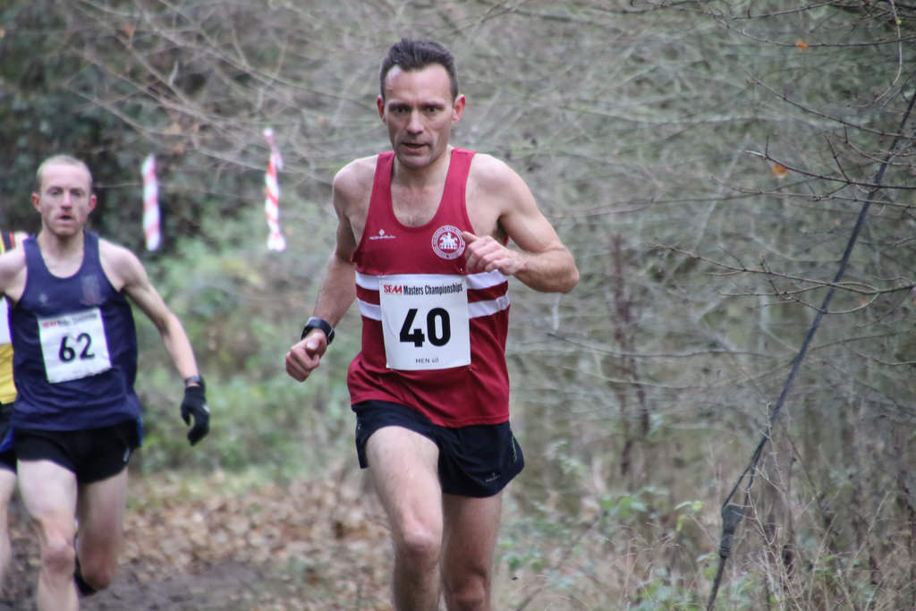
James Skinner
Photo by Barry Cornelius

Haywards Heath runners storm to victory at the South of England Athletic Association Cross Country Championships which was held at Shotover, Oxford on 9th December. Chris Smith, who is a renowned mountain runner cruised to an easy victory in the Mens’ V40 event. For James Skinner, this was his first major cross-country title. James, had a super run by running the same course nearly 3 minutes quicker than last year! He had been gearing all his training towards this one race and he not only was won the Vet 45 age group but was also pipped on the line and finished the race in 4th place overall which was a joint race with the V40 age group.
Chris Smith, giving due respect to, was actually running this event for his first claim club, Thames Valley Harriers but is second claim runner for Haywards Heath Harriers in the brooks Cross-Country League.
Paul Cousins also had a decent run in the Vet 50 race and finished 13th overall in 34 mins and 21 secs and was 4th V55 finisher.

Results were as follows:
Men V40 1st Chris Smith (Thames Valley Harriers / Haywards Heath Harriers) 29:22, 15th Marcus Kimmins (Haywards Heath Harriers) 33:43.
Men V55 4th Paul Cousins 34:21.
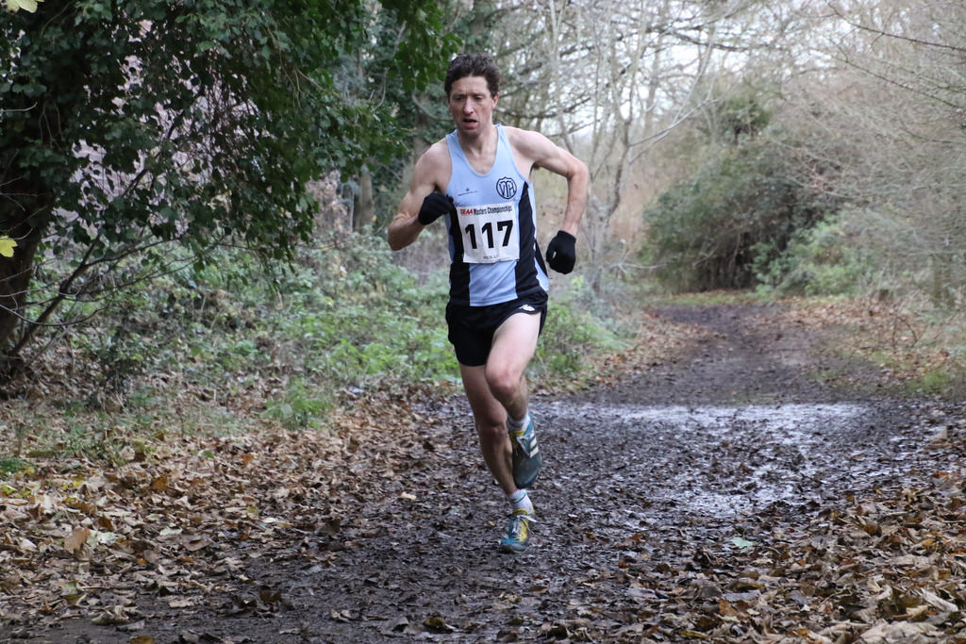
Chris Smith
Photo by Barry Cornelius

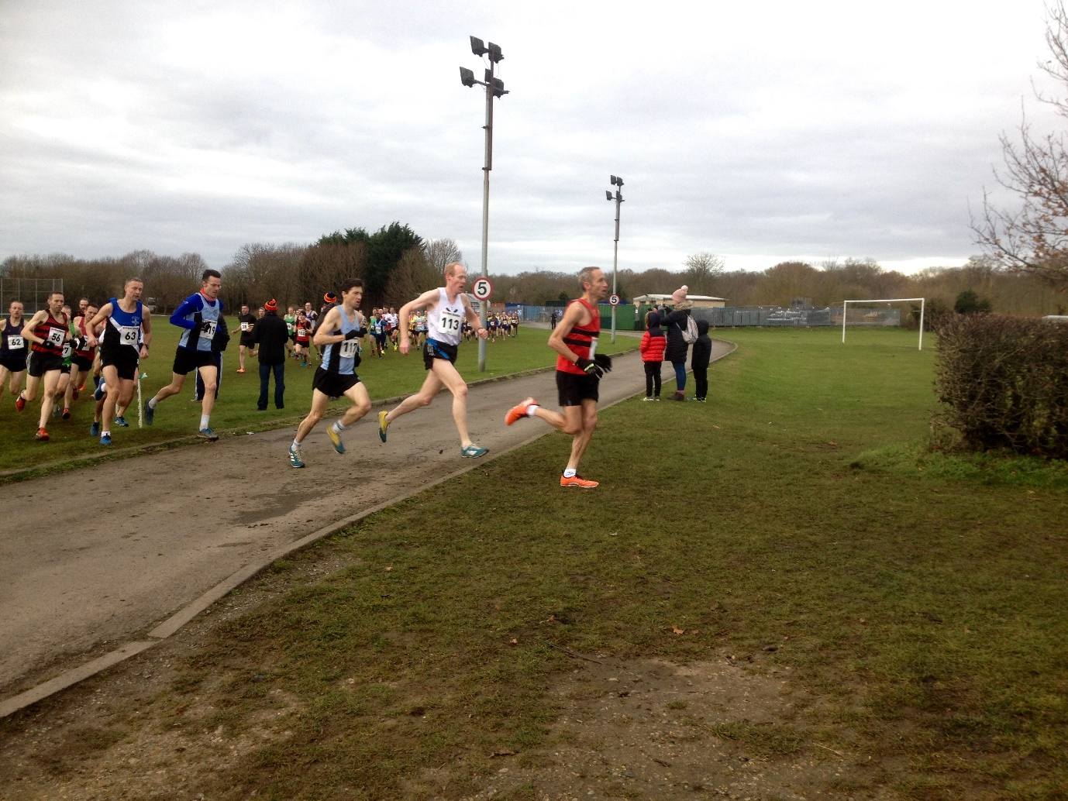
Mens’ V40 and V45 race
In the Inter Counties Cross Country event also held at Oxford, Adam Dray ran in the Boys Under 15 race to finish in 55th place (and 6th Sussex runner) in a time of 14:07.

At the Mince Pie 10 Mile road race at Seaford on 10th December, Shelagh Robinson and Marion Hemsworth both took part. Marion was the first home of the two ladies, in a time of 1 hour 42 mins 19 secs. Shelagh finished in a time of 1 hour 49 mins and 39 secs.

At the Downland Devil 9 mile race on 3rd December, 2 Harriers took part: Richard Haynes came 54th in 1 hour 14 mins and 8 secs and Maresa Pitt came 79th overall in 1 hour 17 mins and 45 secs.

At the Battersea “5000’s of Christmas” race on Saturday 16th December, Russ Mullen ran 16:02 and Emma Navesey ran 19:38.

