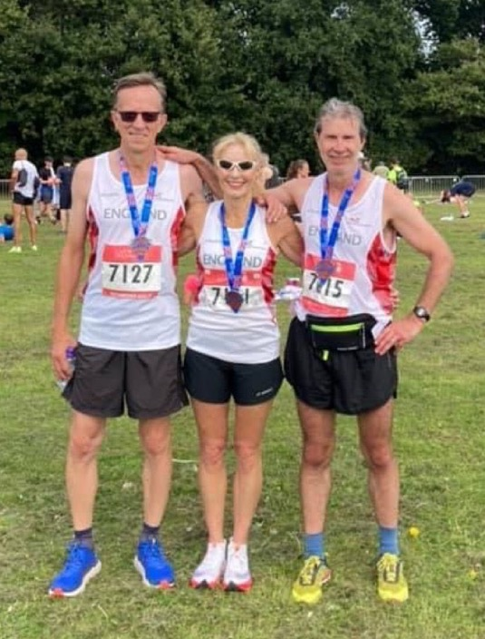
L-R: Tim Hicks, Sam Ridley, Paul Cousins.

Last Sunday, a group of Harriers took part in the British Masters Representative Half Marathon which was part of the Richmond Runfest Half Marathon at starting at Kew Gardens and finished in Old Deer Park.

Sam Ridley, Tim Hicks and Paul Cousins had previously qualified for this event from other races in 2019 but this Masters event was delayed because of the coronavirus. Running in their England vests they were competing against the top runners in their age groups from around the United Kingdom.

Sam Ridley smashed it with a super fourth place in her age group (vet women 55), also improving on her previous best time with a two minutes personal best (and a new Harriers club age record) in a time of 1 hour 34 minutes and 48 seconds. Tim finished in 14th in the vet men 60 age group in 1 hour 37 minutes 30 seconds and Paul 9th in the vet men 55 age group in 1 hour 31 minutes and 27 seconds.

BRIGHTON MARATHON

The last weekend was Brighton Marathon weekend. A host of Haywards Heath Harriers ventured south to Brighton for the marathon and the Brighton 10k races on a hot September day.

Unfortunately, the marathon was over distanced this year by 568 metres for which the Brighton Marathon organisers have apologised.

Despite the unfortunate error in the measurement of this year’s course, the Harriers runners enjoyed the event and were more than pleased to have a local endurance event so close to home to run in after the coronavirus outbreak and the subsequent lockdowns.

The weather was hot for running a marathon, but Darren Bird made light on the conditions (as he was the 3 hours 15 pacer!) and was also the first Harrier club finisher in 3 hours 15 minutes and 26 seconds.

Barry Tullet was next home in 3 hours 23 mins and 31 seconds which was a super run considering that he was unable to do the full marathon training because of an injury.

Liz Earley, in her first marathon, finished in an amazing 5 hours 3 minutes with her partner Mark.

Oliver Farr finished the Brighton Marathon which was his 58th marathon out of 100!

Full Brighton Marathon and Brighton 10km result will appear in the next report.

Other results

In the Great North Run, Andy Hind ran his first run at this event. It was the Great North Run‘s 40th celebration of this great race. Andy’s time was 1 hour 24 minutes and 8 seconds 330th overall and 33rd in the Vet 45 age group.

Michael Burke also completed the Dragons Back Ultra race in 72 hours 38 minutes and 33 seconds. He finished is 41st position.

James Skinner ran close to a personal best at the Paddock wood Half Marathon on 5 September, finishing in a super time of 73 minutes and 55 seconds.

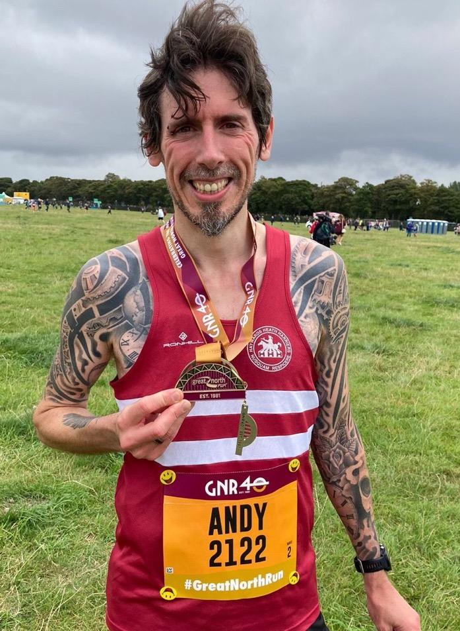
Andy Hind at The Great North Run.

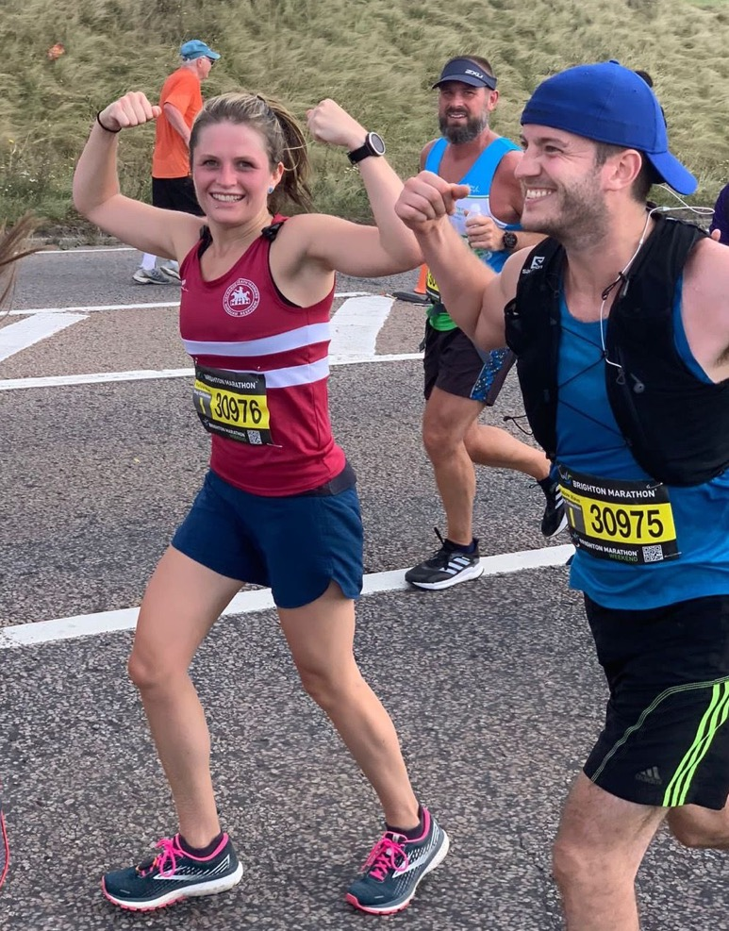
Liz Earley and partner Mark
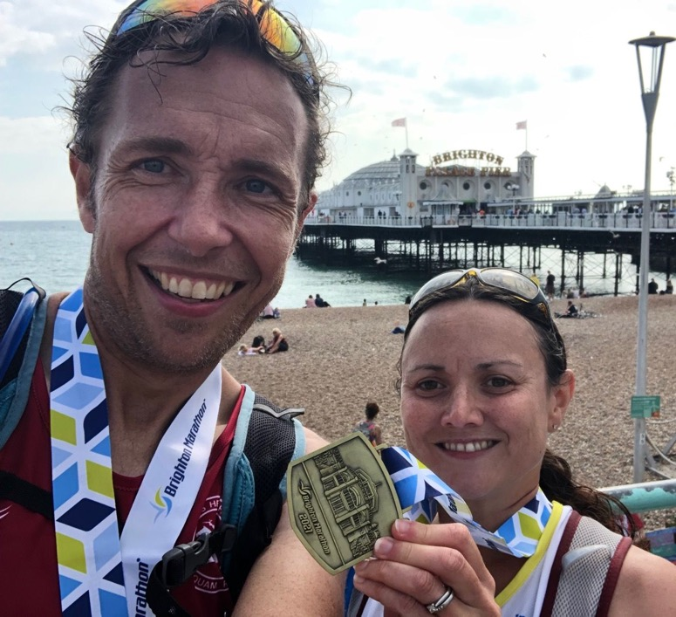
Greg and Clare Hilton

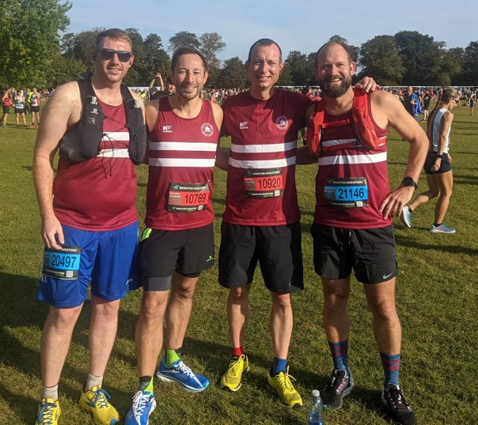
L-R: Ollie Farr. Tim Stannard, Pete Francis and Sam Atkin.

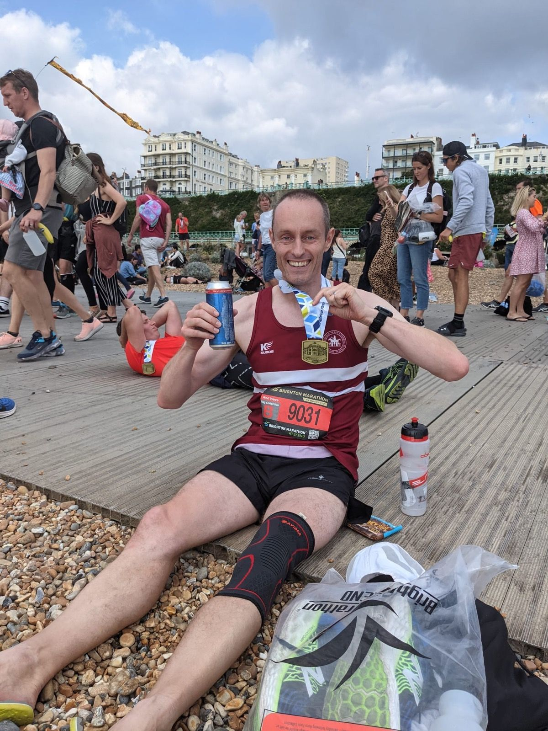
Dave Warren
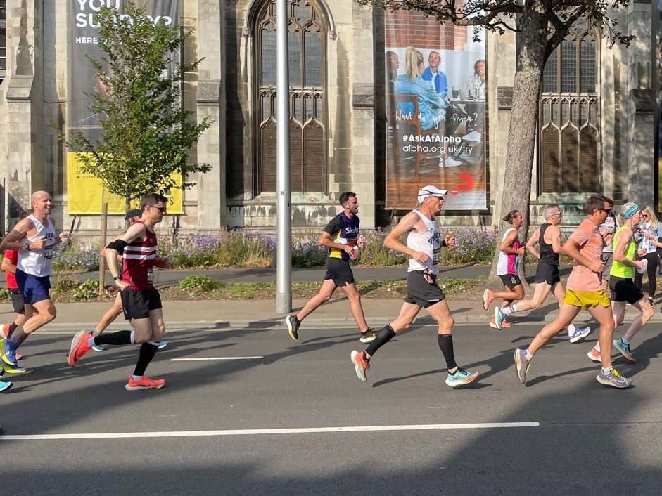
Sean Duff

Parkrun

Parkrun have now been back-up for a few weeks now and it’s been good to see the numbers of people taking park increasing. Parkrun is a good way to get yourself fit and also a great place to meet and socialise with people – especially after a long period of probably not having direct contact with people.

At Clair parkrun last Saturday, there were 132 finishers.

Harriers results this week were as follows:

Clair parkrun:
Russ Mullen 18:19, Will Grey 18:21 (pb), Sam Fernley 18:27 (pb), Arun Khursheed 19:59, Rob Watts 20:35, Isobel Russell 22:41 (1st female), Eric Hepburn 24:25, Ian Dumbrell 25:18, Mark Sykes 25:23, Jacqueline Barnes 28:17, Michael Parish 29:25, Caroline Mackey-Khursheed 29:26 (pb), Shelagh Robinson 29:49, Maureen Rea 41:19.

East Grinstead parkrun: Ewan Kemsley 20:08, James Smyth 25:39.
Horsham parkrun: Mark Green 19:03.
Letchworth parkrun: Julie Essex 28:53.
Orpington parkrun: Carl Bicknell 24:43.
Preston Park parkrun: (1st female) Kim Lo 20:16.
Worthing parkrun Ben Duncan 17:14, Andy Dray 19:54.

