Middy Report 13 December 2020

This is my first report since lockdown began back in March!

As we are currently under Tier 2 restrictions, Haywards Heath Harriers athletes have been able to return to something resembling ‘business as usual’.

Our ongoing ‘Virtual’ series of events have proved popular amongst members and has allowed our endurance runners and young athletes alike to keep in the groove.

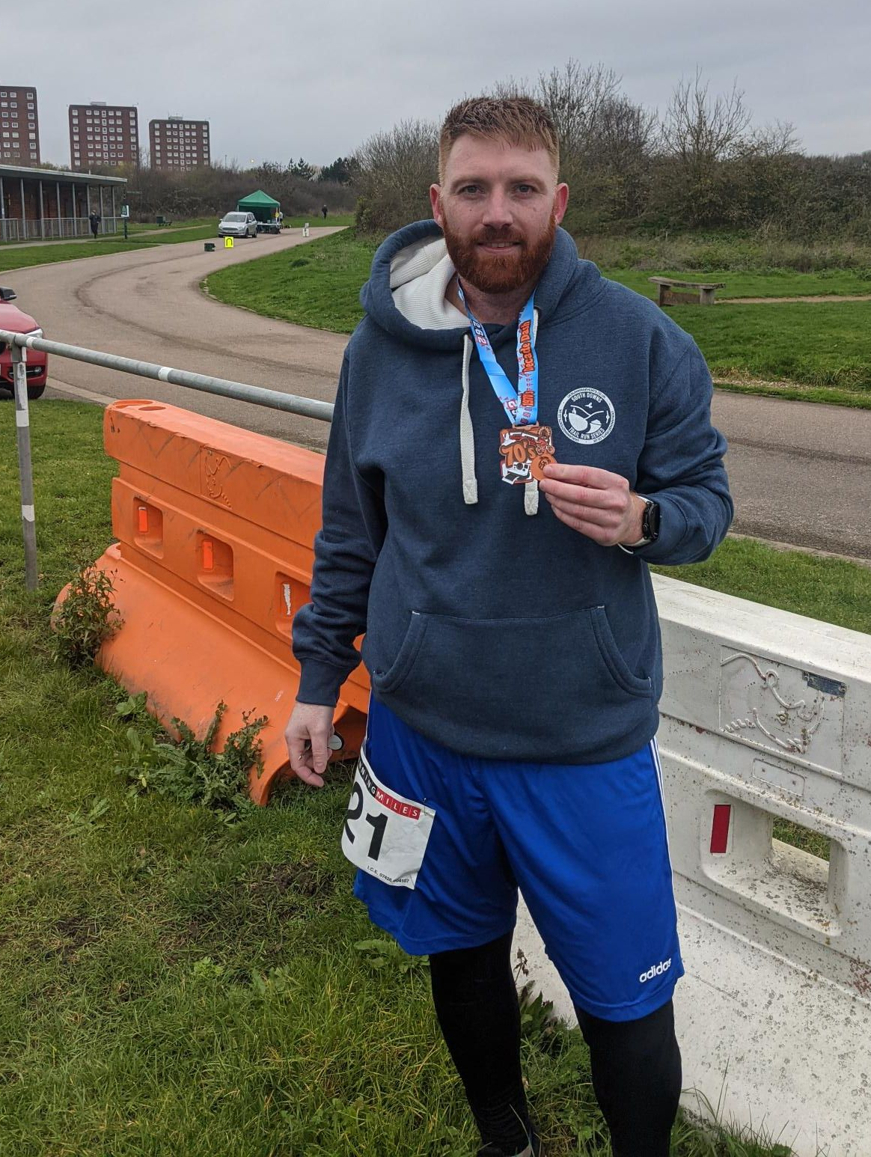
Marathon Man - Oliver Farr – after his 51st marathon.

Well done to Oliver Farr who ran his 51st marathon at the ‘Decade Dash’ in an impressive 3h:57m at the Hillingdon Cycle Circuit in Minet Country Park, North West London on 10 December.

Blackcap Handicap

The latest virtual competition to take place was an Inter-Club 5 miles handicap race between Haywards Heath Harriers, Lewes Athletic Club, Burgess Hill Runners and Phoenix Athletic Club in Brighton.

The competition was held in memory of Chris Smith who recently lost his life whilst out on a run in Scotland.

The handicap run took place on the South Downs between the points of Ditchling Beacon and the trig point at Blackcap. Runners could start at either end of the course.

Each runner was given a handicap time based on a calculation of their current form to run the distance.

The age grading was a separate calculation detailing a person’s official race time compared to that of the world record holder for the distance, in this case of 5 miles. So, basically, the higher the age grading the better the ‘good for your age’ that the runner is.

Results of the Harriers individual handicap were as follows:

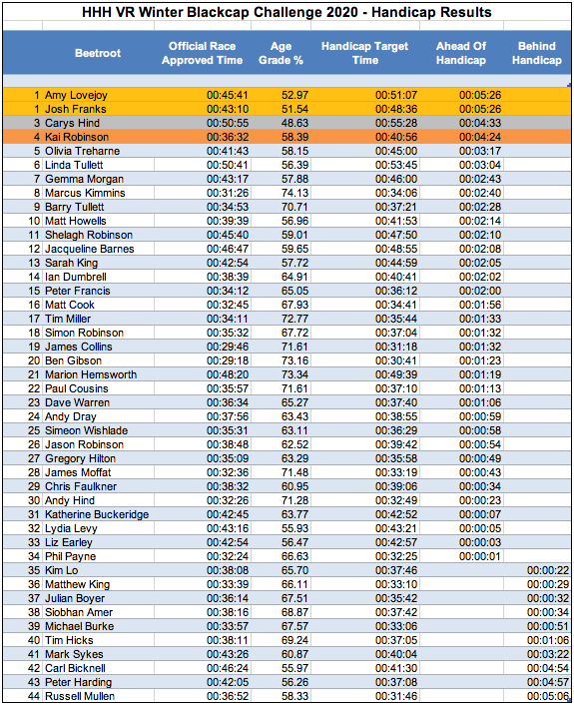

Ardingly PB5K Winter Race Series

Last Sunday was the PB 5k Winter Race Series event at Ardingly South of England Showground.

There were 4 graded races based on previous 5K times being recorded by the runners. The runners were set off in small, socially distanced groups.

Twenty-one Harriers took part in this event.

Haywards Heath Harriers results were as follows:

James Skinner 16.09; Jamie Topping 17.15; Matt King 17.38; Ewan Kemsley 18.04; James Moffatt 18.12; Ryan Armstrong 18.44; Tim Miller 18.53; Arun Khursheed 19.11; Simon Robinson 19.26; Martin Forsyth 19.31; Pete Francis 19.36; Tim Hicks 19.45; Barry Tullett 19.49; Daniel Maskell 20.25; Andy Dray 20.43; Siobhan Amer 20.47; Sam Ridley 20.53; James Smyth 20.53; Matt Howells 21.05; Lindsey Blain 21.05; Chris Faulkner 21.06.

Clearly, some of you had been on the Weetabix as we saw no fewer than four Harriers club records fall. Congrats to Ewan Kemsley (MU20), Tim Hicks (MV60), Sam Ridley (WV55) and Lindsey Blain (WV50).

The next PB5k race will be on Saturday 2 January 2021. Two further PB5k races are set for Saturday 23 January and Saturday 6 February.

To enter this event please go to the website link at https://www.pb5k.co.uk/

Running Grand Prix Goodwood

On the 6 December at Goodwood Motor Circuit, near Chichester, there were a series of multi distance races held under Covid restrictions.

Ben Gibson, Matt King, Jamie Topping and Harvey Alcock all competed in the half marathon. This was Harvey’s first ever half marathon and he finished in an impressive one hour 35 minutes and 30 seconds. Ben Gibson knocked two minutes off his best, Matt King knocked a superb 3 minutes off his best time and Jamie knocked an amazing 2 and a half minutes off his best time. Paul Cousins also ran his first 20-mile race.

Results were:
Half Marathon: Ben Gibson 73:00, Jamie Topping 78:59, Matt King 80:34. Harvey Alcock 95:30.
20 Mile race: Paul Cousins: 2h19m

