HARRIERS DO WELL AT THE BRIGHTON MARATHON

Lots of exciting running activity has been taking place in Sussex over the last two weekends with the Brighton Marathon and the Brighton 10k last weekend and the Sussex Road Relay Championships at Horsham the previous weekend.

Harriers had their very own Darren Bird as an official pace maker for the 3 hour 15 minute runners in the Brighton Marathon. Then there was the Harriers trying to get under that all but elusive 3 hour and 4 hour barriers. There also were those running their first marathon. All in all, with the good running conditions on Sunday and with the sun coming out late morning to warm the thousands of spectators that came down to Brighton seafront to watch the all the action taking place a good time was had by all and many great achievements were accomplished.

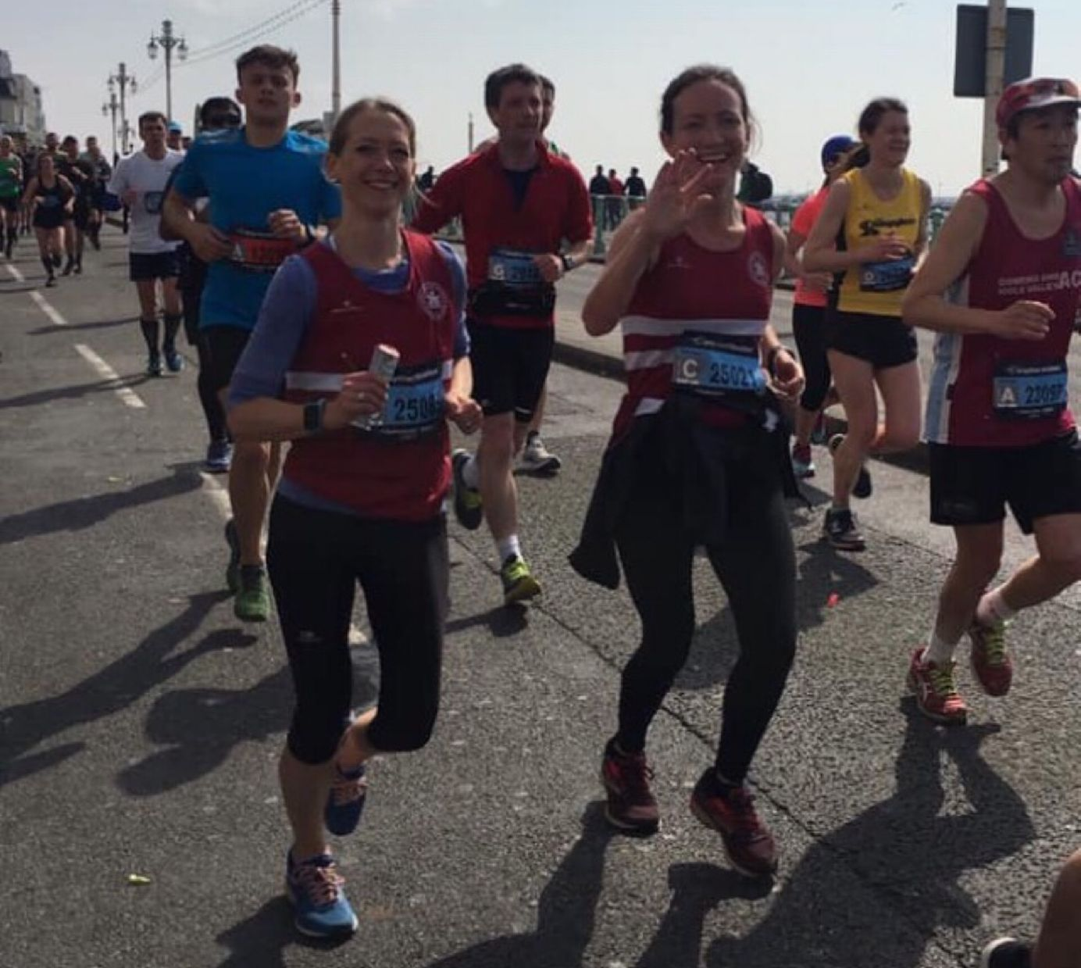
Georgina Mugridge and Gemma Morgan both heading for sub 4 hours.

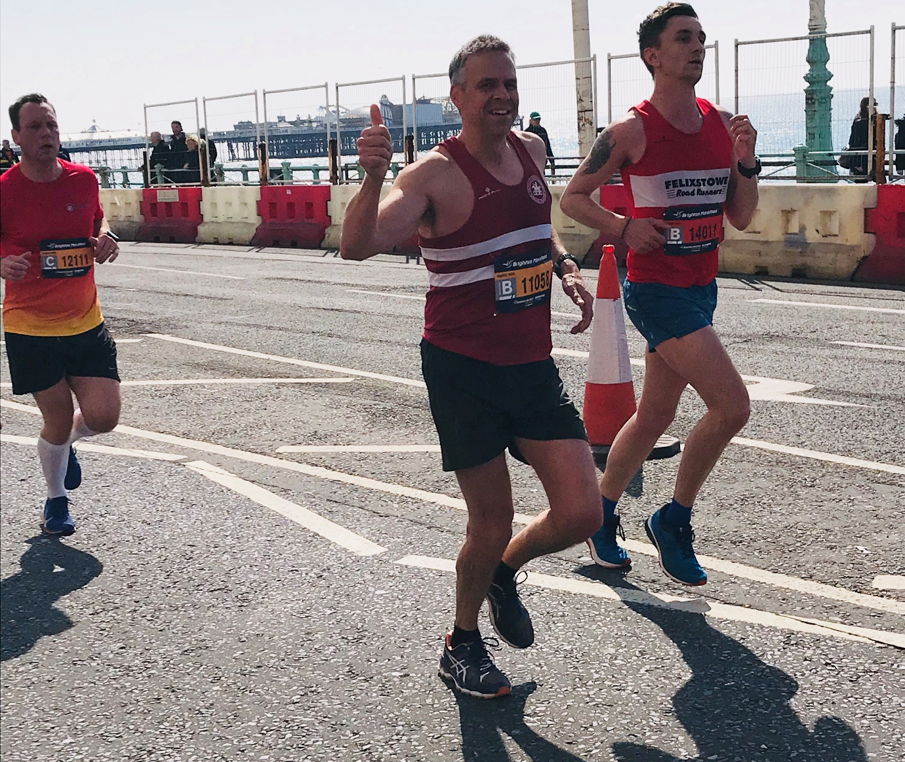
Barry Tullett at the halfway point.

Marathon results were as follows:
20th Josh Pewter 2 hrs 39 mins 09 secs, Matt King 3 hrs 2 mins 14 secs, Julian Boyer 3 hrs 8 mins 15 secs, Michael Burke 3 hrs 11 mins 14 secs, Darren Bird (pace maker for 3 hrs 15 minutes) 3 hrs 14 mins 34 secs, Barry Tullett 3 hrs 17 mins 20 secs, Greg Hilton 3 hrs 29 mins 29 secs, Tim Miller (first marathon) 3 hrs 30 mins 47 secs, Paul Cousins 3 hrs 34 mins.58 secs, Georgina Mugridge 3 hrs 45 mins 26 secs (pb), Ian Dumbrell 3 hrs 47 mins 18 secs, Gemma Morgan (first marathon) 3 hrs 59 mins 56 secs,

10km results were:
Ben Gibson 33 mins 26 secs, Emma Navesey 38 mins 00 secs, Theresa Almeida Silva 1 hr 00 mins 09 secs.

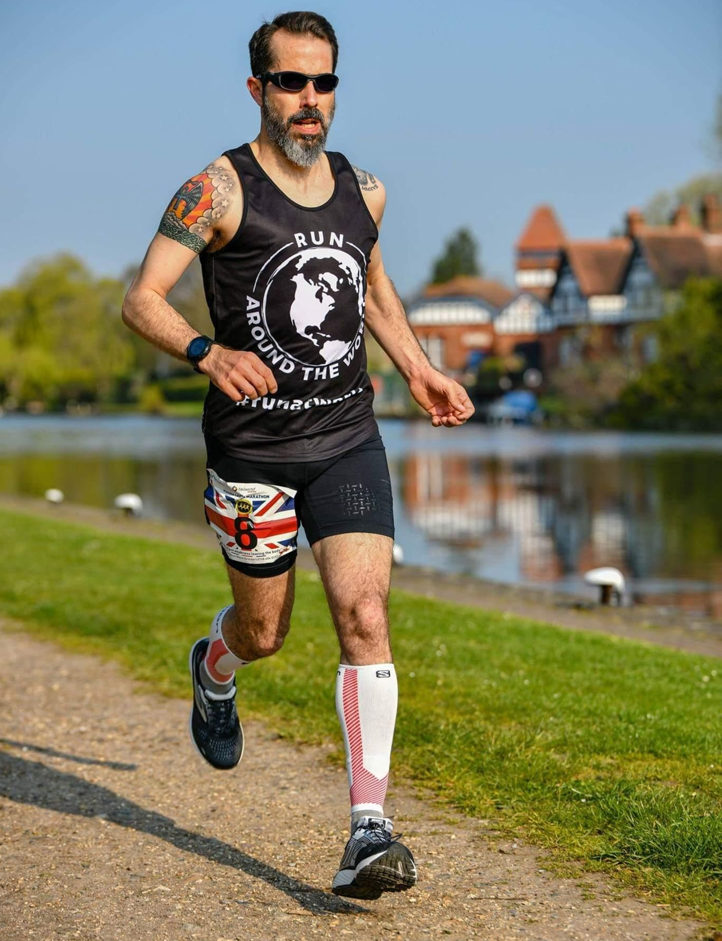
Michael Burke
Michael Burke also had a busy weekend. He not only took park in the Brighton Marathon on the Sunday but he also ran in the Magna Carta Marathon the day before in which he won for the second time in two years. Not only did Michael win the Magna Carta Marathon but he ran a super time of 3 hours 1 minute and 33 seconds. Michael then went on to run 3 hours 11 minutes and 14 seconds in the Brighton Marathon the next day. Oli Farr also ran the Magna Carta Marathon for his 33rd marathon in 4 hrs 9 mins and 43 seconds.

On the previous weekend, on 6 April, the Sussex Road Relays Championships took place at Christ Hospital, near Horsham. The Harriers had a host of teams taking part from the juniors to the vet men and vet ladies. This year a new off road course had been designed in the grounds of Christs Hospital. The under 13’s and under 15’s course being of the distance of one mile and the under 17’s and over being of two miles. The Harriers were not so much at the forefront of the competition this year as previous years but the relays proved to be a great team event as usual for the club to partake in with many experiencing there first time in a relay competition.

The top results were from Adam Dray who was the second fastest in the Under 17 Boys age group and Darja Knotkova-Hanley who was the third fastest in the Under 20 women’s race.

The relay results were as follows:

Under 13 Girls race:
HHH A team: 8th (Maya Dell’Aira Bromley 7:49, Amy Rutherford 7:06, Ella Chatfield 7:15) 22:10.
HHH B team: 23rd (Maia Bliss-Tomlinson 8:00, Kitty Gandarez 8:42, Bethany Hilton 8:58) 25:40.

Under 13 Boys race:
HHH A team: 6th (Arun Khursheed 6:08, Sam Fernley 6:33, Charlie Bonwick-Adams 6:46) 19:27.
HHH B team: 13th (Jonathan Parkin 6:42, Alex Todd 6:50, Seb Dell’Aira Bromley 6:45) 20:17.
HHH C team: 15th (George Bonwick-Adams 6:59, Jonathan Beckett 6:47, Harry Russell 6:59) 20:45.

Under 15 Boys race:
HHH A team: 11th (Ryan Armstrong 6:09, Harry Pulham 6:30, William Lord 6:37) 19:16.

Under 15 Girls race:
HHH A team: 8th (Harriet Dray 7:03, Lara Berzins 6:57, Rosie Beckett 7:01) 21:01.
HHH B team: Lily Bliss Tomlinson 7:56.

Senior Women’s race:
HHH A team: 13th (Jasmine Mamoany (U17) 13:46, Darja Knotkova-Hanley (U20) 12:27, Isobel Russell (U17) 13:24) 39:37.
HHH B team: 24th (Gemma Morgan 14:08, Lydia Levy 14:29, Georgina Mugridge 14:24) 43:01.

Vet 40 Women’s race: HHH 16th (Shelagh Robinson 16:20, Sarah Baston 13:53, Jenny Denyer (V60) 22:12) 52:25.

Vet 50 Women’s race: HHH 11th (Karen Thompson 14:32, Sarah Hamilton 16:00, Linda Tullett 18:26) 48:58.

Senior Men’s race:
HHH A team: 14th (Adam Dray (U17) 10:10, Darren Bird 11:08, Nick Skov 11:56, Oli Nelms 11:50, Ian Dumbrell 12:46, Darren Bird 11:25) 1 hr 09:15.

Vet 40 Men’s race:
HHH A team: 6th (Rob Watts 11:42, Dave Warren 12:00, Sim Wishlade 12:29, Andy Dray 12:21) 48:32.
HHH B team: 9th (Ben Adams 11:50, Jack Chivers 11:55, Jason Robinson 13:26, Dave Harper 13:52) 51:03.

Vet Men’s 50 race:
HHH A team 6th (Julian Boyer 11:32, Barry Tullett 12:24, Chris Russell 12:52) 36:48.
HHH B team: 15th (Phil Scott 13:32, Michael Parish 16:55, Graham Kenward 14:10) 44:37.

Vet Men’s 60 race:
HHH A team: 9th (Cliff Comber 13:19, Mark Sykes 13:33, Richard Bates 18:42) 45:34.

Hot off the press!
Haywards Heath Harriers very own Track & Field Meeting is being held on Thursday 25th April at K2, Crawley. Races for all ages from 9 upwards. Entries accepted in advance or on the night. Please see link below for further information regarding this event:

http://www.haywardsheathharriers.co.uk/

If you’re interested in learning to run, there is the J and M Running group which is linked to Haywards Heath Harriers. J & M are starting another Learn2Run course on 25th April for six weeks. For more information go to groups.runtogether.co.uk/JandMRunning or email Marion at marionhemsworth@aol.com.

