By Michael Parish and Paul Cousins.

**The Sussex under-13 Track and Field and under-11 Quad Kids Championships were held at Brighton’s Withdean Stadium on Sunday 7 July.**

Youngster Oscar Dalgliesh turned up the heat on the opposition when he not only won the Under 11’s Quadkids event, but was actually supreme over all the opposition and won by 20 points from the nearest competitor with an amazing 265 points amassed. The Quad kids is an event where the young athletes compete in various athletic disciplines: namely the 75 metres sprint, the 600 metres and the Standing Long Jump and the “Howler” (a throwing event like a javelin). This is the first time that Haywards Heath Harriers has had winner at this event! Oscar also breaking the Under 11 age group 75 metres Harrier club record with a time of 11.08 seconds.

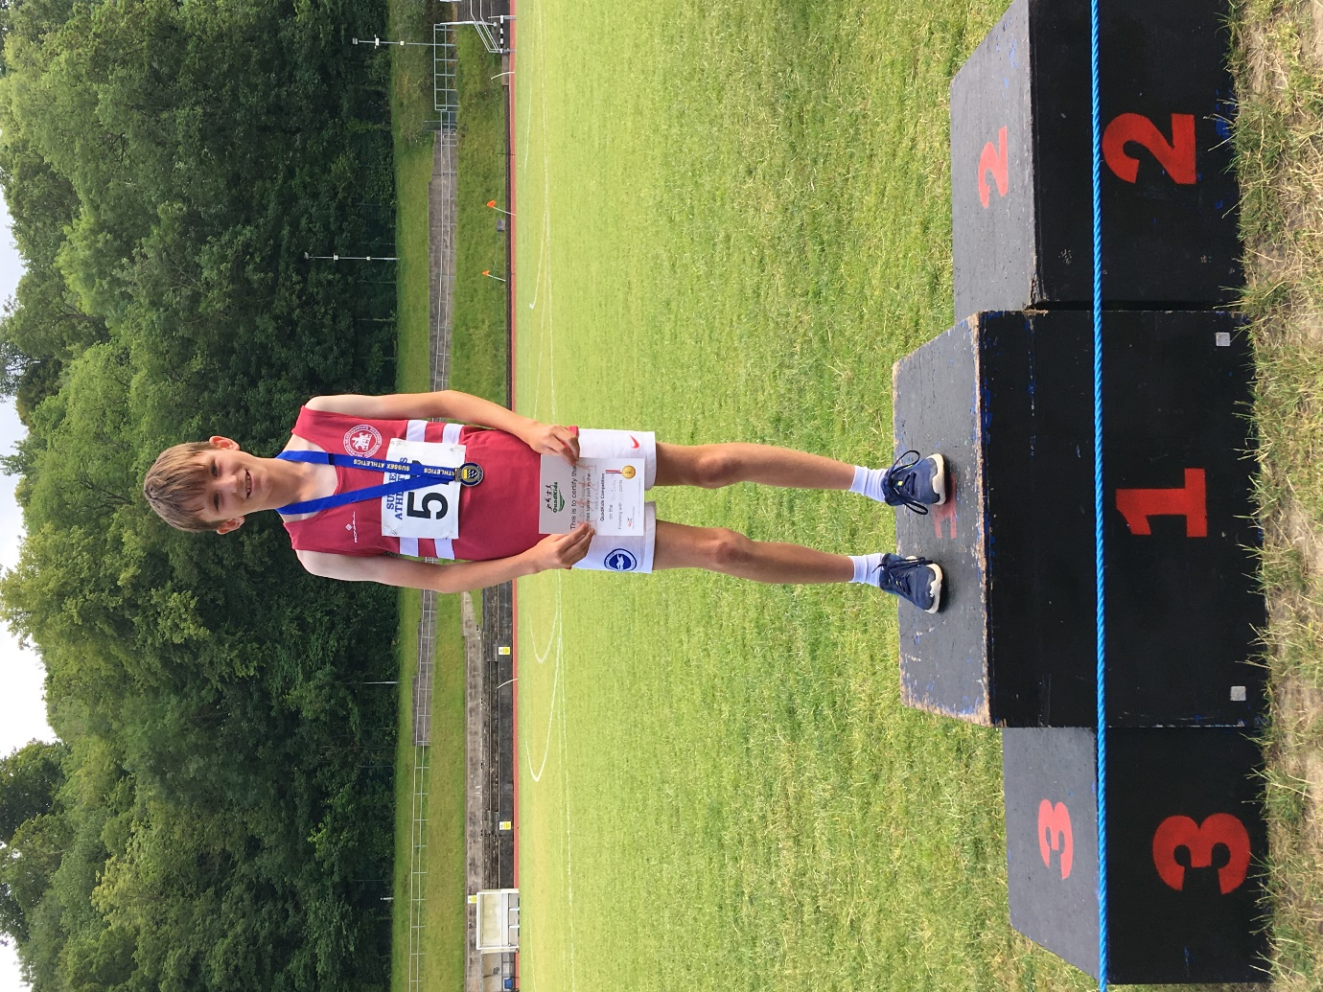

**Sussex Under 11 QuadKids Champion: Oscar Dalgliesh.**

Harriers who finished the Quadkids were:

1st Oscar Dalgliesh 265 points, Miller Hale 204 points, Noah Seymour 189 points, Lucas Lupton-Jones 174 points.

In the Sussex Under 13 Championships Track and Field Championships, Arun Khursheed and George Bonwick-Adams both won silver medals. Arun in the 800 metres with a time of 2 minutes 22.02 seconds (pb) and George in the Discus with a throw of 18.10 metres (pb).

Results in full:

Charlie Bonwick-Adams: 8th 100m m (final) 14.37 secs (pb), (heat) 14.78 secs, 6th (final) 200m 30.12 secs, 2nd 200m (heat) 30.07 secs, 14th 800m 2 mins 38.80 secs.

George Bonwick-Adams: 6th 200m (heat) 32.78 secs, 2nd Discus 18.10m (pb)

Arun Khursheed: 2nd 800m 2 mins 22.02 secs, 6th 75m Hurdles 14.27 secs, (heat 15.00 secs), 12th Long Jump 3.57m.

Oscar French: 75m Hurdles 6th (heat) 17.11 secs, 19th Long jump 3.25m (equal pb).

Jonathan Parkin: 4th Long Jump 4.35m (pb), 6th Javelin Throw 26.37 metres (pb)s.

4th 4 x 100m: HHH 58.47 secs (Arun, Jonathan, Charlie & George).

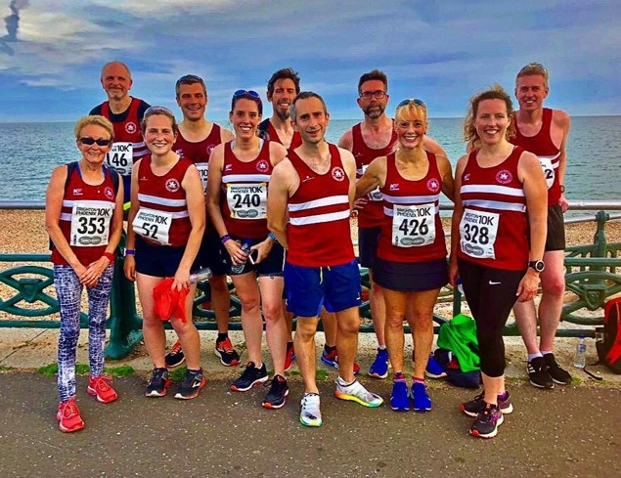**Harriers at the Phoenix 10km race in Brighton.**

Wednesday 10th July heralded the Brighton Phoenix 10km run. This is an important run for members of the Harriers as it is the third race of the season that contributes to the Bill Page awards.

The extremely well-marshalled course runs from Hove Lawns along the promenade, through the industrial area and out past Shoreham Power Station where it turns around at the 5km mark and heads back to the finish line. It forms part of the course for the Brighton Marathon and is notorious for runners achieving personal best times as the course is relatively flat and fast.

The run was attended by runners from the many affiliated running clubs across Sussex as well as other running club and non club runners. The Harriers turned up in force and all ran a fast paced race with everybody achieving under one hour on their personal chip times.   There were a number of personal best times that included Andy Hind, Steve McNulty, Carys Hind and Michael Parish.

James Skinner was first home for the club in eleventh place overall in a super come back race after a recent injury.

A full “debrief” was held with Harriers and other club members at The Brunswick free house after the event.

Results:  11 James Skinner 33:32, 52 Robert Watts 37:34, 59 Andy Hind 37:41 (pb), 87 Julian Boyer (pb) 38:49, 113 Ben Adams 39:38, 130 Jack Chivers 40:17; 144 Paul Cousins 40:49, 157 Darja Knotkova-Hanley 41:19 (pb), 184 Steve McNulty 42:22, 251 Samantha Ridley 44:44 (pb), 262 Steve Mitchell 44:59 (pb), 294 Jason Robinson 46:18 (pb); 305 Oliver Farr 46:46 (pb); 332 Lydia Levy 47:38 (pb); 402 Amanda Soper 50:52; 464 Shelagh Robinson 54:04; 485 Marion Hemsworth 55:17, 523 Peter Cobbett 58:02, 525 Carys Hind 58:19 (pb), 547 Michael Parish 59:35 (pb).

**Other Harrier Results:**

Mike Bale competed at the Vets Athletics Championships regional championships at Kingston. Mike where Mike won the gold medal achieving a new Harriers Vet club record of 34.21 metres. Mike also competed in the Shot and Discus (results in next Middy report).

On 3 July at the Roundhill Romp, Richard Bates was the only runner from Haywards Heath Harriers taking part finishing in 313th place in 65 minutes and 7 seconds.

On the 14 July, the Hove Hornets held their version of the West Sussex Fun Run League. The race called Hover Hornets Stinger followed a course from Waterhall Rugby Ground along a 3 mile climb up on to the South Downs and back down to the rugby ground. First home for the club was Andy Hind in 13th place overall in a time of 42 minutes and 20 seconds.

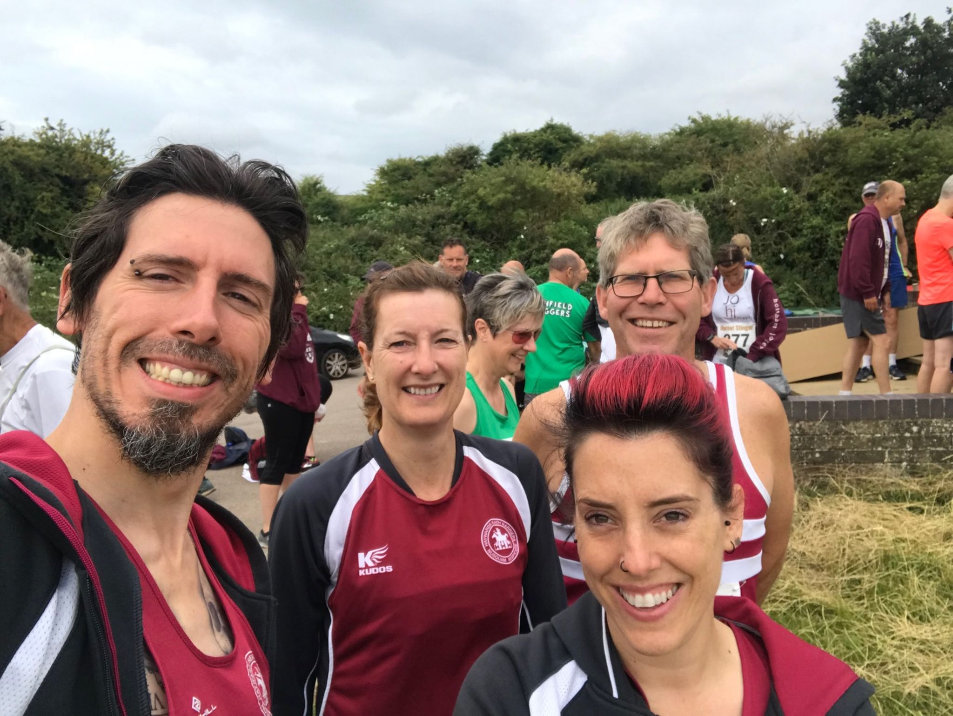

**Harriers at Hornet Stinger: (L-R: Andy Hind, Kath Buckeridge, Phil Scott and Carys Hind).**

Harriers results from the Hornets Stinger were:

79th Phil Scott 53:33, 143th Kath Buckeridge 59:45, 236th Carys Hind 76:26, 237th Richard Bates 76:56.

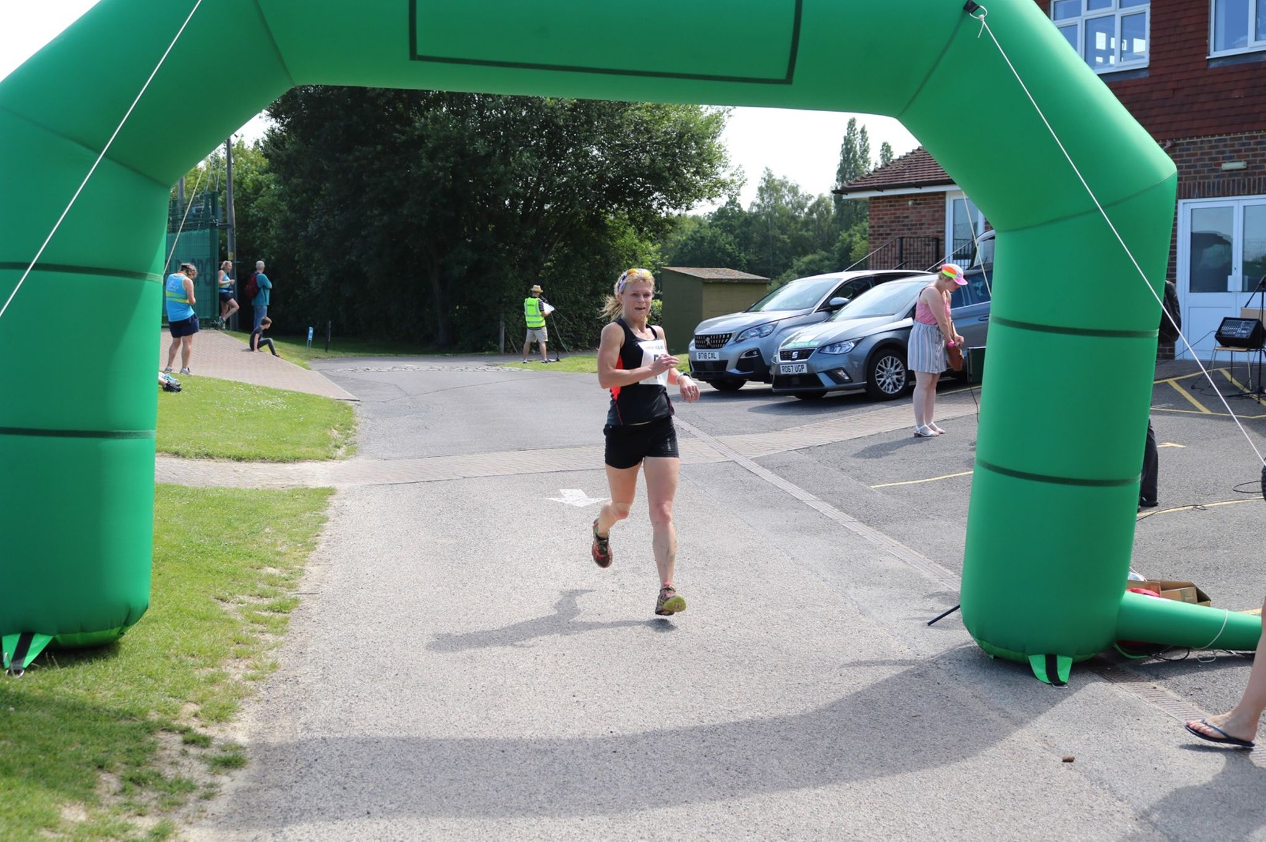

**Kim Lo at the Lingfield 10 Miler.**

At the Lingfield 10 mile event on 30 June, Harriers Kim Lo and Phil Payne took part in this event. Phil finished in 3rd place in 64 minutes and 48 seconds and Kim finished in 76 minutes and 38 seconds. Kim finished as first lady!