HARRIERS AT THE BERLIN MARATHON

At the Berlin Marathon last Sunday, a group of 5 Harriers travelled to Berlin to take part in this fast and furious race flat race: they were Phil Payne, Kim Lo, Matt Cook and Carl Bicknell and Sam Ridley. Their results were as follows:
Phil Payne 4 hrs 52 mins 17 secs, Kim Lo 3 hrs 12 mins 55 secs, Matt Cook 3 hrs 11 mins and 32 secs, Carl Bicknell 4 hrs 14 mins 05 secs and Sam Ridley 3 hrs 42 mins 28 secs.

Sam Ridley also was completing what was the final part in her quest for the World Marathon Majors that are held in 6 cities across the world: namely Chicago, New York, Tokyo, Boston London and Berlin (and at other Championship marathons). This is where marathon runners across the world can collect a special medal for taking part in 6 races (see below).

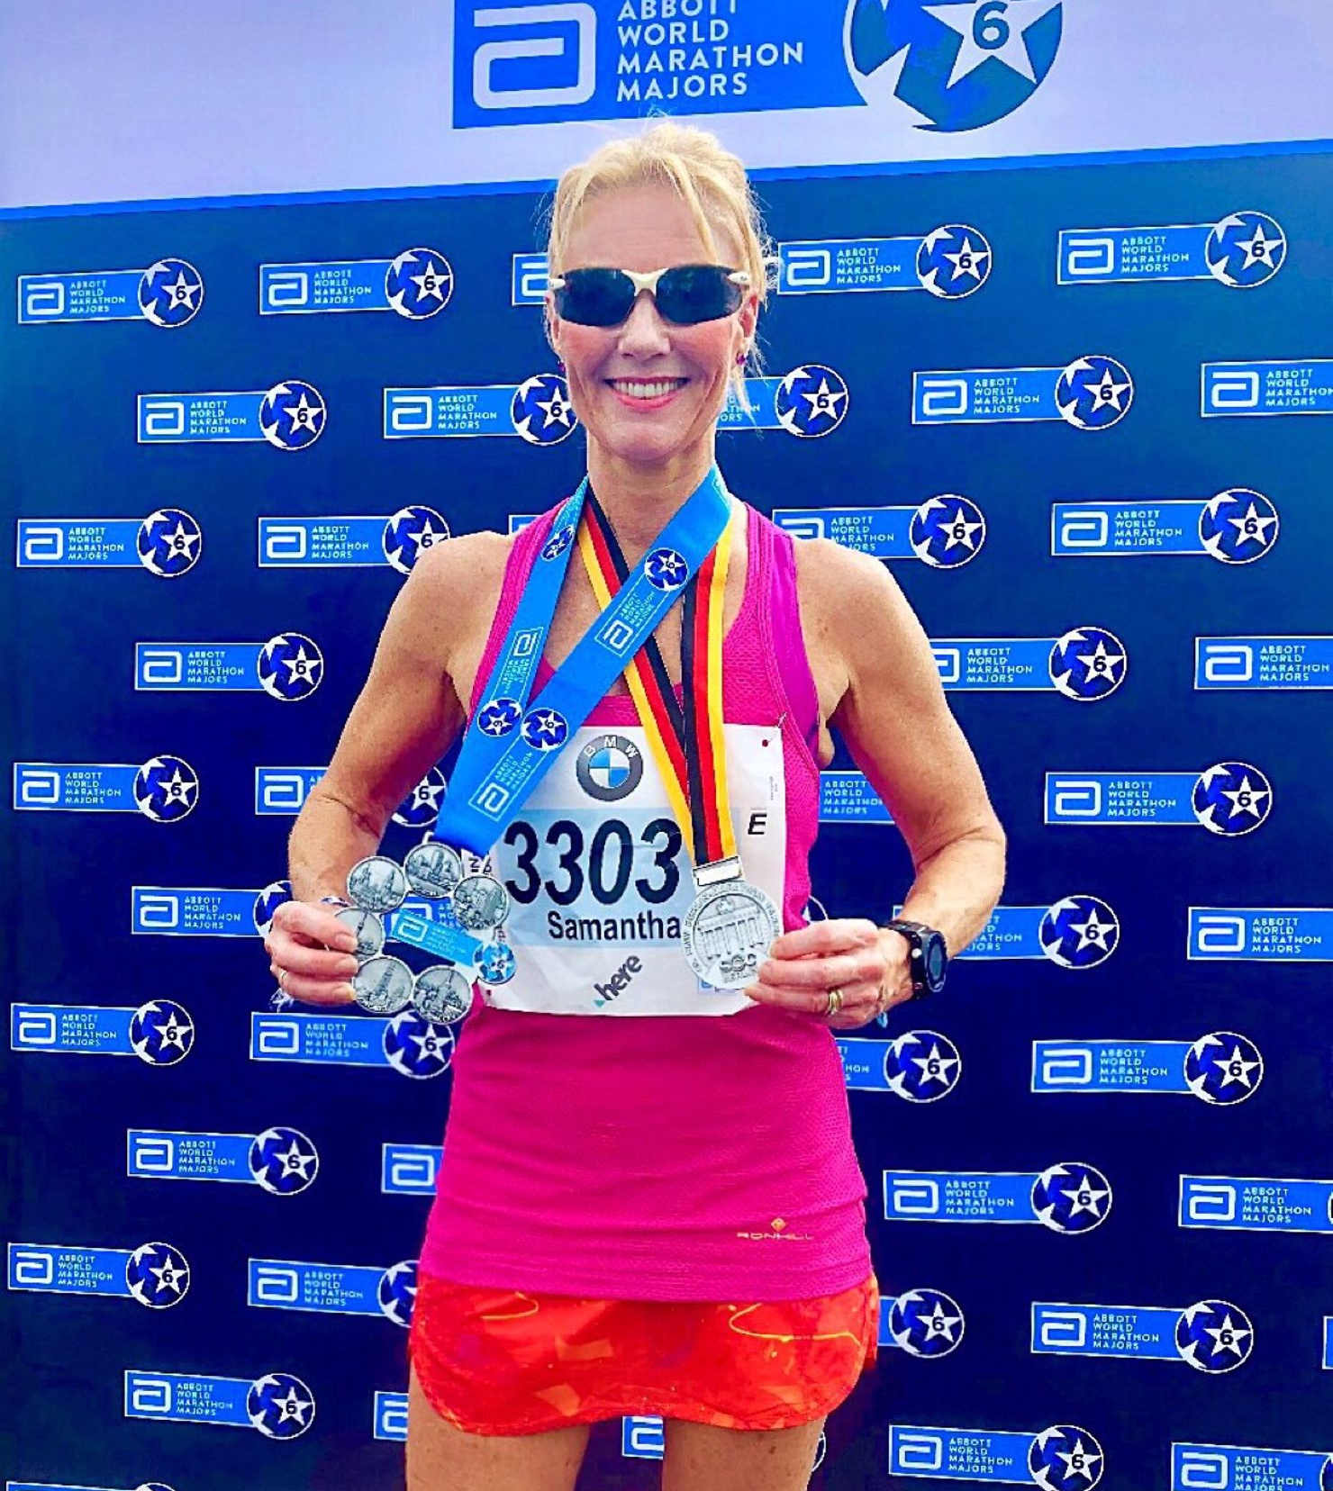

Sam Ridley with her World Marathon Major medal and Berlin Marathon medal.

Sam is planning to run the Bournemouth Marathon in a few weeks’ time in a much quicker time!

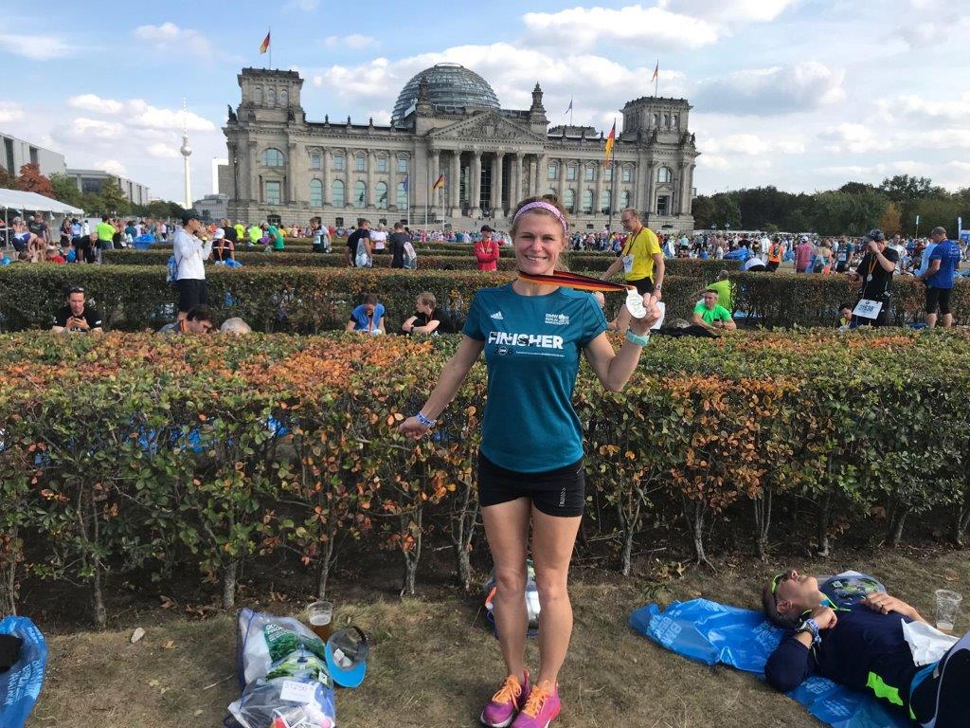
Kim Lo with her Berlin medal.

Meanwhile, back at Reigate for the Half Marathon event that was also held last Sunday, Katie Morgan was 2nd lady finisher in a time of 1 hour 29 minutes and 22 seconds. Also running was Michael Burke who finished in a time of 1 hour 28 minutes and 18 seconds, James Bennett in 1 hour 32 minutes and 13 seconds, Matt Quinton in 1 hour 36 minutes and 7 seconds, Oli Farr who finished in 1 hour 44 mins and 15 seconds and Chris Glanfield in 1 hour 59 minutes and 32 seconds.

Katie Morgan ran in the New Forest Half Marathon on 9th September and finished in 61st overall and was 6th lady in as super time of 1 hour 29 minutes and 26 seconds.

At the Hellingly 10 km race on 9 September, eight Haywards Heath Harriers took park in this hilly race that is held near Hailsham. First home was Ben Duncan in a time of 37:43, Karen Thompson was 1st Vet 50 lady to cross the line.

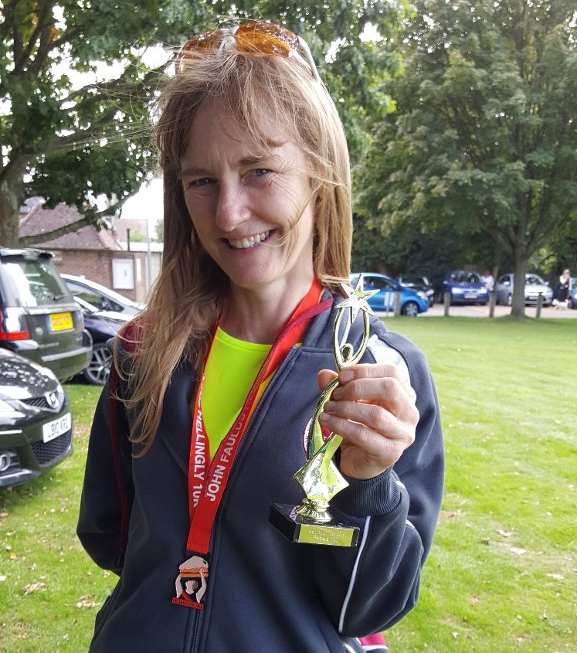
Karen Thompson with her V50 medal.

Results were as follows:
8th Ben Duncan 37:43, 22nd Jack Chivers 40:13, 58 Matt Quinton 45:03, 64th Matt Howells 45:40, 91st Oliver Farr 48:26, 101st Carl Bicknell 49:15, 130th Karen Thompson 51:29, 238th Peter Cobbett 63:32.

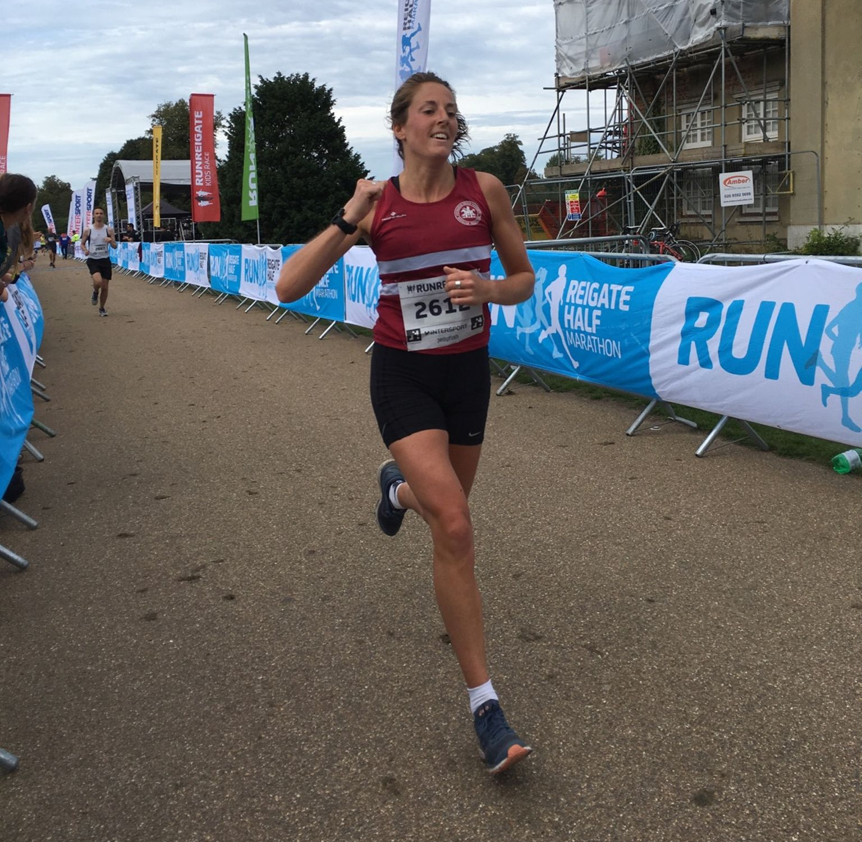
Katie Morgan finishing at Reigate Half Marathon.

At the Sussex 3000m County Championships were held at the K2 stadium at Crawley on Sunday 2nd September, James Skinner won the Senior mens’ title in a superb time of 8 minutes and 54.49 seconds crowning him as Sussex Champion. His time also was a new Harrier Vet 40 record and he now is the number one the UK for Vet 45 age group for the 3000 metres for 2018. This is another club record to add to the list of quality performances by James this summer.

On Saturday 18 August at Tooting was the final Southern Athletic League event of the track and field season. James Skinner shining through with a win in the 5000m race.

Results were as follows:

Men:
John Palmer: 4th 100m ‘B’ 15.2 secs; 5th 200m n/s 30.7 secs (pb); 4th 400m n/s 69.3 secs (pb).
Tim Popkin: 3rd 800m ‘B’ 2 min 30.6 secs; 3rd 400m n/s 67.3 secs; 3rd 5000m ‘B’ 21:33.1 secs; 4th Shot Putt ‘A’ 5.77m; 3rd ‘A’ Hammer 10.66m.
Adam Dray: 1st 800m ‘A’ 2 mins 04.4 secs.
James Skinner: 1st 5000m ‘A’ race 15:28.4 secs.

Women:
Jenny Denyer:2nd ‘A’ 2000m s/c 14 mins 35.6 secs; 3rd ‘B’ Shot Putt 5.27m; 4th ‘A’ Discus 15.18m; 2nd ‘B’ Hammer 18.47m; 4th ‘A’ Javelin 14.61.
Brittany Croydon-Kempster: 3rd ‘B’ 200m 30.3 secs; 2nd ‘B’ 400m 71.4 secs; 3rd ‘B’ Discus 14.27m.
Women’s 4 x 100m Relay: Lewes & Haywards Heath 3rd 56.7 secs.
Women’s 4 x 400m Relay: Lewes & Haywards Heath: 2nd 3 mins 56.6 secs.

If you would like to get involved in coaching at the club, and join a lively team, there are volunteer opportunities available. We need help with Junior and Senior Sprints coaching. Our main training evening is Tuesday.
Expenses will be paid, and qualification costs covered. For further information contact our Head Coach: Michael Essex.

