Daniel Moll-Morgan won the Goodwood Half Marathon in on 3 April in a super-fast personal best time of one hour sixteen minutes and twenty one seconds. Daniel is preparing himself for the Milton Keynes Marathon on 2 May and is hoping to run another super-fast time..

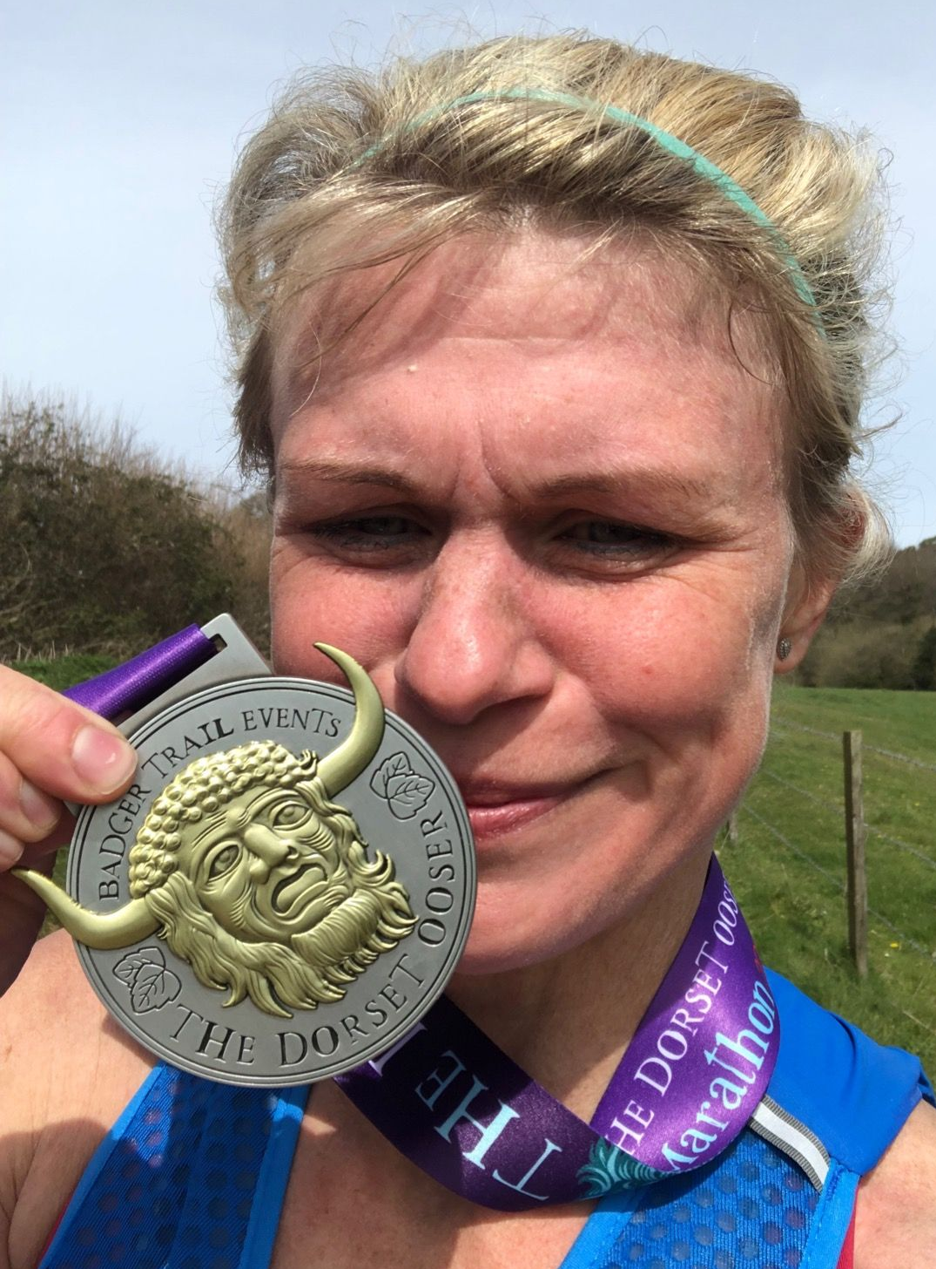
Kim Lo with her medal.

Kim Lo ran in the hilly trail marathon at the Dorset Oozer in a time of 4 hours 12 minutes and was 4th lady finisher. The race had an elevation of over 2,600 feet.

Tim Hicks ran in the Kew Half Marathon on Sunday 10 April. He finished in a time of one hour forty-two minutes and thirteen seconds.

Tim Stannard ran a super personal best in the Manchester Marathon on April 3rd. He finished in a time pf 3:11.50 which was a personal best by nine minutes.

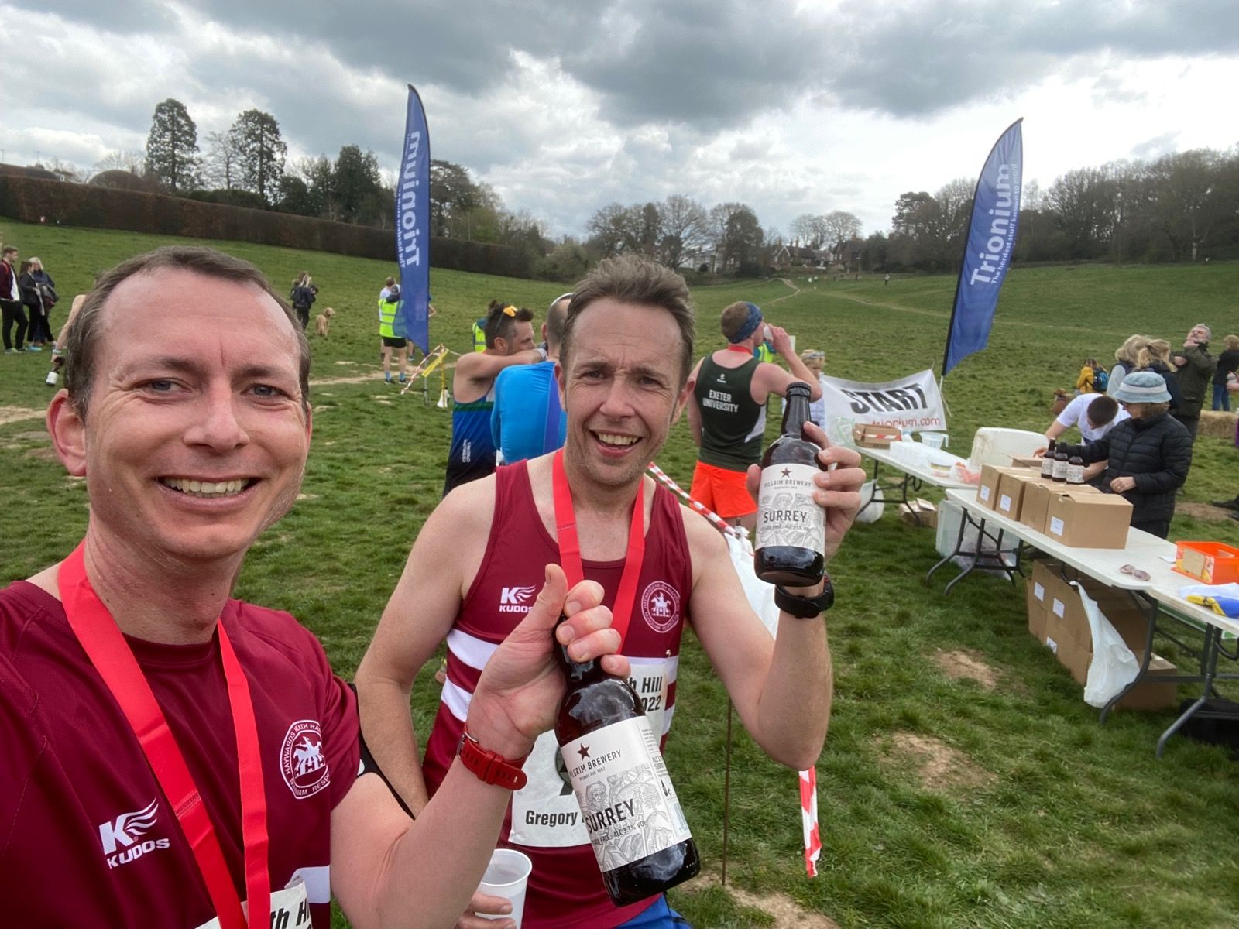
Pete Francis (left) and Greg Hilton celebrating their run at Leith Hill.

Greg Hilton and Pete Francis both ran in the Leith Hill Half. A half marathon both finished in 1 hour 39 minutes, but seconds apart from each other. Pete finishing in 1 hour 39 minutes and 39 seconds and Greg finishing in 1 hour 39 minutes and 42 seconds.

Andrew Wilson ran in the Findon Grand National 10km race, finishing in a time of 55 mins 45 secs.

Parkrun round-up.

The Harriers had a good time at parkruns around the country last weekend.

Notable runs were from Jonathan Beckett who smashed his personal best with a time of seventeen minutes and eight seconds at Hove Prom (which also was a new under 17 club record!). At Worthing parkrun, Harriers took the first four places; Will Grey equalled his overall parkrun pb and Annabel Axford improved on her personal best time at Clair parkrun.

Clair parkrun: 2nd Ewan Kemsley 18:45, 3rd Sam Fernley 18:59, 4th Harvey Alcock 19:19, 5th Andy Hind 19:29, 9th George Adams 20:20, 10th David Adams 20:21 (pb), 12th Paul Cousins 20:44, 15th Simon Robinson 21:11, 17th Kai Robinson 22:05, 21st Isobel Russell 22:42, 25th Bob Adams 23:13, 26th Simeon Wishlade 23:18, 30th Katie Reed 23:39, 36th Annabel Axford 24:24 (pb), 65th Clare Kenward 27:59, 83rd Shelagh Robinson 29:41, 118th Greg Hilton 33:41, 123rd Carys Hind 34:35.

Brighton & Hove parkrun: 186th Michael Parish 28:25
Havant parkrun: 167th Ian Dumbrell 33:36.
Braunstone parkrun: 17th Pete Francis 20:43.
Tilgate parkrun: 53rd Eric Hepburn 23:01; 125th Sarah Hamilton 27:03.
Queen Elizabeth parkrun: Emma Pryor 30:13.
Lanhydrock parkrun: 6th Finlay Blythe 20:04, 74th Noah Blythe 28:10.
Hove Prom parkrun: 4th Jonathan Beckett 17:08 (pb), 29th Arun Khursheed 19:57, 92nd Ian Tomkins 23:01, 94th Barry Tullett 23:02, 321st Linda Tullett 31:39.
Worthing parkrun: 1st Daniel Moll-Morgan 16:50, 2nd Jamie Topping 16:52 (pb), 3rd James Collins 17:20, 4th Marcus Kimmins 17:44.
East Brighton parkrun: 20th Carl Bicknell 25:27, 28th Kath Buckeridge 26:49.
Seaford parkrun: 2nd Will Grey 17:28 (equalled pb).
Uckfield parkrun: 2nd Ryan Armstrong 19:18.
St Mary’s parkrun: 24th Abby Ross 22:24.
Chipping Norton parkrun: 10th Abigail Redd 22:02.

