Harriers Shine at the Moyleman
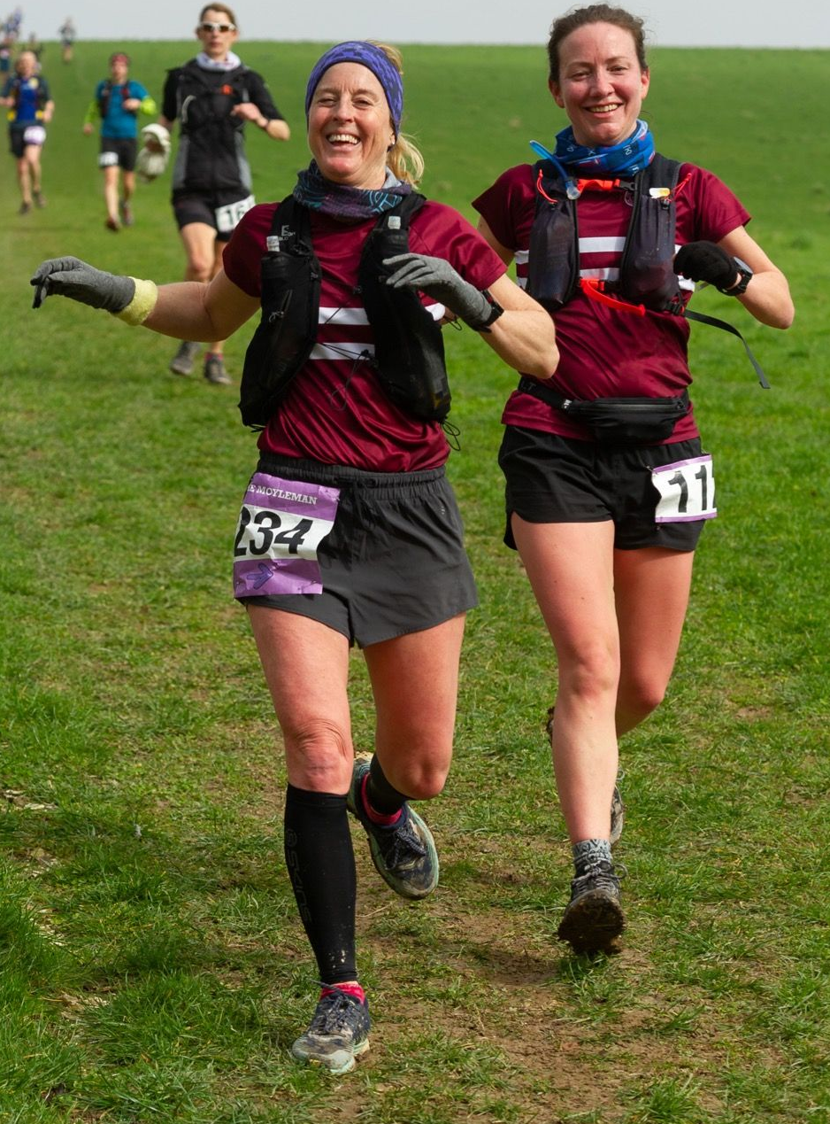
Siobhan Amer and Gemma Morgan at the Moyleman Marathon

A large group of Harriers took part in the Moyleman Marathon and Half Marathon on Sunday 12th March. This is a local (hilly) trail marathon that started back in 2014 in memory of a local runner Chris Moyle. The marathon circumnavigates the town of Lewes in Sussex in an anti-clockwise manner. Much of the course follows the South Downs Way footpath, finishing at the Harveys brewery in Lewes where the finishers are welcomed by a pint and a pizza!
The race was won by James Turner (Brighton and Hove Athletics Club / Lewes Athletics Club) in a very quick two hours and fifty-two minutes and forty-two seconds. The first woman was Jade Elphick (Brighton and Hove Athletics Club) who finished in fifth place overall in a time of three hours and thirty-two minutes and fifty-nine seconds, which was a new ladies course record!
First Harrier over the line was Jamie Gibson in seventh place in three hours and thirty-nine minutes and thirty-eight seconds.
Other Harrier’s results were:
15th Greg Hilton 3:54.03; 31st Simeon Wishlade 4:10.38; 40th Siobhan Amer 4:16.58; 58th Julie Kamel 4:26.08; 59th Gemma Morgan 4:26.33; 130th Shelagh Robinson 5:04.09;

Other Harrier’s results:

Brighton Half Marathon
There were lots of exciting results from this popular and very local half marathon. At the Brighton Half marathon on 26 February,
Hanne Boggon ran a massive personal best time of one hour fifty minutes improving on her previous best time of two hours and three minutes by running sub two hours for the first time.
Emma Pryor also improved on her half marathon time by running a new best of two hours and one minute (an eight-and-a-half minute improvement).
Kevin Frost also ran his first half marathon at Brighton in one hour forty-three minutes.
Jamie Topping was the first Harrier home in one hour fifteen minutes and twenty-five seconds in thirty-fourth place for a new personal best time. Sam Ridley was the first Harrier lady across the line in one hour thirty-four minutes and forty-five seconds.
Harrier’s results were: Jamie Topping 1:15.25; Tim Stannard 1:23.53; Matt Cook 1:24.28; Sam Ridley 1:34.45; Sam Atkin 1:38.29; Chris Faulkner 1:39.30; Phil Scott 1:43.24; Kevin Frost 1:43.29; Kim Lo 1:43.34; Hanne Boggon 1:50.07; Emma Pryor 2:01.31; Carys Hind 2:28.38; Michelle Robinson 2:49.46

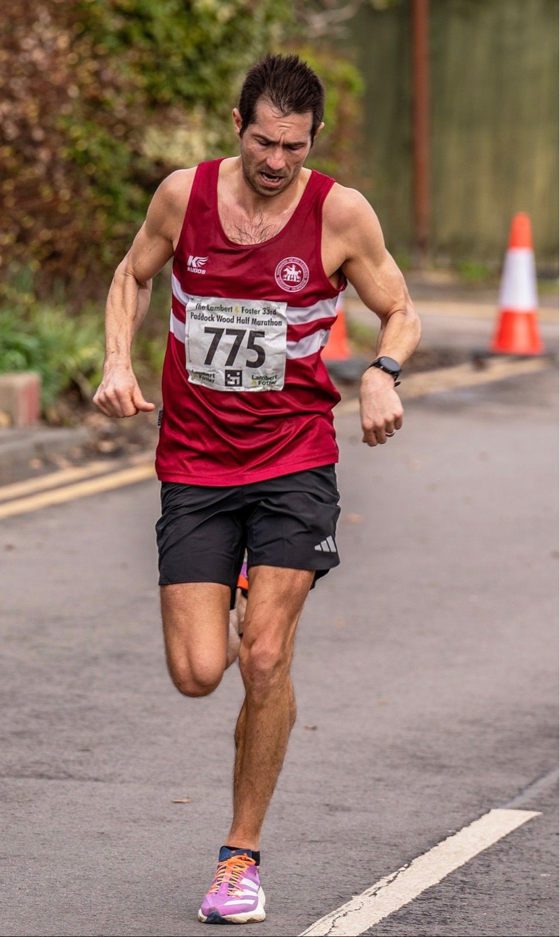
Chris Turner at the Paddock Wood Half Marathon
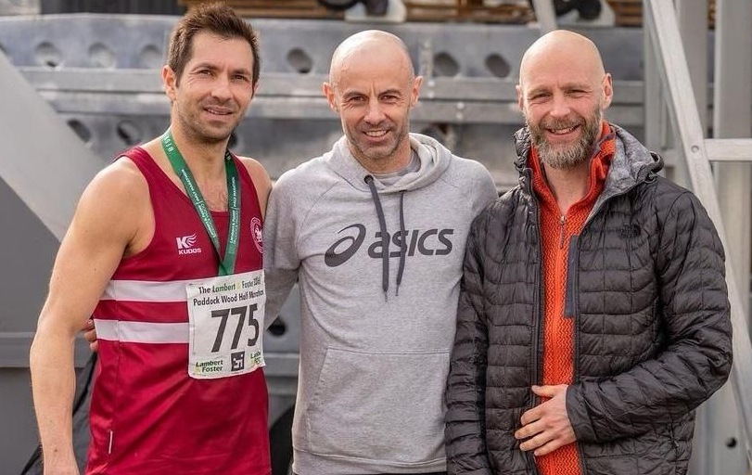
Harriers at Paddock Wood Half Marathon
Chris Turner ran a super race at the Paddock Wood Half Marathon on 12 March. Chris finished in forty-fifth place overall in one hour thirteen minutes and fifty-two seconds for a new personal best time. Other Harriers who finished this race were Jamie Topping in sixty-seventh place in one hour fifteen minutes and forty-seven seconds followed by Daniel Moll-Morgan in one hundred and fifty-sixth place in a time of one hour twenty-two minutes and twenty seconds.
Ollie Farr ran his 95th marathon at the Saturn Teenage Mutant Ninja Run at Staines-upon-Thames on eleventh of March. On his way to the magical one hundred marathon club, he finished well under five hours in a time of four hours and twenty-nine minutes. Ollie is hoping to complete his hundredth run at Richmond in May.
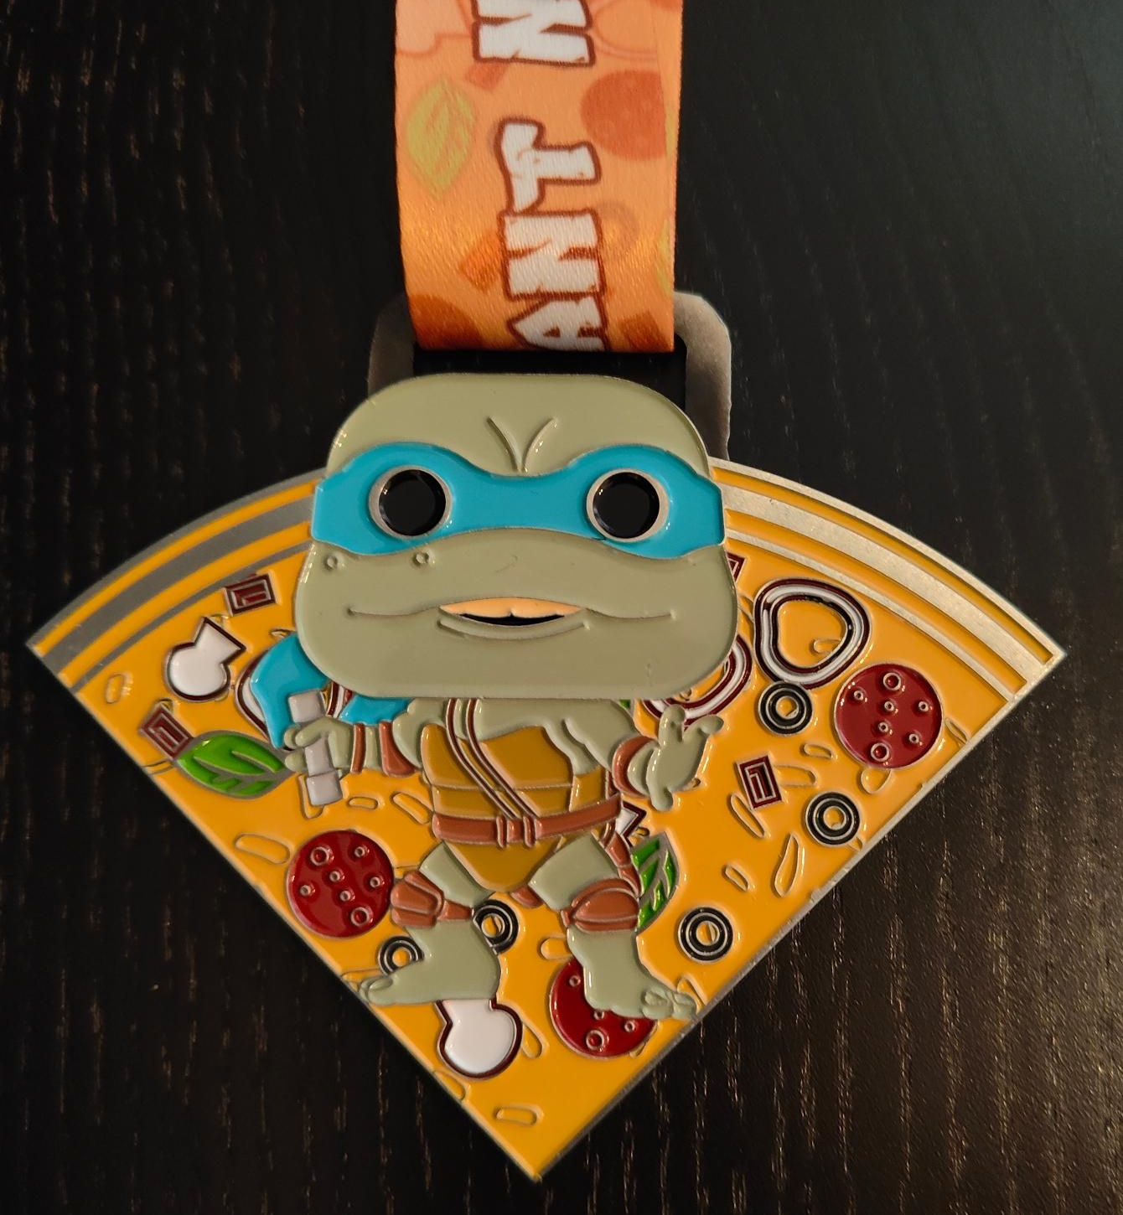
Ollie Farr’s ninety-fifth marathon medal.

