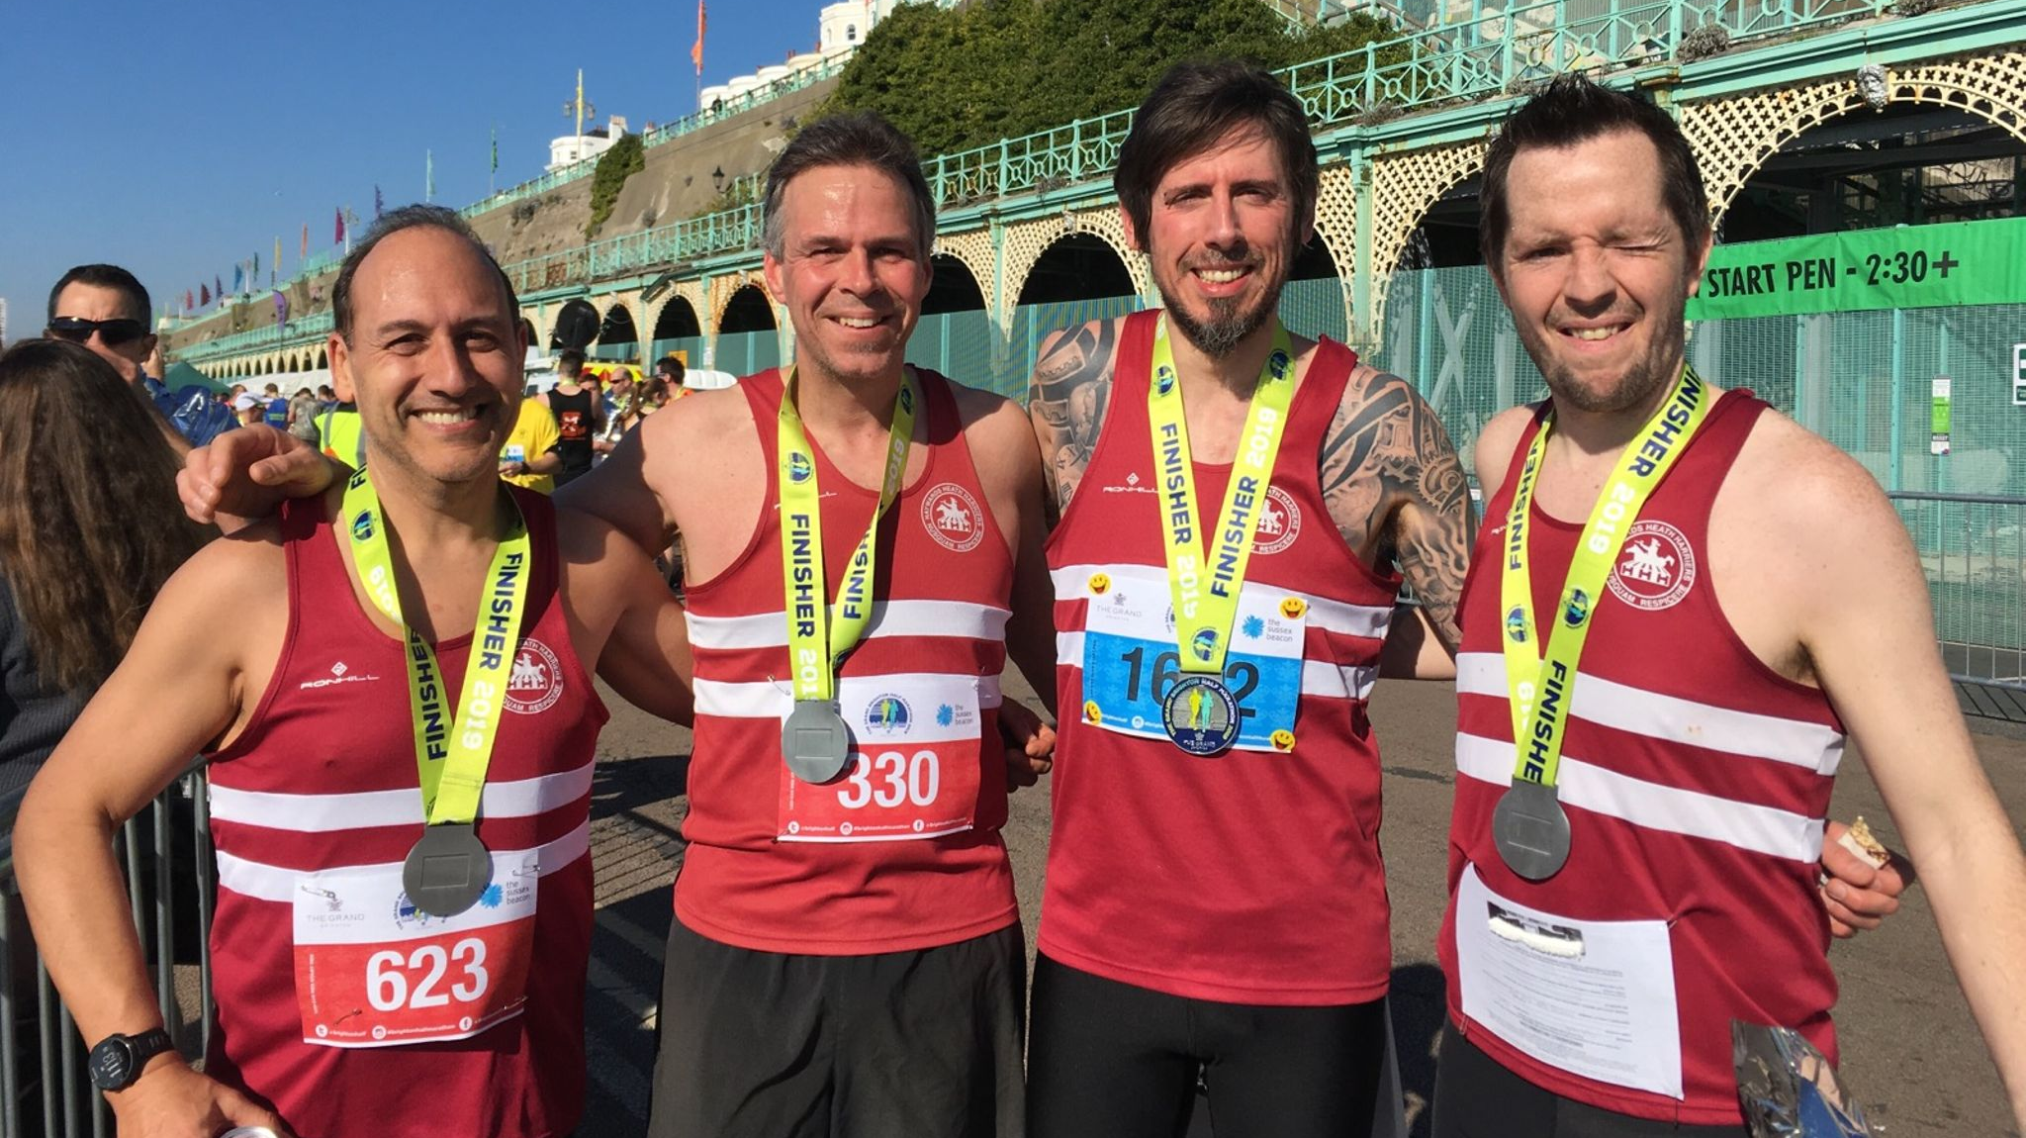
Harriers at the Brighton Half Marathon.

Last weekend, a host of Harriers took part in the annual Brighton Half Marathon. For many of them it as part of their marathon training. For others, it was perhaps their first taste of a long distance event.
Emma Navesey had a super run finishing seventh female and smashing the Harriers Senior Women’s Half Marathon record in the process that has been held by Ann Sinnett since 2006 of 1 hour 26 minutes and 26 seconds. Emma’s time of 1 hour 22 minutes and 43 seconds is unlikely to last long as she is in such fine form and improving with each race.

Results at the Brighton Half Marathon:
Russ Mullen 1 hr 15 minutes 6 seconds, Matt Cook 1 hr 20 minutes 2 seconds, Julian Boyer 1 hr 21 minutes 57 seconds (pb), Darren Bird 1 hr 22 minutes 25 seconds (pb), Emma Navesey 1 hr 22 minutes 43 seconds, Andy Hind 1 hr 26 minutes 57 seconds, Richard Gould 1 hr 28 minutes 16 seconds (pb), Tom Mullen 1 hr 29 minutes 27 seconds, Tim Miller 1 hr 31 minutes 36 seconds (pb), Barry Tullett 1 hr 35 minutes 10 seconds, Samantha Ridley 1 hr 40 minutes 24 seconds, Richard Bartlett 1 hr 47 minutes 43 seconds (pb), Beth Quittenton 1 hr 57 minutes 0 seconds (pb), Theresa Almeida Silva 2 hrs 24 minutes 43 seconds, Linda Tullett 2hrs 43 minutes 48 seconds.

At the Armagh International Road Race on the 14th February, Emma Navesey ran in the 3 kilometres road race and finished in 59th place in the Senior Ladies race in a time of 10 minutes and 18 seconds and Russ Mullen finished in 22nd place in the 5 kilometres race in a time of 16 minutes and 29 seconds. The competition was of a very high calibre.

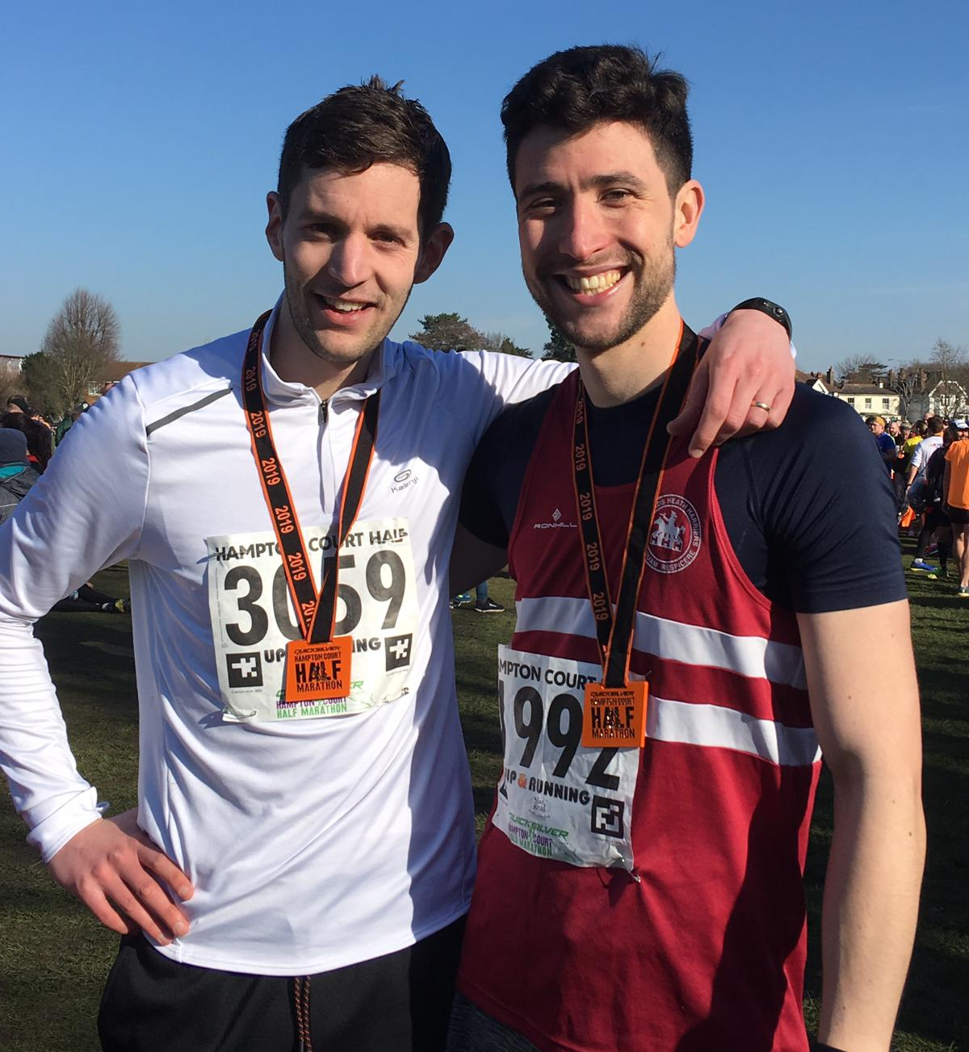
Callum Wooller and Oli Nelms after the Hampton court half Marathon.

Other Harrier results:
At the Hampton Court Half marathon on 17 February, Callum Wooller ran his first half marathon in a time of 1 hr 37 minutes and 5 seconds. Oli Nelms finished in front of Callum in a time of 1 hr 28 minutes and 53 seconds.
Maresa Pitt ran at the Egham Half Marathon and finished in a time of 1 hr 43 minutes 14 seconds.
Paul Cousins ran at the Wokingham Half Marathon and finished in a time of 1 hr 20 minutes 12 seconds.
Darren Bird ran at the Tunbridge Wells Half Marathon on 17 February and finished in a time of 1 hr 23 minutes 55 seconds.

Jasmine Mamoany ran in the English National Cross Country Championships at Leeds on Saturday 23 February and finished in a very respectable 150th place out of a field of 220. She is the first harrier to run in this national event for many years. Hopefully some more Harriers will be inspired to take part in this great event in the future.

Arun Khursheed smashed his personal best at the Clair parkrun that is held in Haywards Heath running a fabulous time of 19 minutes and 24 seconds for the 5 kilometer course.

Phil Payne and Kim Lo ran in the Marriott’s Way Half Marathon which follows the Marriott way from Norwich to Aylsham and finished in a time of one hour and 34 minutes and Kim finished in one hour 35 minutes and 30 seconds. This is a trail half marathon.
Runners

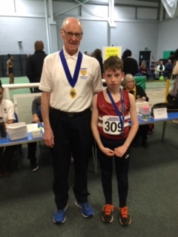
Charlie Bonwick-Adams.

Great results at the Sussex Indoor Athletics Championships recently with Charlie Bonwick-Adams winning bronze in the Under 13 Boys 60m in a time of 8.80 seconds. Arun Khursheed finished in fourth place in the Under 13 Boys Long Jump with a jump of 3 metres 60 centimetres. Whilst in the Under 15 Boys, Charlie Parvin finished equal second in a time of 8.6 seconds.

Also, young Harriers, Siobhan McMahon, Megan Eyre, Lucy Barker, Arun Khursheed, Jack Twibell, Charlie Parvin and Ethan Lambert and Sam Fernley have all been selected to represent Sussex in the sports hall inter counties in March. Well done to these young athletes.

Sportshall League.

The last Sussex Sportshall League was held at Tandridge House, Horsham on Sunday 10 Feb. The Harriers did well to finish in fourth place for the boys and fourth place for the girls. Notable performance was from Ethan Lambert who equalled the league record of 90 in the speed bounce in the Under 15 Boys age category.

Girls u/11:
2 Lap Sprint: ‘A’ race: 2nd Siobhan McMahon 23.7 secs, ‘B’ race: 4th Emma McMahon 27.0 secs.
4 x 1 Lap Relay:2nd Haywards Heath 50.4 secs.
Speed Bounce: ‘A’ 2nd Siobhan McMahon 52, ‘B’ 4th Lois Perrett 43.
Standing Long Jump: ‘A’ 2nd Siobhan McMahon 1.98m, ‘B’ 4th Emma McMahon 1.42m.
Girls u/13:
2 Lap Sprint: ‘A’ race: 4th Mae Robinson 25.1 secs.
4 Lap race ‘A’: 5th Holly Wilkinson 59.6 secs.
6 Lap race ‘A’: 4th Isabelle Eifler 1 min 28.9 secs.
8 Lap Parlauf: 5th Haywards Heath 1min 48.8 secs.
Speed Bounce: ‘A’ 3rd Isabelle Eifler 76, ‘B’ 4th Mae Robinson 69.
Shot Putt: ‘A’ 5th Holly Wilkinson 4.78m.
Vertical Jump: ‘A’ 2nd Holly Wilkinson 51, ‘B’ 4th Isabelle Eifler 34.
Standing Triple Jump: ‘A’ 3rd Mae Robinson 5.72m, ‘B’ 5th Millie Fairbrother 1.68m.
Girls u/15:
Vertical Jump: ‘A’ 4th Emma Vince 46.
Shot Putt: ‘A’ 4th Emma Vince 4.91m.

Boys u/11:
2 Lap Sprint: ‘A’ race: 5th Jack Twibell 24.4 secs, ‘B’ race: 3rd Arun Khursheed 24.3 secs.
4 x 1 Lap Relay:4th Haywards Heath 49.2 secs.
Standing Long Jump: ‘A’ 2nd Arun Khursheed 1.93m; ‘B’ 5th Oscar French 1.78m.
Speed Bounce: ‘A’ equal 2nd Toby Simpson 53, ‘B’ 4th Nye Sim 45.
Boys u/13:
2 Lap Sprint: ‘A’ race: 1st Charlie Parvin 21.9 secs; ‘B’ race: 3rd Alex Booth 24.1 secs.
4 Lap race: ‘A’ 3rd Charlie Bonwick-Adams 51.8 secs; ‘B’ race’: 2nd George Bonwick-Adams 52.5 secs.
6 Lap race ‘A’ 2nd Sam Fernley 1:17.2 secs, ‘B’ race 2nd Sebastian Dell’Aira Bromley 1:25.0 secs.
8 Lap Parlauf: 1st Haywards Heath 1min 36.7 secs.
4 x 2 Lap Relay:2nd Haywards Heath 1min 35.4 secs.
Shot Putt: ‘A’ 4th George Bonwick-Adams 5.79m, ‘B’ 4th Noah Perrett 4.12m.
Vertical Jump: ‘A’ 2nd Charlie Parvin: 53, ‘B’ 2nd Sebastian Dell’Aira Bromley 43.
Standing Triple Jump: ‘A’ 4th Alex Booth 5.54m, ‘B’ 4th Charlie Bonwick-Adams 5.22m.
Speed Bounce: ‘A’ 2nd Charlie Bonwick-Adams 74, ‘B’ Equal 1st Jack Bannister 68.
Boys u/15:
2 Lap Sprint: ‘A’ race: 3rd Ethan Lambert 22.3 secs; ‘B’ race: 3rd Lio Robinson 23.1 secs.
4 Lap race ‘A’ 4th Louis Henry 54.3 secs.
8 Lap Parlauf: 3rd Haywards Heath 1min 45.2 secs.
Speed Bounce: ‘A’ 1st Ethan Lambert 90 (Equalled Record); ‘B’ 1st Lio Robinson 84.
Standing Long Jump: ‘A’ 2nd Ethan Lambert 2.27m, 2nd Lio Robinson 2.14m.
Standing Triple Jump: ‘A’ 4th Louis Henry 5.46m.
Shot Putt: ‘A’ 4th Louis Henry 4.64m.

Non-Scoring:
2 Lap Race: Maggie Goodman 25.8 secs, Isobel Redd 27.7 secs, Lois Perrett 28.8 secs, Nye Sim 24.3 secs, Ewan Wilkinson 27.2 secs, Timothy Sayers 24.8 secs,
Finlay Blythe 24.5 secs, Oscar French 25.4 secs, Toby Simpson 25.3 secs, Noah Perrett 26.2 secs, Jack Bannister 26.5 secs.

Speed Bounce: U11 Boys: Jack Twibell 51, Oscar French 43, Ewan Wilkinson 45, Finlay Blythe 48, Arun Khursheed 47, Timothy Sayers 47.
Speed Bounce: U11 Girls: Emma McMahon 44, Isobel Redd 43, Maggie Goodman 47.
Standing Long Jump U11 Boys: Finlay Blythe 1.67m, Ewan Wilkinson 1.31m, Toby Simpson 1.65m Timothy Sayers 1.68m, Jack Twibell 1.86m, Nye Sim 1.75m,
Standing Long Jump U11 Girls: Isobel Redd 1.36m, Maggie Goodman 1.43m, Lois Perrett 1.30m.
Standing Long Jump U13 Boys Jack Bannister 1.70m.

Match result: Girls 4th 82 points; Boys 4th 170 points.

