Middy Report 24.07.17

Last Saturday, James Collins from Haywards Heath Harriers completed the International Snowdon Race - a 10 mile race from Llanberis to the summit of Snowdon and back. Conditions under foot on the day were not ideal due to heavy rain in the morning and visibility throughout the race was poor. However, he managed to reach the summit in a great time of 55:07 and completed the descent to finish in 87th position in 1:26:03. It is a challenging event where competitors run alongside international teams from as far afield as Italy. James will be returning next year, aiming for a quicker time, when hopefully he will be fitter and won’t suffer from burst blisters on the descent!

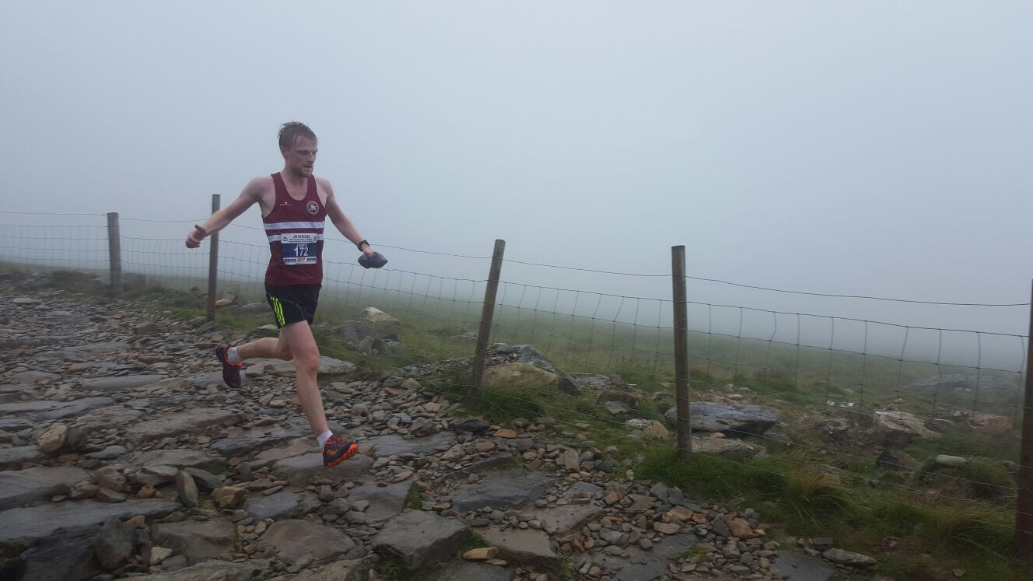

Picture: James Collins running down Snowdon

Haywards Heath Harriers youngsters were in action last Friday at Horsham in the Sussex Under 15 League.

The results were as follows:
Girls:
Hattie Collins: 6th ‘A’ string 100m in 15.4 secs, 5th‘A’ string 75m Hurdles in 16.1 secs, 5th ‘A’ string Long Jump 3m31.
Emma Vince: 4th ‘A’ string 300m in 50.3 secs, 6th ‘A’ string Shot Putt 3m93, 5th ‘A’ string Javelin 6m86.
Lily Bliss-Thomlinson: ‘A’ string 1500m 4th in 5:40.1.
Isobelle Russell: ‘B’ string 1500m 2nd 5:47.1, ‘B’ string Long Jump 5th 3m69.
4 x 100m relay: Haywards Heath Harriers 5th in 61.6 secs.

Boys:
James Boyer: ‘A’ string 100m 4th in 13.0 secs, 200m ‘A’ string 3rd in 27.4 secs.
Alfie Geere: ‘B’ string 100m 5th in 14.4 secs, Long Jump ‘A’ string 6th 4m21.
Ethan Lambert: ‘B’ string 200m 4th in 31.4 secs, 5th Long Jump 3m90.
Ben Fenner-Meadows ‘A’ string 1500m 6th in 5:11.1 secs, 5th Shot Putt 4m99.
4 x 100m relay Haywards Heath Harriers 6th in 58.3 secs.

Meanwhile at Horsham on the 20 July, the Sussex Under 13 League took place.
Results were as follows:

Boys:
Freddie Johnson: ‘A’ string 75m Hurdles 5th in 11.1 secs, ‘A’ string 150m 4th in 22.1 secs.
Louis Henry: ‘B’ string 75m Hurdles 4th in 11.7 secs, ‘A’ string Shot Putt 4th 4m26.
Oliver Simpson: ‘A’ string 600m 5th in 1:55.3 secs, ‘B’ string long Jump 3rd 3m78.
Alex Todd: ‘B’ string 600m 4th in 1:56.7 secs, ‘A’ string Long Jump 4th 3m98.
4 x 100m relay Haywards Heath Harriers 4th in 61.3 secs.

Girls:
Ella Greenslade: ‘A’ string 75m Hurdles 4th in 12.0 secs, ‘A’ string 150m 5th in 23.7 secs.
Jessica Bashford-Dickens: ‘B’ string 4th in 13.0 secs, ‘B’ string Shot Putt 5th 3m93.
Anna Piper: ‘B’ string 150m in 23.7 secs, ‘B’ string Long Jump 4th 2m75.
Anna Contreras: ‘A’ string 1000m 3rd in 3:52.0 secs.
Millie Francis: ‘A’ string 70m Hurdles 4th in 16.2 secs, ‘A’ string Shot Putt 3rd 5m52.
Millie Sommerville: ‘B’ string 70m Hurdles 3rd in 13.6 secs, ‘A’ string Long Jump 5th 3m28.
4 x 100m relay Haywards Heath Harriers 5th in 66.0 secs.

On Sunday the 23 July, the older youngsters were at Croydon competing in the Youth Development League and were in a combined team with Eastbourne Rovers, East Grinstead Athletics Club and Lewes Athletics Club, in a team called Team Sussex. The Team Sussex came 2nd.

The Harriers results were as follows:
Simeon Cousins ‘A’ string 400m 5th in 53.4 secs, 100m n/s 11.7 secs.
Katie Grant: ‘A’ string 100m 2nd in 13.6 secs, ‘A’ string 200m 2nd in 28.7 secs.

