Middy Report 25.03.18

Haywards Heath Harriers were spread across many events this last weekend. From parkruns to a marathon in Barcelona. With most of the endurance runners in deep preparation for their spring marathons, running one of the long endurance races helps in their preparation for practicing the pacing for the marathon.

The most notable performance this week must be of that by young Grace Holdstock, who following in her mum’s footsteps took part in her first ever parkrun. At Horsham parkrun, young Grace ran a personal best time of 39 minutes and 37 seconds. May she have many more!

At the Jog Shop 20, which is a 20 mile race over the South Downs which starts and finishes at the Brighton Marina. The race has iconic views of the South Downs and is a race that is tough to finish!
Results were: 6th Marcus Kimmins 2 hrs 30 mins 16 secs, 9th Darren Bird 2 hrs 31 mins 23 secs, 13th Rob Watts 2 hrs 38 mins 19 secs.

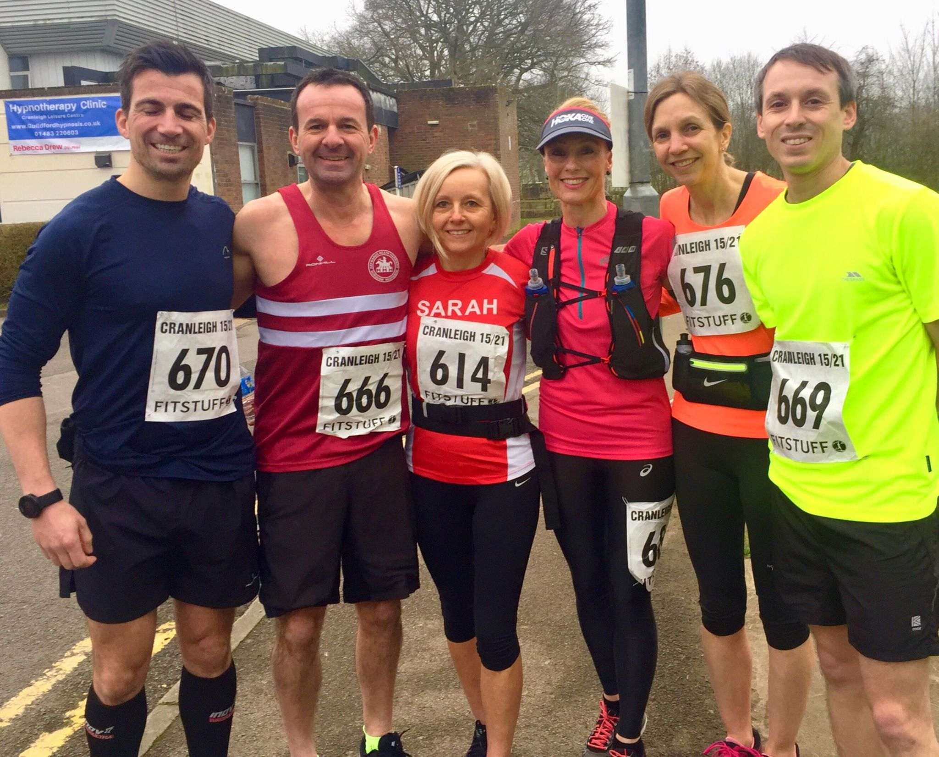
Harriers with other runners at the Cranleigh 15 and Cranleigh 21.

At the Cranleigh 15 miler on 25th March, another group of Harrier’s took part. Sam Ridley had a good run, finishing 5th lady overall in a superb 1 hr 59 mins and 27 secs, 71st Andrew Wilson 2 hrs14 mins 30 secs. In the 21 Mile race, Mark Green finished in 75th place in 2 hrs 32 mins and 58 secs, 227th Bryan Tiller 3 hrs 2 mins 14 secs, 228th Andrew McCluskey 3 hrs 2 mins 15 secs, 246th Sarah Banks 3 hrs 6 mins 0 secs.

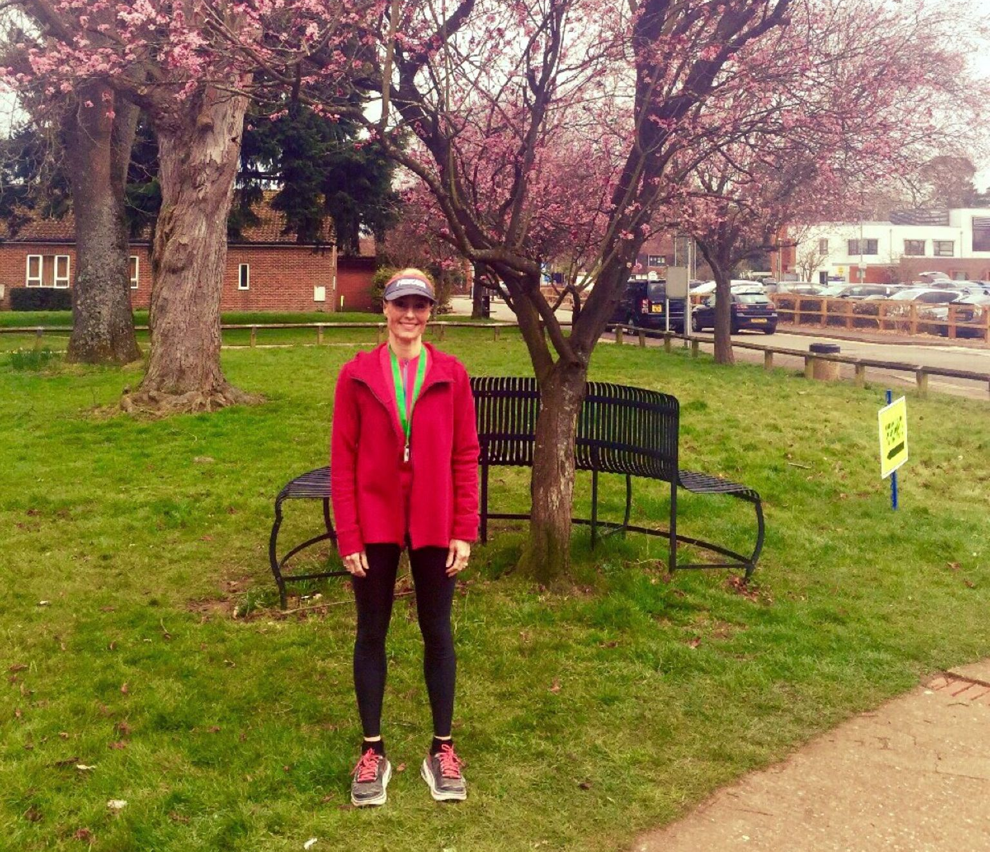
Sam Ridley with her finishing medal at the Cranleigh 15.

A new 10km race started on Sunday at the Lancing College. The Lancing College10km which takes in the beautiful grounds at Lancing College. On an undulating course, Julian Boyer was 9th in 41:08. Other Harriers finishers were: 25th Matt Quinton 44:17, 50th Matt Howells 47:17, 57th Graham Jenner 48:07, 71st Phil Scott 49:32, 97th Carl Bicknell 51:00, 162nd Karen Thompson 54:38.

Also, last Sunday was Mel’s Milers 10km race in XXX. A group of Harriers took part with James Collins taking a second place this year (compared to his first place last year!). Results were as follows: 2nd James Collins 34:24, 18th Jack Chivers 39:09, 141st Marion Hemsworth 52:44, 188th Gina Hobson 56:28, 194th Justine Tanner 56:51, 199th Amy Mitchell 57:03; 267th Michelle Holdstock 62:16 and 351st Jenny Denyer 78:50.

Colchester Half marathon, Hannah Gibson was 12th lady in 1 hr 34 mins 1 secs.

Also, at the Barcelona Marathon on 11 March, Thomas Brooks from Haywards Heath, ran an impressive 3 hrs 6 mins and 45 seconds.

At the Lee Valley Run Fest Half Marathon on Sunday, Michael Burke ran 1 hr 26 mins and 39 secs.

Also, at the Yeovil Half Marathon, Barry Tullett ran 1 hr 26 mins and 12 secs.

