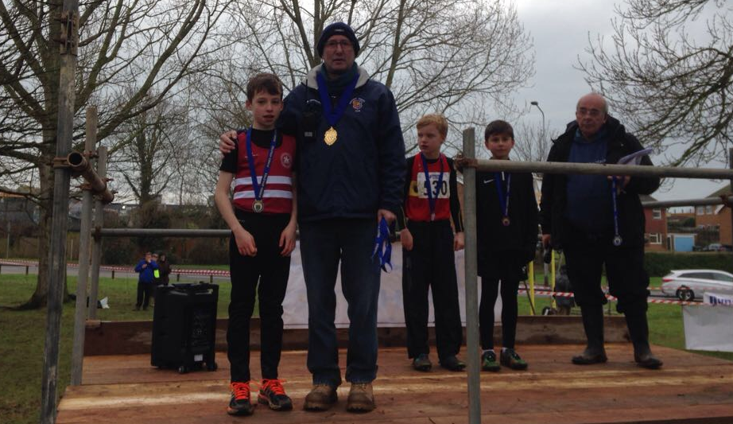
Charlie Bonwick-Adams – 2018 U11 Sussex County Cross Country Champion
At the Sussex County Cross Country Championships at Bexhill last Saturday the Harriers were represented by many runners across the club and for one up and coming youngster, Charlie Bonwick-Adams, it had to be one of the best races of his life when he won his race on Saturday in the Under 11 Boys race. He was followed soon after by his twin brother George who finished in 4th place overall.

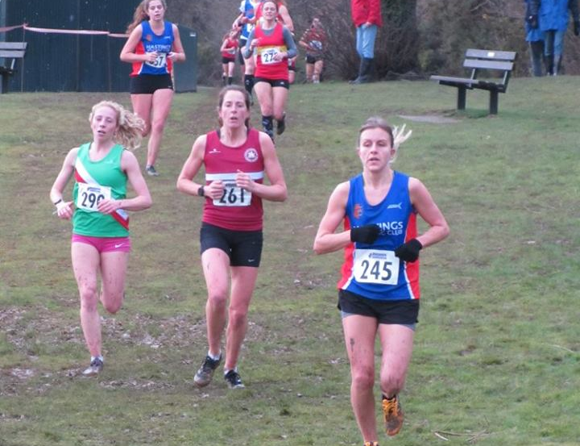
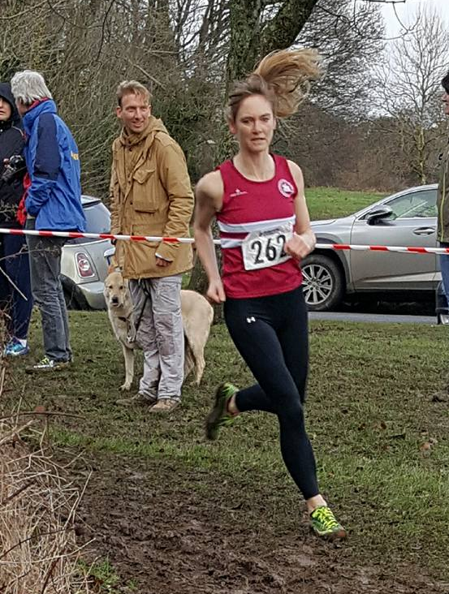
Karen Thompson in the Senior Ladies race.
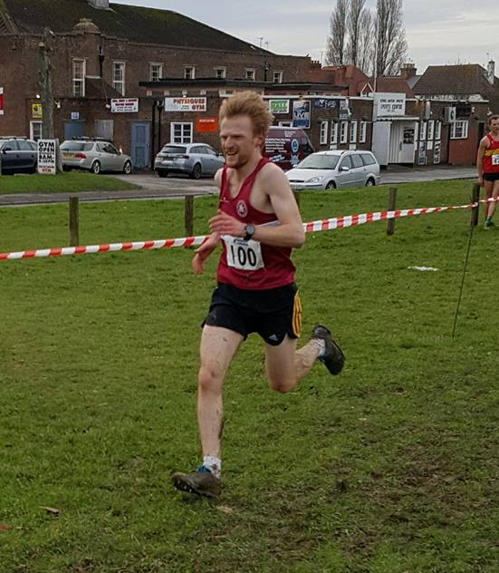
James Collins – first Harrier home in the Senior Men’s Race
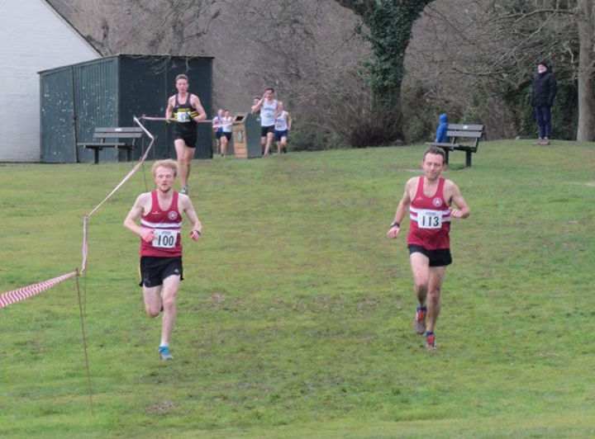
James Collins (left) racing team-mate James Skinner at the Bexhill Cross Country

Results as follows:
U11 Boys: 1st Charlie Bonwick-Adams 4:26, 4th George Bonwick-Adams 4:40, 33rd Harvey Gwyn 5:34, 36th Finlay Willis 6:08.
U17 Women: 9th Darja Knotkova-Hanley 23:56, 14th Jasmine Mamoany 26:46.
Senior Women: 10th Katie Morgan 28:05, 33rd Siobhan Amer 30:20, 45th Hannah Gibson 32:35, 62nd Karen Thompson 35:58, 76th Sarah Hamilton 41:26.
Senior Men: 13th James Collins 43:21,15th James Skinner 43:29, 26th Ben Gibson 45:02, 45th John Kettle 47:29, 46th Phil Payne 47:42, 64th Mark Green 49:54, 73rd Tom Mullen 50:38, 84th Alex McGregor 53:41, 98th Julian Boyer 56:36, 99th Tim Hicks 56:58.

At the Hangover 5 on 1st January 2018 was the first West Sussex Fun Run League event of the year which was held at Hill Barn, Worthing. The Harriers results were as follows:
18th Katie Morgan (3rd lady) 37:15, 30th Tim Hicks 39:03, 130th Clare Kenward (29th lady) 48:49, 144th Graham Kenward 50:16, 213th Richard Bates 57:50, 259th Michael Essex 65:11.

Sussex Sports Hall League results at Horsham on 10 December.

Special mention should go to Ethan Lambert who equalled the league record in the speed Bounce with a stunning 90 bounces in 1 minute!

Girls u/11.
2 Lap Sprint: ‘A’ race: 3rd Mae Robinson 25.4 secs, ‘B’ race: 4th Millie Fairbrother 27.0 secs
Speed Bounce: ‘A’ 4th Mae Robinson 47; ‘B’ 4th Millie Fairbrother 42.
Standing Long Jump: ‘A’ 4th Mae Robinson 1m76, ‘B’ 4th Brooke Bashford-Dickens 1m07.

Girls u/13.
2 Lap Sprint: ‘A’ race: 4th Hannah Taylor 24.2 secs; B’ race: 4th Jessica Bashford-Dickens 29.4 secs.
4 Lap race: ‘A’: 5th Amy Rutherford 55.3 secs; B’ race: 4th May Stevenson 57.0 secs.
6 Lap race ‘A’: 5th Jessica Bashford-Dickens 1min 40.7 secs.
8 Lap Parlauf: 4th Haywards Heath 1min 46.2 secs.
4 x 2 Lap Relay: 5th Haywards Heath 1min 48.4 secs.
Speed Bounce: ‘A’ 4th May Stevenson 69; ‘B’ 2nd Amy Rutherford 68.
Shot Putt: ‘A’ 5th Poppy Stapley 4m46; ‘B’ 4th May Stevenson 3m00.
Vertical Jump: ‘A’ 5th Amy Rutherford: 37, ‘B’ 5th Poppy Stapley: 37.
Standing Triple Jump: ‘A’ 5th Hannah Taylor 4m73; ‘B’ 5th Jessica Bashford-Dickens 4m47.

Girls u/15:
2 Lap Sprint: ‘A’ race: 5th Emma Vince 25.2 secs.
Vertical Jump: ‘A’ 5th Emma Vince 40.

Boys u/11:
2 Lap Sprint: ‘A’ race: 4th Thomas Pearce 24.6 secs; ‘B’ race: 2nd Jack Twibell 24.1 secs.
4 x 1 Lap Relay:4th Haywards Heath 51.9 secs.
Standing Long Jump: ‘A’ 3rd Thomas Pearce 1m99; ‘B’ 4th Ben Taylor 1m69.
Speed Bounce: ‘A’ 2nd Harry Krombas: 52, ‘B’ 1st Equal =Thomas Pearce 49.

Boys u/13:
2 Lap Sprint: ‘A’ race: 4th Tom Swanston 25.3 secs.
6 Lap race: ‘A’ 4th Charlie Bonwick-Adams 1 min 19.5 secs.
8 Lap Parlauf: 4th Haywards Heath 1 min 48.7 secs.
Shot Putt: ‘A’ 4th George Bonwick-Adams (U/11) 4m37.
Vertical Jump: ‘A’ 2nd Tom Swanston:46, ‘B’ 2nd George Bonwick-Adams (U/11): 39.
Standing Triple Jump: ‘A’ 4th Tom Swanston 5m07; ‘B’ 4th Charlie Bonwick-Adams 4m88.
Speed Bounce: ‘A’ 1st Charlie Bonwick-Adams (u/11): 76, ‘B’ 1st George Bonwick-Adams (u/11): 76.

Boys u/15:
2 Lap Sprint: ‘A’ race: 5th James Boyer 21.7 secs; ‘B’ race: 4th Lio Robinson 23.5 secs.
4 Lap Race: ‘A’ race: 5th Harvey Bashford-Dickens 49.2 secs; B’ race: 4th Ethan Lambert 49.2 secs.
4 x 2 Lap Relay: 4th Haywards Heath 1 min 35.9 secs.
Speed Bounce: ‘A’ 1st Ethan Lambert (Equal League Record) 90; ‘B’ 1st Lio Robinson 78.
Standing Triple Jump: ‘A’ 4th Ethan Lambert 5m95; ‘B’ 4th Lio Robinson 5m91.
Vertical Jump: ‘A’ 3rd James Boyer 62, ‘B’ 5th Harvey Bashford-Dickens: 42.
Shot Putt: ‘A’ 5th James Boyer 7m21; ‘B’ 5th Harvey Bashford-Dickens 5m29.

Non-Scoring:
2 Lap Race1: 6th Brooke Bashford (u/11) 29.1 secs.
2 Lap Race 7: 4th Ben Taylor (u/11) 25.8 secs.
2 Lap Race 8: 5th Oscar Clark (u/11) 25.3 secs.
2 Lap Race 9: 2nd Harry Krombas (u/11) 25.4 secs.

Speedbounce: U/11 Boys: Jack Twibell 47; Oscar Clark 48; Ben Taylor 39.
Standing Long Jump:U/11 Boys: Jack Twibell 1m75; Harry Krombas 1m55; Oscar Clark 1m58.

Speedbounce: U/11 Girls: Brooke Bashford-Dickens 24, Illy Saunders 41.

Standing Long Jump: U11 Girls: Millie Fairbrother: 1m51.

