HARRIERS AT HENFIELD

Harriers at Henfield Seven Stiles.

At Henfield on the 28 July was the Seven Stiles race which is part of the west Sussex Fun Run League. The race this year had no stiles but they did have a kissing-gate which got a lot of use as 388 runners passed through it! The harriers had eleven runners which is good because for the league purposes there needs to be ten runners to score.

First home for the club in eighth place was Andy Hind in 24 minutes and 42 seconds.
Other Harrier results were: 12th Mark Green 25:13, 14th Julian Boyer 25:33, 99th Lydia Levy 31:27, 130th Gemma Morgan 32:57, 142nd Kath Buckeridge 33:37, 147th Ian Tompkins 33:54, 170th Carl Bicknell 35:10, 213th Sarah Hamilton 38:02, 235th Carys Hind 38:58, 286th Richard Bates 42:48.

On Tuesday 16 July the Sussex Under 13 Track and Field League was held at K2 sports centre at Crawley. The Harriers finished in third place out of six Sussex clubs. Great performances by the young athletes with Arun Khursheed improving on his 1000 metres record to 3 minutes 9.8 seconds. The results were as follows:

Boys results:
Thomas Peace: 4th ‘A’ string 75m in 11.5 secs, 2nd ‘B’ string 75mHurdles in 16.6 secs.
Philip Williamson: 5th ‘A’ sting 150m in 22.0 secs, 5th ‘A’ string JT 19.92m.
Calum Crowe: 2nd’ B’ string 150m in 22.8 secs, 3rd ‘B’ string SP 5.85m.
Arlo Merchant: 5th ‘A’ string 600m 1:58.5 secs, 4th ‘A’ string LJ 3.56m.
Finlay Blythe: 3rd ‘B’ string 600m 1:59.6 secs, 4th ‘B’ string LJ 3.12m.
Arun Khursheed: 1st ‘A’ string 1000m 3:09.8 secs; 2nd ‘A’ string 75H in 14.3 secs.
Jonathan Beckett: 3rd ‘B’ string 1000m 3:33.9 secs, 4th ‘A’ string High Jump 1.15m.
C. Crouch: 3rd ‘B’ string HJ 1.10m, 3rd ‘A’ string SP 5.96m.
Johnny Rutherford: 3rd ‘A’ string DT 12.24m, 1st ‘B’ string JT 17.78m,
4 x 100m Relay: HHH 5th 61.0 secs.

Girls results:
Lucy Barker: 3rd ‘A’ string 75m 11.3 secs, 4th ‘A’ string 150m 23.0 secs.
Magdalena Goodman 4th ‘B’ string 75m 12.1 secs.
Holly Wilkinson: 3rd ‘B’ string 150m 22.8 secs.
B. Crouch: 4th ‘A’ string 600m 2:12.2 secs, 3rd ‘B’ string DT 9.07m.
Ella Chatfield: 2nd ‘B’ string 600m 2:14.9 secs, 4th ‘B’ string SP 3.19m.
Grace Dobson: 3rd ‘A’ string 1000m 3:31.6 secs.
Megan Eyre: 2nd’B’ string 1000m 3:40.8 secs.
Mae Robinson: 4th ‘A’ string HJ 1.15m, 5th ‘A’ string 3.30m.
Millie Fairbrother: 3rd ‘B’ string HJ 1.15m, 4th ‘B’ string LJ 3.20m.
Erin Gaston: 3rd ‘A’ string SP 5.10m, 3rd ‘A’ string DT 15.87m.
4 x 100m Relay: HHH 3rd 62.9 secs.

Non-scoring :
Boys: 4 x 100m relay: HHH B Team 65.7 secs.
Girls: 4 x 100m relay: HHH B Team 65.4 secs.

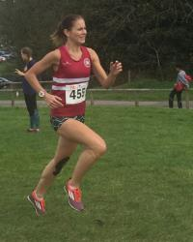
Other Results:

Emma Navesey competed for the county of Sussex recently at the Senior Inter Counties event held at Ashford. Emma winning the ‘B’ race in a personal best time of 10 minutes 16.37 seconds.

Mike Bale competed at the Vets Athletics Championships at Kingston on 14 July. Mike won the gold medal achieving a new Harriers club record of 34.21 metres in the Vet 60’s age category. Mike also competed in the Shot and Discus where he putted the shot 8.06 metres and threw the discus 27.33 metres.

Emma Navesey.

Teresa Mockridge ran in the Sevenoaks Seven on 14 July and finished in 63 minutes and 49 seconds.

Tim Miller had a great run in the Brighton Trailblazer Run which was held on Sunday 21 July. Tim finished in thirteenth place in a time of 41 minutes and 5 seconds.

On 14 July was the Wakehurst Willow. Hayward Heath Harriers have organised this mid-week evening race which is now into its fourth year. The race was held at Wakehurst near Ardingly in and around the beautiful botanical gardens. First place went to Kieran Barnes who finished in a time of 28 minutes and 41 seconds. First lady across the line was Sue Mcdonald in a record time of 33 minutes and 48 seconds.
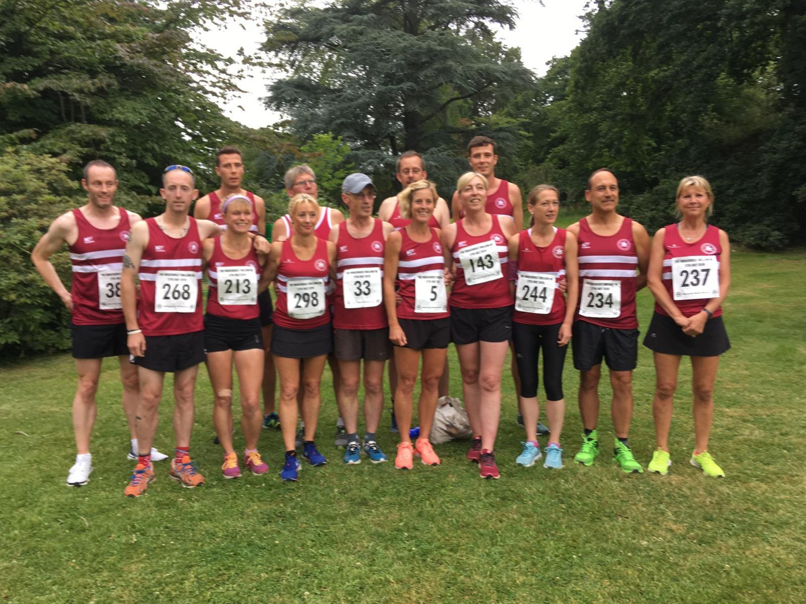
Wakehurst Willow 5 Mile race.

Harriers results were as follows:
2nd Ben Gibson 28:57, 5th Phil Payne 30:56, 7th Jamie Gibson 31:23, 15th Tim Miller 33:46, 31st Dave Warren 35:34, 36th Kim Lo 36:07, 43rd Siobhan Amer 37:08, 64th Sam Ridley 38:57, 72nd Carl Bicknell 39:41, 87th Phil Scott 40:35, 95th Georgina Mugridge 41:03, 115th Gemma Morgan 42:09, 142nd Andrew Wilson 44:00, 167th Teresa Mockridge 45:27, 253rd Sarah Hamilton 51:34.

