Middy Report 29.10.17

Last weekend the Harriers were involved in various competitions that were being held in Sussex. The Beachy Head Marathon and Beachy Head 10km, The Hove Prom 10km race and the West Sussex Fun Run League race, the Steepdown Challenge.

At the Beachy Head Marathon there were 6 Harriers taking part in the gruelling 26.2 mile run. The route has over 3,900 feet of elevation over the South Downs, following trail paths across the countryside of East Sussex, up and down hillsides, following parts of the South Downs Way, through Alfriston and then Litlington and back along the coast to the finish at Eastbourne via the Seven Sisters.

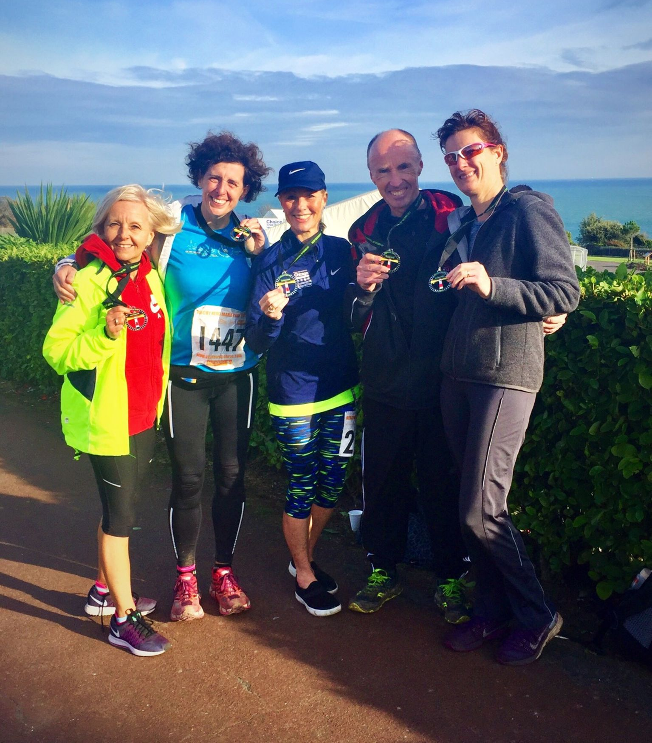
Harriers at Beachy Head Marathon (left to right: Sarah Banks, Clare Kenward, Samantha Ridley, Carl Bicknell and Kath Buckeridge).

The Harriers had 9 finishers at Beachy Head Marathon: 131st Michael Burke 3 hrs 56 mins 33 secs, 683rd Carl Bicknell 4 hrs 55 mins 34 secs, 737th Samantha Ridley 4 hrs 59 mins 02 secs, 933rd Kath Buckeridge 5 hrs 17 mins 38 secs, 985th Clare Kenwood 5 hrs 22 mins 29 secs, 986th Sarah Banks 5 hrs 22 mins 26 secs, 1087th Liam Banham Raywood 5 hrs 29 mins 38 secs, 1549th Klara Boarder 6 hrs 13 mins 39 secs, 1897th Neal Barton 7 hrs 20 mins 05 secs.

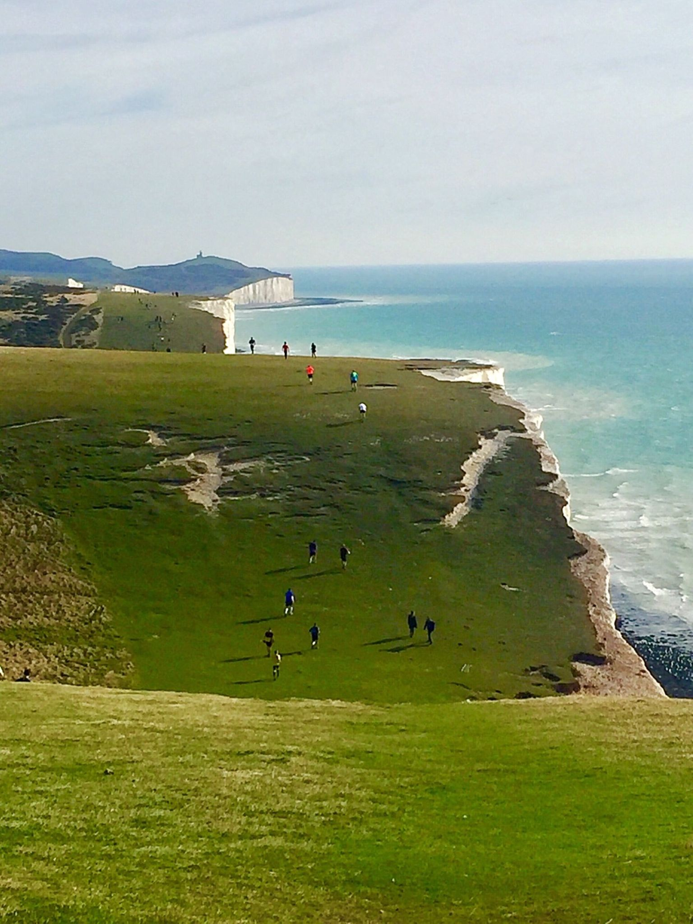
Heading along the Seven Sisters towards Beachy Head…
At the Beachy Head 10km race, Ben Duncan was 5th fisher overall in 39:41. Ben said of the race that it was the hilliest 10km that he had run.

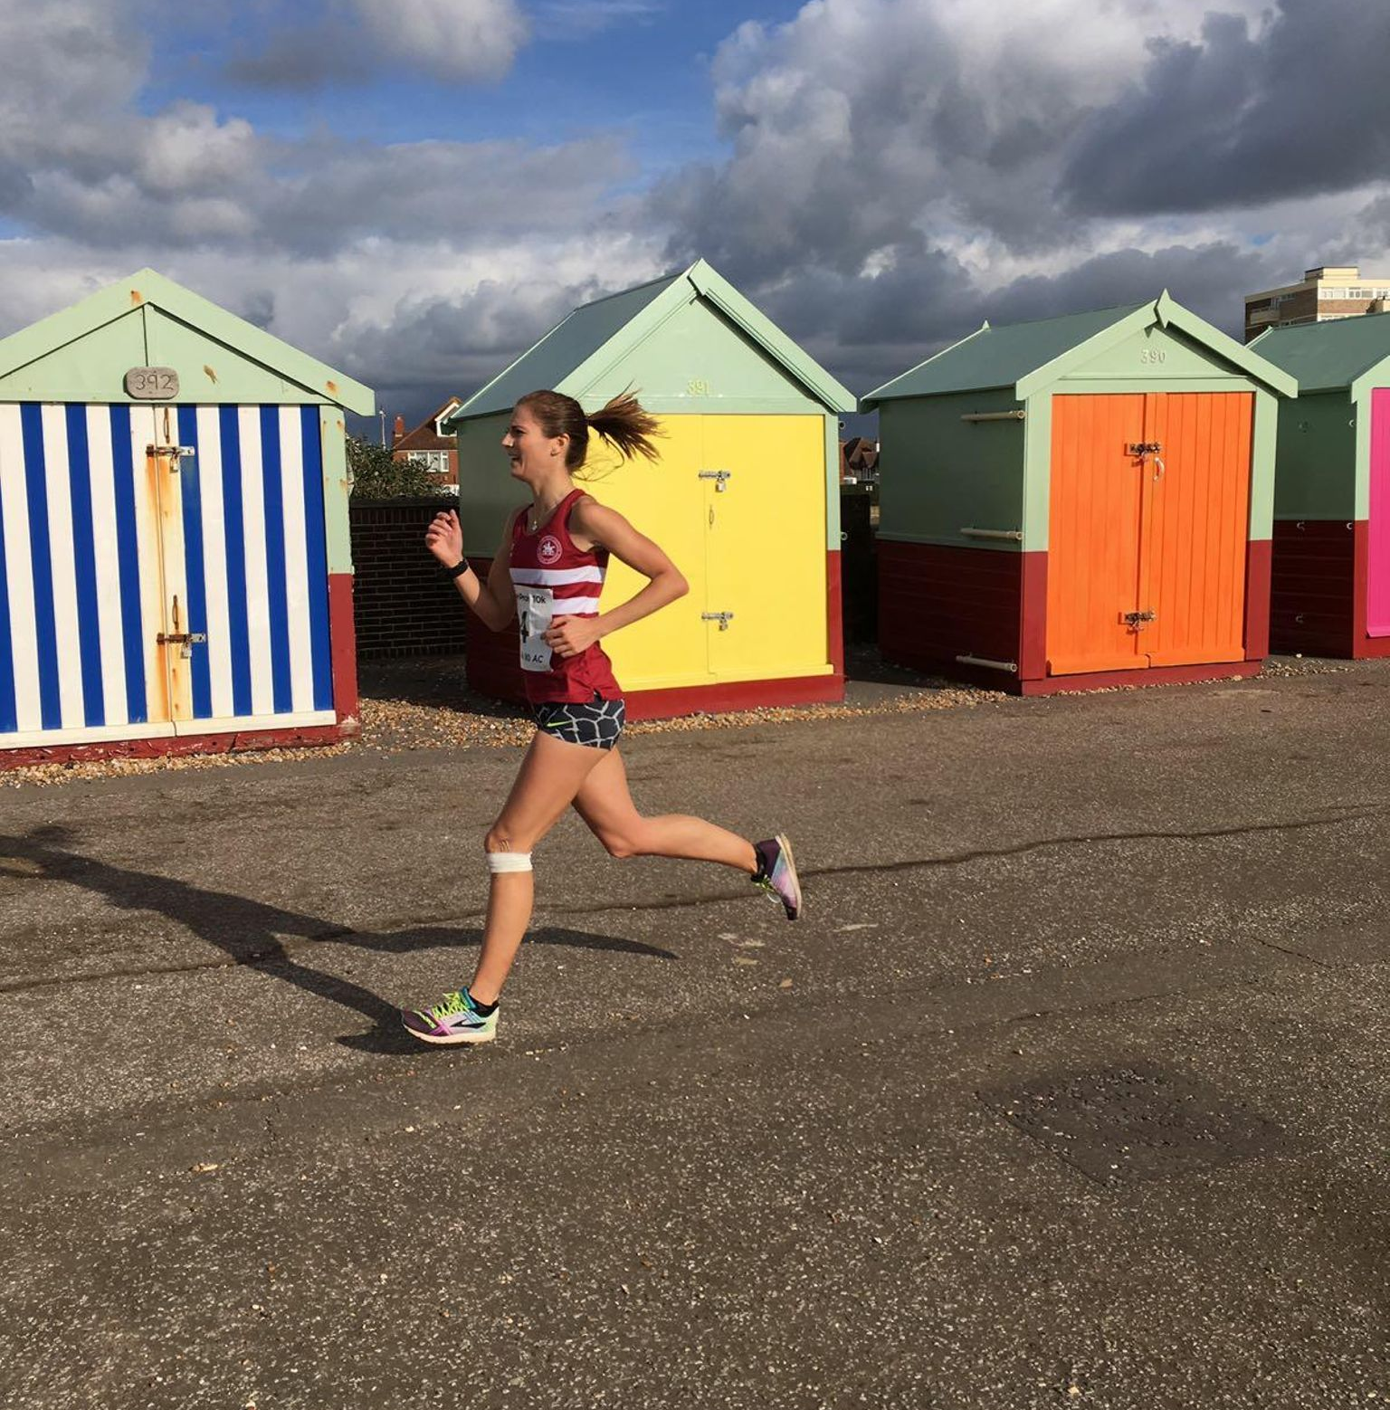
Emma Navesey
At the Hove Prom 10km race, the Haywards Heath Harriers were dominant in both the men’s and ladies’ races. On a flat and normally fast course the only obstacle for the runners was a strong headwind. In the men’s race, Harriers had 5 male runners in the top 11 and in the ladies’ race Harriers had 3 in the top 5! A mention should also go to Phil Scott who ran his fastest 10km by 3 minutes.

Top finishers were James Skinner and Katie Morgan, both taking 3rd place in the men’s and ladies races respectively.

Complete club results at Hove Prom 10km were as follows:
3rd James Skinner 33:51 (pb), Ben Gibson 35:03, 8th Marcus Kimmins 35:28, 10th Russ Mullen 36:08, 11th Rob Watts 36:20, 59th Katie Morgan 40:09 (pb) (3rd lady), 67th Emma Navesey 40:36 (pb) (4th lady), 77th Kim Lo 41:33 (5th lady), 90th Phil Scott 42:03 (pb), 92nd Matt Quinton 42:10, 145th Naomi Cikalo 45:47 (pb), 266th Amy Mitchell 56:25, 290th Peter Cobbett 58:55.

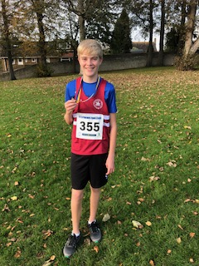
Ryan Armstrong

6 Harriers also took part in the Steepdown Challenge, a 5 mile cross country race at Lancing involving one very long hill!
Phil Payne was first Harrier home in 8th place in 31:15. Other Harriers finishing were:
11th Paul Cousins 32:12, 31st Julian Boyer 34:26, 36th Barry Tullett 34:44, 180th Mark Sykes 45:20, 289th Linda Tullett 56:45, 321st Jenny Denyer 1hr 05:06.

In the Junior race at Lancing, Ryan Armstrong was a clear winner in 5:41.

Jack Chivers also ran in the Dublin Marathon and finished in 4 hrs 11 mins 58 secs.

