Harriers Shine Bronze at Sussex Cross Country Relays.

Goodwood Cross Country Relays

Linda Tullett

BATTLE FOR BRONZE
Haywards Heath Harriers took part in the Sussex Cross Country Relays which were held at Goodwood Racecourse on 25 September 2021.

The relays were held on the short course in dry conditions underfoot at Goodwood, with the expectation of mud and hills in the up and coming cross-country league events in the winter months to come.

The Goodwood relays are a warmup for the longer cross country events ahead and for Harriers and other competing teams’ opportunity to test out their cross country skills and also their spike or trail running shoes.

First of the medals came from the Haywards Heath Harriers Under 15 Boys trio of Arun Khursheed, Finlay Blythe and Jonathan Beckett ran the race of their lives to finish with the bronze team medal. After a tough first leg for Arun, which included some of the fastest boys in the field, he managed to stay in contention for a top 10 place. Finlay then took over and ran a perfect leg, chasing down those in front of him, and came into the change with Jonathan in 3rd place with Brighton closely behind. Could the boys hang onto that bronze medal position? Jonathan paced his leg to perfection and came into the home straight closing down on Chichester ahead, fully aware that the Brighton athlete was closing him down quickly. With a little left in the tank, Jonathan managed to pull away from Brighton and closed the gap ahead to the Chichester athlete but ran out of distance. A well-deserved and hard fought bronze medal for our A team. The boys were supported by Noah Blythe (running as an Under 13 in the Under 15 age group) and Adam Beckett who ran as an incomplete B team but they both finished strongly. With the juniors providing the perfect start, it was over to our Senior and Vets teams to continue the success. Our Senior male and V45 women teams narrowly missed out on a medal but our V40 and V50 male teams continued the success with very creditable bronze team medals.

All of this is good news for the Harriers as the XC League is about to start on 16 October again at Goodwood.

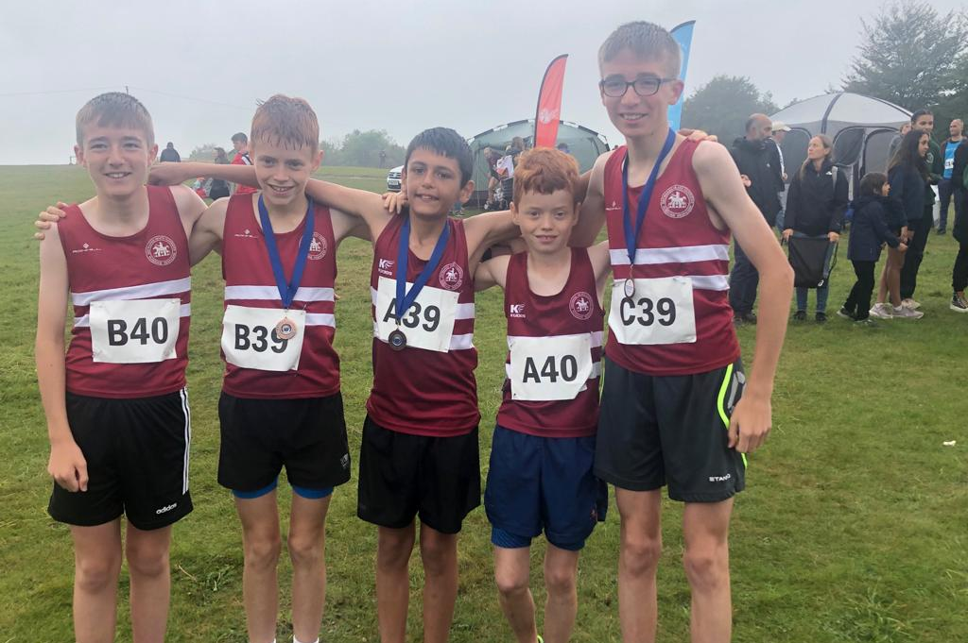
Left to Right: Adam Beckett, Finlay Blythe, Arun Khursheed, Noah Blythe and Jonathan Beckett.

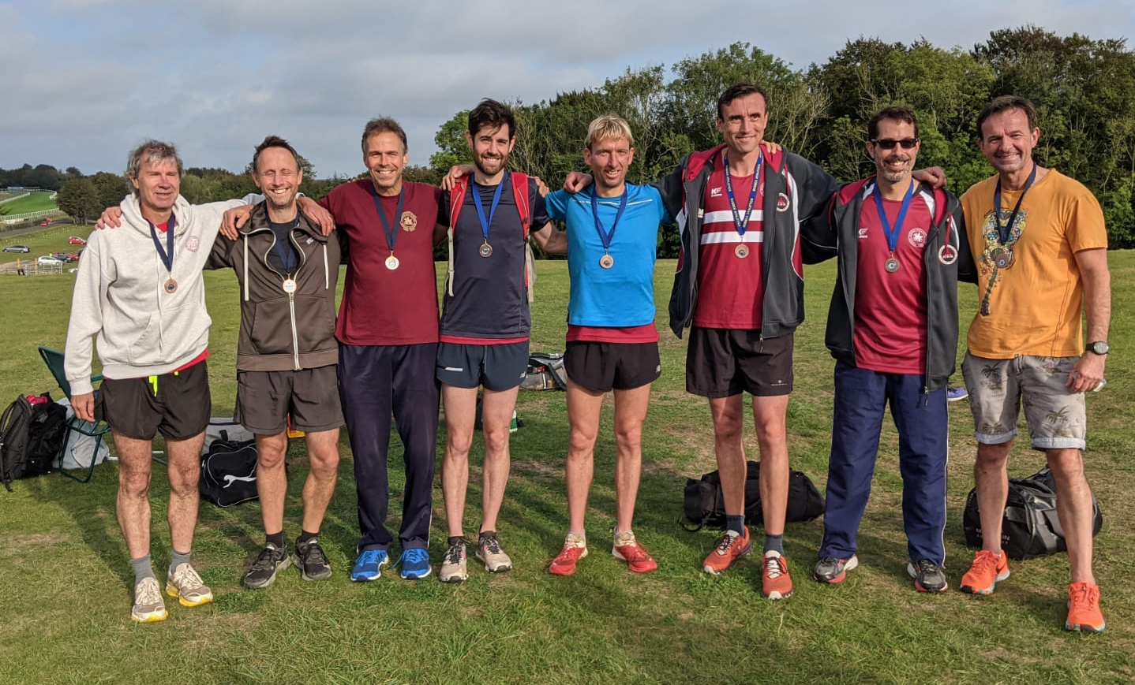
Bronze both for the over 40’s and over 50’s Harriers men’s cross-country teams.

Full Harriers results were as follows:

Under 15 Boys:
3rd (Arun Khursheed 10:01, Finlay Blythe, 10:00, Jonathan Beckett 9:52).
Non-Scoring: Noah Blythe 12:12, Adam Beckett 14:15.

Senior Men:
6th 59:22 (Russ Mullen 14:13, Sam Fernley (U17) 14:44, Mark Green 15:07, Phil Payne 15:18).
Non Scoring: 60:54 (Greg Hilton (V40) 15:51, Rob Watts (V40) 15:54, Ewan Kemsley (U20) 14:38, Russ Mullen 14:31).

Vet Men 40:
3rd 57;24 (James Moffat 14:10, Michael Burke 14:29, Marcus Kimmins 14:03, Ian Kenton 14:42).

Vet Men 50:
3rd 65:33 (Paul Cousins 15:34, Bryan Tiller 17:06, Barry Tullett 16:26, Andy Dray 16:27).

Vet Men 60:
4th 58:49 (Mark Songi 23:22, Carl Bicknell 18:42, Tim Hicks 16:45).
(Tim Hicks: second fastest lap 16:45).

Senior Women:
Katherine Reed (U17) 17:18.

Vet Women 45:
5th 61:40 (Caroline Mackey-Khursheed 20:52, Shelagh Robinson 21:15, Jacqueline Barnes 19:33).

The four Sussex Cross Country Leagues fixtures are to be held at the following venues:

16 October at Goodwood Country Park.
13 November at Stanmer Park, Brighton.
4 December at Ardingly Showground.
12 or 19 January at Little Common, Bexhill.

Road Running

Barns Green

By Michael Parish

THE SMALL village of Barns Green opened its doors to their 39th 10km and half marathon road race, their first since the pandemic, on Sunday 26th September 2021. As athletes converged on the village green it felt as if lockdown was finally over and some normality had returned as athletes and running events returned.

Founded in 1982 where runners just showed up on the day the event attracted over one thousand entrants which took the committee by surprise as a seemingly endless line of cars rolled into the village. The run was due to start at 11am and at three minutes to, athletes were either still registering or warming up. With an anxious plea from the organisers the athletes got into position and one thousand runners were ready to start just in time.

Fast forward to 2021 and you have a well organised run with a lot of experience behind it, there were 1,635 finishers with an average run time of 02:25:32 which raised £123k for charity.

With a fully closed road route that runs two loops through the village and over the outlying West Sussex countryside, it’s best described as undulating and a good challenge for competing athletes.

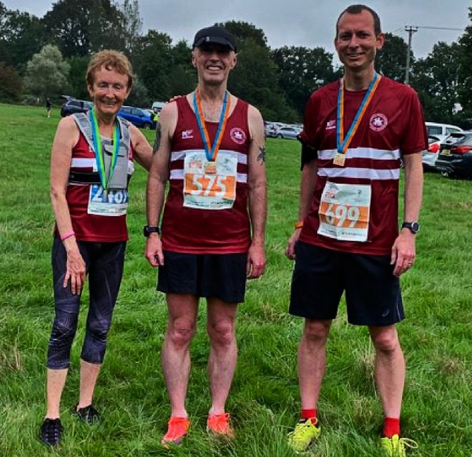
Haywards Heath Harriers finishers (Left to Right): Marion Hemsworth, Carl Bicknell and Pete Francis.

There were some amazing results across the two races.
10 km results: 1st Patrick Martin, not affiliated, 00:32:44; 2nd Gary Tomlinson, Horsham Joggers, 00:34:36 and 3rd Bradley Burke Horsham Blue Star Harriers, 00:35:30. Haywards Heath Harriers results were: 108th Gemma Morgan, 00:50:44; 190th Marion Hemsworth, 00:55:06; and 526th Jennifer Denyer, 01:35:33.

Half Marathon results: 1st Paul Navesey, City of Portsmouth AC, 01:10:26; 2nd Neil Boniface, Crawley AC, 01:12:29; Patrick Acaye, not affiliated, 01:18:29. Haywards Heath Harriers results were 41st Pete Francis, 01:32:51 and 127th Carl Bicknell, 01:44:37. Carl Bicknell also ran Clair parkrun in Haywards Heath for a warm up for his half marathon effort the day before with a time of 00:31:50.

Next year will be a big event for Barns Green with their 40th road race it’s going to be great event.

