**HARRIERS AT THE LINDFIELD ANNUAL FUN RUN**

**By Mike Parish.**

**SUNDAY 22nd May 2022 was the date for the return of the Lindfield Village Run. After being missing from the Mid Sussex running diary for the last two years, it was good to see it return in spectacular style.**

The Lindfield Village Run is a well-established event which sets out two cross county runs: a 10k Village Run and a 5k Family Fun Run. Both take place mostly on paths and tracks through the West Sussex countryside in the immediate vicinity of the village of Lindfield. It has often been described as an old-fashioned cross-country run with plenty of multi-terrain, some slippery surfaces, and the odd cow in fields!

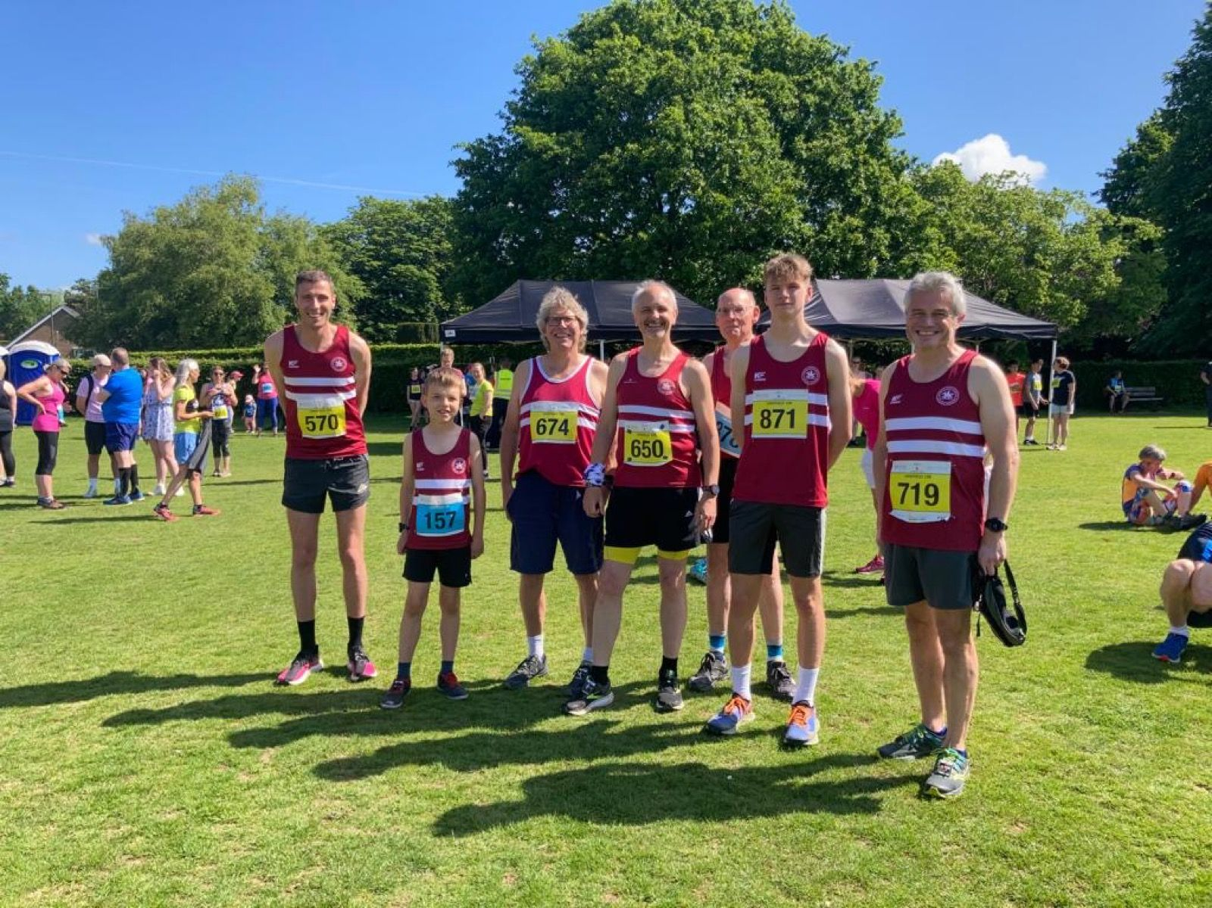

**(L-R): Ben Gibson, Viggo Skov, Phil Scott, Mike Parish, Rupert Purchase, Harvey Alcock and Simon Robinson.**

It's a tough course from roads, to trail and then across country. Athletes have to run stairs that take them up hills and down the other side to multiple bridges, even to the point of jumping streams. It's a beautiful and unique run and takes in the sights of Ardingly Reservoir and College.

Professionally organised, well run and inclusive event. Welcome back Lindfield.

Harrier results at Lindfield Fun Run were as follows:

10k race:

1st **Ian Kenton** 43:47; 2nd **Ben Gibson** 44:07; 4th **Harvey Alcock** 44:30; 10th **Andy Hind** 46:44; 18th **Rory Dalgliesh** 49:38; 19th **George Adams** 49:53; 24th **David Adams** 52:52; 26th **Simeon Wishlade** 53:10; 27th **Abigail Redd** 53:15; 39th **Simon Robinson** 55:21; 58th **Bob Adams** 59:27; 69th **Howard Booth** 61:08; 71st **Phil Scott** 61:23; 73rd **Oscar Dalgliesh** 61:55; 80th **Eric Hepburn** 63:03; 104th **Andrew Wilson** 65:15; 178th **Michael Parish** 75:55.

5k race:

3rd **Jacob Roderick**; 13th **Joseph Roberjot**; 19th **Charlie Stay**; 26th **Ella Chatfield**; 35th **Nick Skov**; 36th **Viggo Skov**; 46th **Jack Bannister**; 51st **Rohan Barnes** 56th **Anya Cole**; 57th **Miller Hale**; 63rd **Lucy Roderick**; 93rd **Lorna Cole**.

**West Sussex Fun Run League**

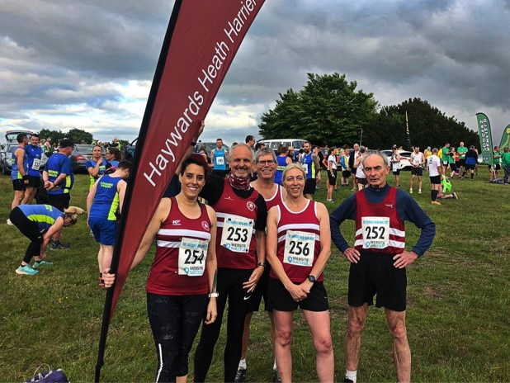

**Harriers at “Trundle View” (L-R): Carys Hind, Michael Parish, Phil Scott, Sarah Hamilton and Richard Bates.**

HOSTED by Chichester Runners and Athletics Club the next run in the West Sussex Fun Run League (WSFRL) took place on the 25th May 2022 called “Trundle View.”   Members from West Sussex’s athletics clubs and fun run clubs converged for a five-mile trail race around the forest surrounding Glorious Goodwood.

The League is made of 18 athletics clubs who nearly all hold one event per year, each race ranging from 5 miles to 10 kilometres. Giving athletes 17 runs over a total distance of 85 miles. Each race has a very different and unique experience and is open to both affiliated and non-affiliated athletes.

The Trundle View race started opposite Goodwood Racecourse, the race then entering the woods. Once there the runners had to complete two loops of about 4 kilometres of trails, before heading back across the fields to the finish line.

Haywards Heath Harriers had some great results with Philip Scott first Harriers across the finish line. Michael Parish was not far behind him running with Sarah Hamilton completing the two laps and crossing the finish line with only three seconds between them.

Results are: 1st Daegan Beaumont, Hove Hornets, 30:02; Alex Rawlinson, Portslade Hedgehoppers, 31:16; Mike Houston, Chichester Runners, 31:35.

Haywards Heath Harriers results are: **Philip Scott**, 44:10; **Michael Parish** 50:53; **Sarah Hamilton**, 50:56; **Carys Hind**, 54:12; **Richard Bates** 01:00:14.

***************************************************************************************

Also, another of the West Sussex Fun Run League races called the Beach Run was held at Littlehampton on Wednesday 18 May.

Results of the Beach Run were as follow:

14th **Jonathan Beckett** 29:22; 26th **Andy Hind** 31:01; 30th **Phil Payne** 31:24; 37th **Paul Cousins** 31:58; 74th **Julian Boyer** 34:07; 295th **Sarah Hamilton** 44:56; 357th **Carys Hind** 49:06; 359th **Caroline Gumm** 49:14; 373rd **Mark Songi** 50:35; 420th **Rupert Purchase** 57:54.

**Athletics**

On Sunday 22 May was the first of the Southern Athletic League competitions which was held at K2 sports centre in Crawley. The conditions were hot and windy for the afternoon of athletics.

Haywards Heath Harriers compete in this league jointly with Lewes Athletics Club.

There were great results by the Harriers and especially **Lucie Venables** who competed in no less than six events!

Youngsters **Mae Robinson**, **Sam Fernley** and **Jonathan Beckett** were all competing for the first time in this league. All are up and coming youngsters tasting adult competition for the first time. Also, newcomer to this league is **Kleri Tantele** who also the current Sussex champion in the javelin.

**Harrier’s results were**:

Women:

**Lucie Venables**: 6th ‘A’ 100m 14.7 secs; 1st ‘A’ 100mH 21.5 secs; 2nd ‘A’ 400mH 87.2 secs; 4th ‘A’ Long Jump 4.07m; 2nd ‘A’ Triple Jump 8.48m.3rd ‘A’ Discus 10.98m.

**Mae Robinson**: 4th ‘B’ 100m 15.6 secs (pb); 2nd ‘B’ Long Jump 3.36m (pb).

**Kleri Tantele**: 2nd ‘A’ Javelin 26.10m (pb).

Men:

**Ho Wan Orin Tang**: 6th A’ 200m 27.7 secs; 4th ‘B’ Long Jump 4.51m.

**John Palmer**: 5th ‘B’ 200m 31.5 secs; 6th ‘B’ 400m 72.1 secs;

**Sam Fernley**: 4th ‘A’ 1500m 4 mins 33.7 secs;

**James Skinner**: 1st ‘A’ 5000m 16 mins 32.0 secs.

**Russ Mullen** 1st ‘B’ 17 mins 21.5 secs.

**Tim Popkin**: 3rd ‘A’ 2000m s/c 9 mins 40.9 secs; 800m (non-scoring) 2 mins 42.2 secs.

**Mike Bale**: 5th ‘A’ Shot Putt 5.89m; 5th ‘A’ Discus 18.75m; 4th ‘A’ Hammer 23.95m; 3rd ‘A’ Javelin 16.88m.

**Jonathan Beckett**: 5000m (non-scoring) 17 mins 15.9 secs (pb).

**Other Harrier Results**

**Oliver Farr** completed yet another marathon at the weekend. Oliver, on his way to a target of one hundred marathon, ran number seventy-five at the “Phoenix Coffethon,” which was by the River Thames. He finished in a time of 4 hours and 29 minutes.

**Parkrun roundup**

Clair parkrun: 2nd **Harvey Alcock** 18:24 (pb); 3rd **Ewan Kemsley** 19:00; 7th **Sam Fernley** 20:21; 8th **Dave Adams** 20:22; 9th **George Adams** 20:23; 17th **James Bennett** 21:54; 23rd **Pete Francis** 22:57; 25th **Katie Reed** 23:07; 29th **Bob Adams** 23:49; 30th **Simon Robinson** 23:59; 37th **Howard Booth** 24:51; 54th **Phil Scott** 26:19; 76th **Emma Pryor** 27:54.

Brighton and Hove parkrun: 156th **Sarah Hamilton** 26:38.

Burnham and Highbridge parkrun: 4th **Russ Mullen** 17:34.

Hove Prom parkrun: 10th **Sean Duff** 18:08 (pb).

Worthing parkrun: 3rd **Jonathan Beckett** 16:48 (pb and U17 Harrier club record); 4th **Will Grey** 17:25 (pb); 5th **Arun Khursheed** 17:29 (pb); 12th **Paul Cousins** 19:11; 15th **Barry Tullett** 19:22; 19th **Julian Boyer** 19:58; 69th **Ian Tomkins** 22:45; 187th **Caroline Mackey-Khursheed** 27:28; 290th **Linda Tullett** 31:13.

Lancing Beach Green parkrun: 20th **Jason Robinson** 23:17 (pb); 56th **Shelagh Robinson** 27:06 (pb).

Ifield Mill Pond parkrun: 24th **Abby Ross** 23:18.

Zuiderpark parkrun: 44th **James Smyth** 27:08 (pb).