Harvey Smashes Mid Sussex Marathon Race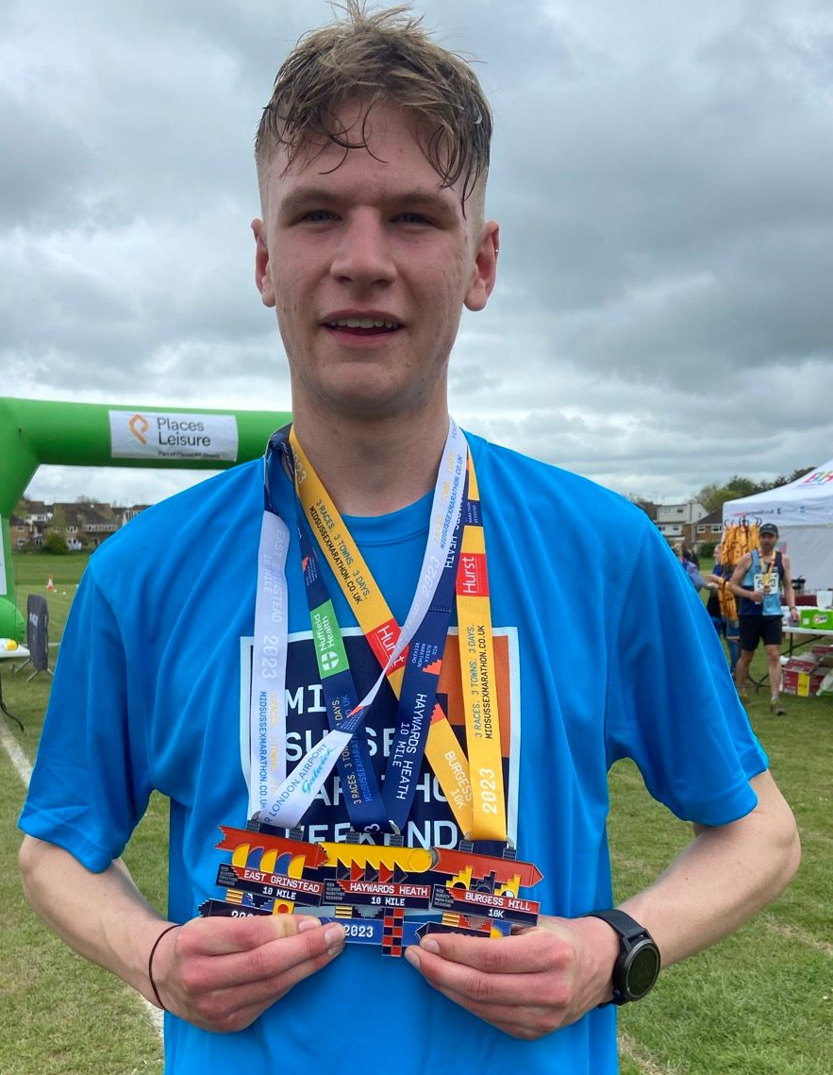
Harvey Alcock at the Mid Sussex Marathon
Harvey Alcock ran superbly finishing in third place overall for the whole marathon distance at the Mid Sussex Marathon weekend held on May Bank Holiday.

There were four Harriers altogether who ran all three races. They were Harvey Alcock who completed the marathon in 2 hours 49 minutes and 21 seconds; Mark Davies in 4 hours 19 minutes and 48 seconds; Richard Jobling in 4 hours 21 minutes and 10 seconds) and Emma Pryor in 5 hours 43 minutes and 42 seconds.

The first race was held at East Grinstead Ten Mile Race on the Saturday 29th April, followed by the Haywards Heath Ten Miler on Sunday 30th April, then followed by a ten kilometres race at Burgess Hill on the bank holiday Monday 1st May.

All three races were multi-terrain with plenty of mud on the Saturday and Monday races.

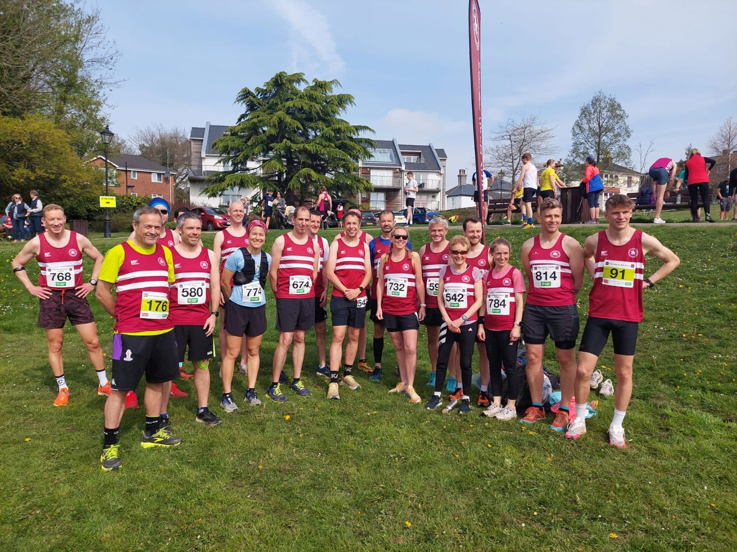
Harriers at Haywards Heath 10: (L-R): Will Herbert, Richard Jobling, Josh Franks, James Smyth, Matt King, Julie Kamel, Oliver Francis, Tom Sommerfelt, Greg Hilton, Graham Moffat, Steven Heath, Abigail Redd, Simon Robinson, Marion Hemsworth, Michael Dickinson, Rachael Overton, Simeon Wishlade and Harvey Alcock.

The complete Haywards Heath Harriers results for the three races were as follows:

East Grinstead ten mile race: 3rd Harvey Alcock 1:09:16; 8th Steve Dallman 1:16:29; 105th Richard Jobling 1:45:18; 121st Mark Davies 1:48:42; 237th Emma Pryor 2:18:21.

Haywards Heath ten mile race: 5th Russ Mullen 1:00:14; 7th Harvey Alcock 1:00:32; 19th James Moffat 1:04:18; 25th Will Herbert 1:05:45; 33rd Greg Hilton 1:08:02; 37th Matt King 1:09:01; 45th Tom Sommerfelt 1:10:33; 52nd Tim Miller 1:11:55; 64th Rachael Overton 1:12:45 (6th lady); 66th Simeon Wishlade 1:13:39; 68th Steven Heath 1:13:55; 76th Michael Dickinson 1:15:49; 85th Abigail Redd 1:16:21; 91st James Smyth 1:16:46; 95th James Booth 1:16:59; 96th Julie Kamel 1:17:29; 102nd Oliver Francis 1:18:42; 121st Sam Atkin 1:21:02; 147th Andrew Wilson 1:24:39; 221st Mark Davies 1:30:38; 250th Richard Jobling 1:34:18; 270th Marion Hemsworth 1:36:10; 314th Emma Pryor 1:41:27;

Burgess Hill ten kilometres race: 4th Harvey Alcock 39:33; 123rd Mark Davies 1:00:28; 136th Richard Jobling 1:01:34; 324th Emma Pryor 1:43:54.

Athletics

On Friday 21st April at the Withdean Stadium in Brighton a group of young Harriers took part in the Sussex Under 15 league. They all achieved personal bests and at the same time experiencing competing in a county league event. Their results were as follows:

U15 Boys: Charlie Stay: 5th 100m ‘A’ 13.7 secs (pb); 7th 200m ‘A’ 28.5 secs (pb); 6th Long Jump ‘A’ 4.27 metres (pb).

U15 Girls: Evie Miller 5th 200m ‘A’ 31.6 secs (pb); Magdalena Goodman: 4th 200m ‘B’ 32.1 secs (pb); Anya Cole 1st High Jump ‘A’ 1.40m; 4th Discus Turn ‘A’ 14.84m.

Sussex Road Relays at Preston Park, Brighton

The Sussex Road Relays were held at Preston Park on the 8th April. The conditions were lovely with spring well into the air.

The relays are generally seen by many as a leveller because all the athletes compete over the same distance of two miles except for the youngest three age groups (up to and including the under fifteens) who run one lap of the one mile circuit).

For the first time in many years the Harriers were missing entrants for both the senior men and senior women’s teams.

Results were as follows:

Under 11 Boy’s race: 6th HHH ‘A’ in 20:43 (Marcos Selby 6:49, Rohan Barnes 7:06; Reuben Nicholson 6:47).

Under 13 Girl’s race: 13th HHH ‘A’ in 22:10. (Coco Rhodes 7:56, Molly Clarke 7:34; Charlotte Threfall 6:39).

Men’s Over 50’s race: 12th HHH ‘A’ in 38:57 (13:42; Andy Dray 13:07; Julian Boyer 12:06).
Men’s Over 60’s race: 2nd HHH ‘A’ in 38:39 (Paul Cousins 12:01; Eric Hepburn 14:14; Mark McLaughlan 12:23); 9th HHH ‘B’ in 44:02 (Carl Bicknell 14.17; 15:27; 14:17).
Women’s Over 50’s race: 5th HHH ‘A’ in (Jacqueline Barnes 15:54; Sarah Hamilton 16:41; Samantha Ridley 14:37).

Other Harrier Results:

Steven Heath (left) with Will Axell.

Steven Heath took part in his first ultra run on 6 May at the “Run To The Sea.” The race starting from Christs Hospital following the Downslink footpath and then along the South Downs Way (eastwards) then down to Brighton just before Ditchling Beacon. Steven finishing the thirty one mile ultra in five hours and twelve minutes thirty five seconds with Will Axell two seconds behind.

James Bennett ran one hour thirty nine minutes and forty six seconds to finish in eleventh place in the Seaford Martello Half Marathon on 16 April. James also finished the Milton Keynes Half Marathon on 30 April in one hour twenty seven minutes and fifty three seconds.

On 30 April at the Worthing Half Marathon the Harriers had two runners competing: Matt Cook and Greg Broad. Matt finishing in one hour twenty three minutes and seven seconds and Greg finished in one hour thirty eight minutes and twenty seven seconds.

Sarah Hamilton ran in the 10 kilometres race, finishing in fifty seven minutes and thirty nine seconds.

