HARRIERS FLY AT GATWICK

Matt King had a great run at the Arun River Marathon on Saturday 11th of May, by finishing in second place overall to Paul Sargeant of Burgess Hill Runners. Matt’s time was 3 hours and 31 minutes and 8 seconds to Paul’s time of 3 hours 21 minutes and 44 seconds. The runners ran alongside the River Arun from Littlehampton and then they had to run up 600 feet onto the South Downs at round the 12 mile point but lucky for them they came back down the same way to get the benefit of the downhill and back to along the river to Littlehampton.

On May 12th the Portslade Hedgehoppers held the Hedgehoppers five mile race. This race being part of the West Sussex Fun Run League. Chris Russell was first home for the club in 43rd place in a time of 37 minutes and 26 seconds. Next home was Phil Scott in 80th place in 40 minutes and 32 seconds. Other results were: 148th Kath Buckeridge 45 mins 40 secs, 203rd Sarah Hamilton 51.40 and 238th Richard Bates 56 mis 58 secs.

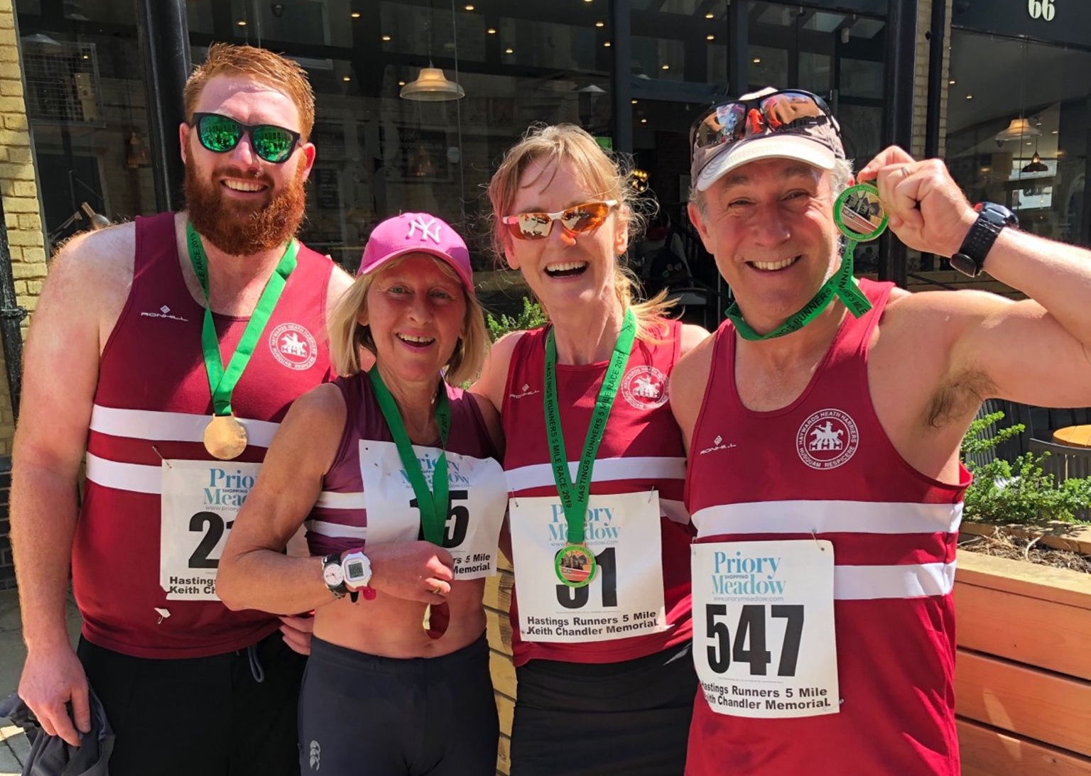
At the Hastings 5 miles Race (L to R): Oliver Farr, Amanda Soper, Karen Thompson, Ian Dumbrell.

At the Hastings 5 Mile race on May 12th five Harriers ran in this flat and fast course. First home was Ian Dumbrell in 35:41, followed by Oliver Farr 37:30 then followed by Karen Thompson 39:54 and Amanda Soper in 39:57 and then Peter Cobbett in 44:55.

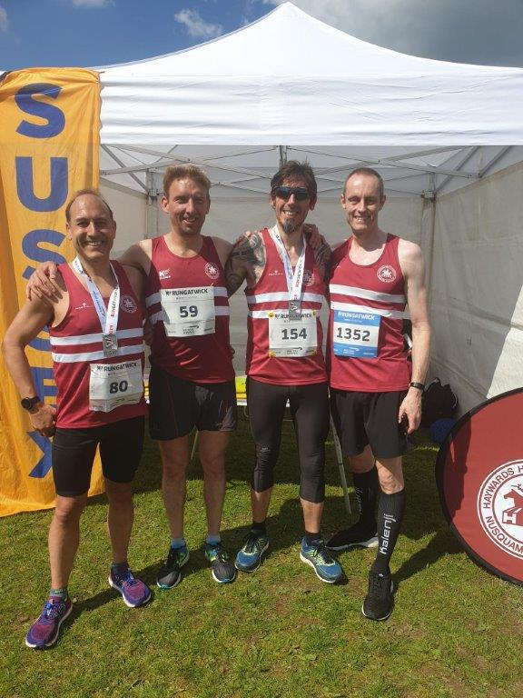
Harriers at the British Airways Gatwick Half Marathon (L-R): Tim Miller, Marcus Kimmins, Andy Hind and Dave Warren.

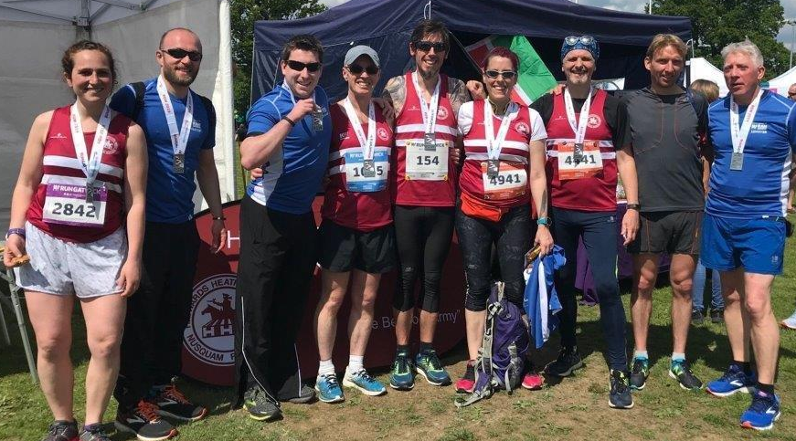
More Harriers at Gatwick Half.

At the British Airways Gatwick Half Marathon and 5 kilometres race last Sunday, twenty one Harriers took part in this second running of the Gatwick Half Marathon with two athletes also in the 5 kilometres race. In the half marathon, Ben Gibson had a great run to finish in fifth place overall. Whilst in the 5 kilometres race, young Arun Khursheed set a new Harrier under 13 record with an amazing time of 18 minutes and 10 seconds not bad for an 11 year old!) with his mother not too far behind!

Results were as follows in the half marathon:
5th Ben Gibson 1:15.01 secs, 24th Andy Hind 1:23.48, 25th Will Herbert 1:24.14, 40th Marcus Kimmins 1:26.05, 46th Nicholas Skov 1:26.51, 58th Dave Warren 1:27.50, 87th Tim Miller 1:29.48, 127th Simeon Wishlade 1:32.35, 179th Matt Quinton 1:35.41, 239th Mark Green 1:38.22, 530th Andrew Wilson 1:47.05, 538th Carl Bicknell 1:47.15, 920th Gary Johnston 1:56.23, 1016th Shelagh Robinson 1:58.05, 1021st Lydia Levy 1:58.08, 1027th Claire Annesley 1:58.11, 1065th Chris Glanfield 1:58.50. 1081st Eric Hepburn 1:59.04, 1111st Greg Hilton 1:59.27 1862nd Carys Hind 2:19.06, 1868th Michael Parish 2:19.14.

Results were as follows in the 5 kilometres race:
8th Arun Khursheed 18:10, 438th Caroline Macley-Khursheed 31;46.

At the Seaford Half Marathon on Sunday, Harrier, Darren Bird finished in first place overall in this particularly hilly multi-terrain half marathon. His time was 1 hour 29 minutes and 25 seconds.
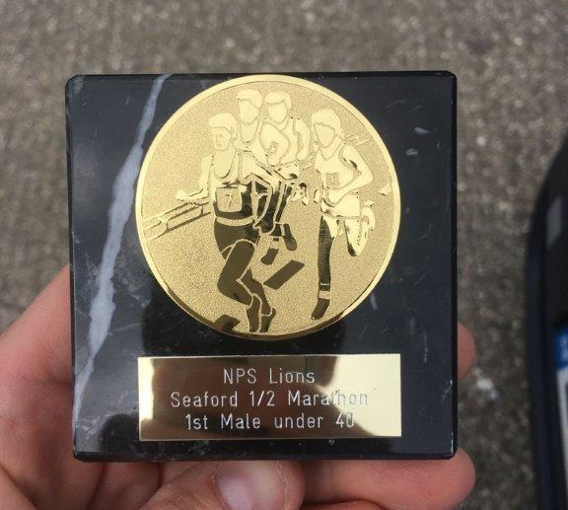----
Darren Bird: trophy at Seaford Half Marathon.

Results of the Sussex Under 13 League held at K2 on 7 May. The Harriers had a great match with many youngsters taking part and finished in third place out of five teams. Charlie Bonwick-Adams ran a flying 4th leg in relay, after running the 1000m ten minutes before, and took over into second place some five to six metres behind Crawley and pipped the Crawley athlete.

Results were as follows:

Boys:
Charlie Bonwick-Adams: 2nd 75m ‘A’ in 11.1 secs; 3rd 1000m ‘B’ 3:29.9 secs.
Johnathan Parkin: 1st 75m ‘B’ 11.1 secs; 2nd Long Jump ‘A’ 4.05m.
Jack Twibell: 4th 150m ‘A’ 24.0 secs.
Nye Sim: 5th 150m ‘B’ 25.0 secs.
Arun Khursheed: 2nd 600m ‘A’ 1:49.2 secs.
Oscar French: 2nd 600m ‘B’ 1:55.3 secs; 4th Shot Putt ‘B’ 4.28m.
Jacob Roderck: 3rd 1000m ‘A’ 3:21.7 secs.
Thomas Pearce: 3rd 75mH ‘A’ 17.0 secs.
C. Crouch: 3rd 75mH ‘B’ 18.5 secs; 3rd High Jump ‘B’ 1.15m.
Jonathan Beckett: equal 3rd High Jump 1.15m.
Jack Bannister: 3rd Long Jump ‘B’ 3.67m.
George Bonwick-Adams: 4th Shot Putt ‘A’ 5.80m; 2nd Discus ‘A’ 13.36m.
Johnny Rutherford: 2nd Discus ‘B’ 11.33m; 4th Javelin ‘A’ 15.79m.
Philip Williamson: 3rd Javelin ‘B’ 14.62m.
HHH: 1st 4 x 100m Relay 59.1 secs.

Girls:
Siobhan McMahon: 2nd 75m ‘A’ 11.3 secs; 4th Long Jump ‘A’ 3.33m.
Kitty Gandarez: 4th 75m ‘B’ 12.1 secs; 5th Long Jump ‘B’ 2.90m.
Lucy Barker: 3rd 150m ‘A’ 23.5 secs.
Maggie Goodman: 3rd 150m ‘B’ 24.7 secs; 3rd 70mH ‘A’ 15.3 secs.
Ella Chatfield: 5th 600m ‘A’ 2:09.8 secs; 3rd Discus ‘B’ 6.53m.
B.Crouch: 3rd 600m ‘B’ 2.10.0 secs.
Megan Eyre: 3rd 1000m ‘A’ 3.45.5 secs.
Maya Dell’Aira Bromley: 2nd 1000m ‘B’ 3.55.9 secs.
Mae Robinson: 3rd 70mH ‘B’ 15.5 secs; equal 5th High Jump ‘A’ 1.10m.
Erin Gaston: 5th Shot Putt ‘A’ 4.65m; 5th Discus ‘A’ 9.89m.
Millie Fairbrother: 3rd Shot Putt ‘B’ 4.07m.
HHH: 3rd 4 x 100m Relay 61.1 secs.

Non-Scoring Boys:
75m : Finlay Blythe 12.5 secs, Noah Perrett 12.5 secs, Philip Williamson 11.4 secs, Oliver Cooper 11.9 secs, Nye Sim 12.0 secs, Oliver Cooper 12.7 secs, Thomas Pearce 11.3 secs, Jack Twibell 12.1 secs.
600m: Finlay Blythe 1:59.9 secs.
1000m: Jonathan Beckett 3:33.7 secs.
4x100m Relay: HHH 62.4 secs, HHH 62.9 secs, HHH 67.8 secs.
Long jump: Arun Khursheed 3.73m, Noah Perrett 3.13m, Oliver Cooper 2.86m.

Non-Scoring Girls:
75m: Lucy Barker 11.5 secs,
4x100m Relay: HHH 65.7 secs, HHH 68.0 secs.
Long Jump: Megan Eyre 2.89m.

Other Harrier results:

At the Youth Development League held at Medway Park on Sunday 5th May, Rosie Beckett finished first in the under 17 years age group in the 3000 metres race in 12 mins 36.91 secs.

At the Barcombe 10km on 6 May Michael Essex finished in 51:05 and Lydia Levy finished in 53:18.

On April 28th at the Angmering Bluebell 10 miles race Michelle Robinson finished in one hour and 37 minutes.

