Harrier’s teenagers show the way forwards.

Youngster at the helm! Young Finlay Blythe leading the Haywards Heath Harriers parkrunners home this this week with a super personal best at Hove Prom parkrun in 17 minutes 52 seconds. Sam Fernley also leading a very large contingent of twenty Harriers at Clair parkrun. Arun Khursheed and Jonathan Beckett both running superfast times of 18 minutes 2 seconds and 18 minutes 13 seconds at Preston Park parkrun.

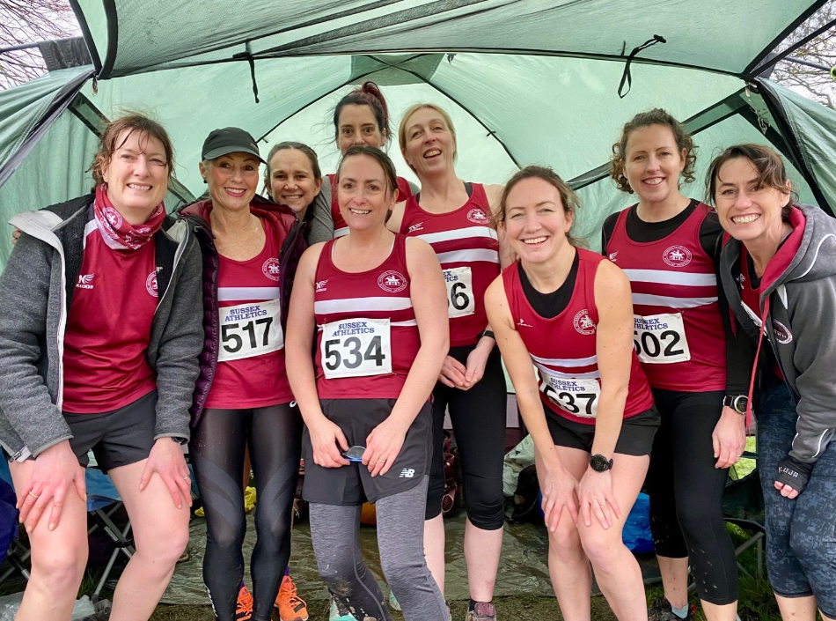
Senior ladies in the Sussex Cross Country Championships at Bexhill.

The Sussex County Cross Country Championships were held at Bexhill on the 8 January 2022. There was good turnout by the youngsters and also by the Senior Women. Unfortunately, the Senior Men’s race lacked in numbers, which is the first race for many years where so few actually ran.

The conditions were very muddy over the Bexhill course at Bexhill Down.

In the Under 15 Boy’s race, the Harriers finished in fourth place, which was the highest Harriers team result of the afternoon. Finlay Blythe leading the boy’s home in eleventh place. Finlay also was the highest Harrier finisher of the day.

All the races were very competitive as lots of new runners coming through from all the Sussex clubs.

A big thankyou to Sussex Athletics for making the event happen and all the volunteers, marshals and timekeepers.

Special mention has to go to Darja Knotkova Hanley, who was a previous Haywards Heath Harrier member and now runs for Lewes Athletic Club, as she ran a super race to finish third in the Senior Women’s race at the Sussex Cross Country Championships.

Haywards Heath Harriers results were as follows:

Under 11 Boy’s race:
12th Rafael Selby 8 mins 33 secs.

Under 11 Girl’s race:
17th Annabel Axford 9 mins 39 secs.

Under 13 Boy’s race:
22nd Noah Blythe 14 mins 16 secs.

Under 15 Boy’s race:
11th Finlay Blythe 15 mins 19 secs; 18th Arun Khursheed 15 mins 49 secs; 19th Jonathan Beckett 15 mins 52 secs.

Under 17 Boy’s race:
18th Sam Fernley 21 mins 23 secs.

Under 20 Men’s race:
12th Ewan Kemsley 34 mins 4 secs.

Senior Women’s race:
34th Sam Ridley 43 mins 53 secs; 38th Lindsey Blain 44 mins 14 secs; 40th Gemma Morgan 45 mins 42 secs; 49th Katherine Buckeridge 50 mins 54 secs; 50th Sarah Hamilton 51 mins 16 secs; 52nd Jacqueline Barnes 51 mins 50 secs; 54th Caroline Mackey-Khursheed 54mins 35 secs; 55th Shelagh Robinson 56 mins 2 secs; 56th Carys Hind 58 mins 50 secs.

Senior Men’s race:
71st Andy Hind 44 mins 51 secs.

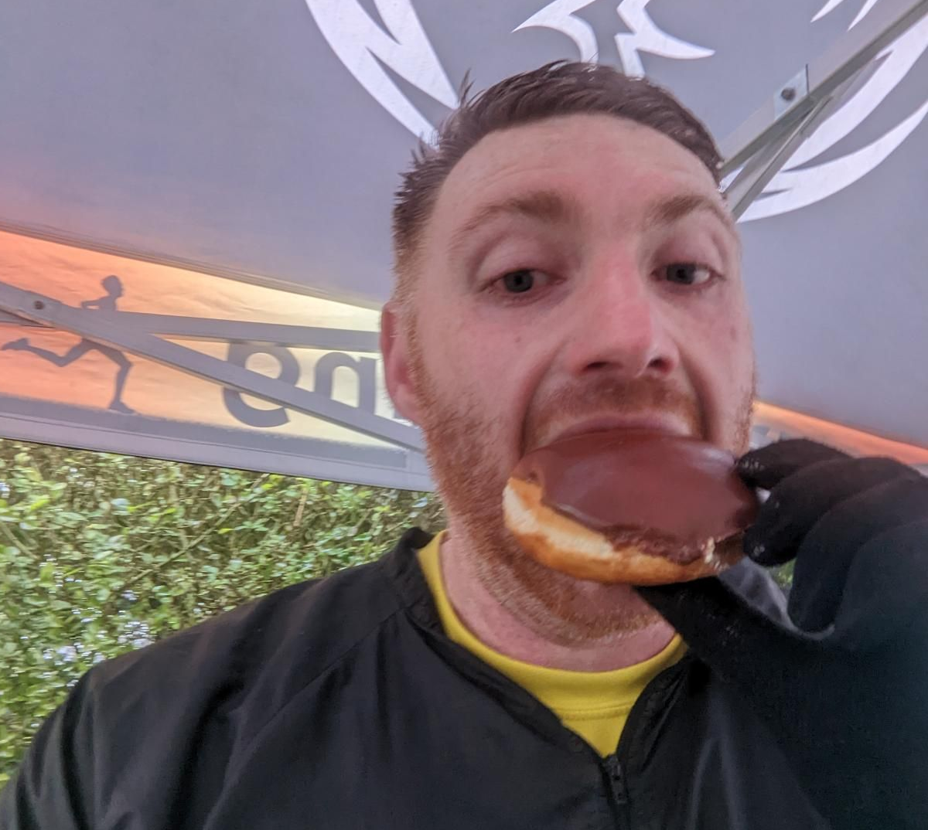
Oli Farr at the Phoenix Doughnut Dash!

Other Harriers Results:

Oliver Farr completed his 64th marathon at the Phoenix Doughnut Dash on Saturday January 15th.

Harrier’s Parkrun Round-up:

Roundshaw Downs parkrun: 1st Ben Gibson 18:56.
Coventry parkrun: 62nd Kai Robinson 22:52.
Tilgate parkrun: 61st Jack Chivers 24:45; 184th Sarah Hamilton 30:13.
Clair parkrun: 3rd Sam Fernley 18:32; 4th Russ Mullen 18:49; 5th James Moffat 19:02; 6th Harvey Alcock 19:35; 7th Marcus Kimmins 19:39; 8th Andy Hind 19:50; 9th Sean Duff 20:07; 13th Graham Hart 20:49; 14th Pete Francis 21.04; 15th Simon Robinson 21:08; 19th Oliver Francis 21:39; 22nd Dave Warren 22:40; 27th Katie Reed 23:23 (pb); 31st Jason Robinson 23:52; 43rd Paul Cousins 25:16; 48th Phil Scott 25:50; 75th Shelagh Robinson 28:11; 101st Howard Booth 30:37; 116th Marion Hemsworth 32:08; 130th Caroline Gumm 33:26 (pb).
Preston park parkrun: 3rd Arun Khursheed 18:02 (pb); 5th Jonathan Beckett 18:13 (pb); 50th Abby Ross 21:39; 84th Ian Tomkins 22:59.
East Grinstead parkrun: 14th Eric Hepburn 26:14.
Hove Prom parkrun: 5th Finlay Blythe 17:52 (pb).
Seaford parkrun: 23rd Carl Bicknell 22:32; 67th Katherine Buckeridge 25:56.

