**Wakehurst Willow Makes A Welcome Return (By Ian Dumbrell)**

**(L-R): Amelia Brown, Sarah Roberts, Dan Celani and Ben Short at Wakehurst Willow.**

We missed the smiles, and the struggle, and the sense of common achievement, and the collective fun, and the all-round togetherness.

So, it was GREAT to have it all back at Wakehurst on Wednesday 13th July at the much-wanted return and fifth running of, the Wakehurst Willow!! Yee Hahh!

A beautiful summer’s evening had been ordered by the organisers and by jigeddy did they come up trumps on that front! A beautiful mid-summer sun beamed down on 320 smiling, happy, and super keen runners from all over Sussex and beyond. The eagerness to get underway was palpable and whoosh off they all went like a herd of wildebeest across the plains of the Serengeti! Approaches to the run varied from the outrageously fast lean and keen athletes, all the way through to the more leisurely ‘tourist taking in the scenery’ approach. All were perfect! Downhills, lakes, redwood giants, forests, uphills, even some flat bits – the Wakehurst Willow has everything, and to heap joy upon joy the runners got to do everything twice!

Judging by the smiles on faces around the course and on the finish line, the seasonal heat did not get in the way of our runners enjoying every step of the course. Let’s face it, Wakehurst is a beautiful place to be enjoyed and what better way of seeing it than running it with friends?  Medals, trophies, water bottles, vocal supporters, kindly marshals, even a slice of water melon (Ooo that water melon!), all seemed to help with the feel-good factor at home time.

Despite the heat it was a record-breaking year at the front of the field - Ben Short (28:58), Dan Celani (31:02), Amelia Brown (32:54) and Sarah Roberts (33:48) - a very well done on the medals and a year’s membership for Wakehurst kindly donated as prizes by the Wakehurst team.

This year, Harriers also joined forces with Wakehurst to put on a 5k mini-run. Well done to all the runners who enjoyed a beautiful Sunday 3rd July morning. Congratulations to **Harry Russell** (22:24), Chris Philpott (24:59), Jenny Hughes (24:13) and Louise Cornish (25:19) for leading the field of sixty or so around the new course.

**Haywards Heath Harrier Harry Russell takes 1st place at the Wee Willow 5k.**

Events like these take a lot of skilled people’s time and effort to make happen. I’d very much like to thank our friends at Wakehurst, Lorraine Lecourtois and her team, Eva, Josie, Tom and Fiona, and I am sure many more of their colleagues, for being so supportive of Sussex running and our event. Their knowledge of the venue and their management of it has helped us greatly over the years to showcase some of the beauty of Wakehurst to our runners. Their hard work makes the events so much fun everyone involved.

We also lean heavily on the good nature of our members at Haywards Heath Harriers who give up their time to support the runs. We would not be able to put on the events without them. I know that many runners think that the supportive marshals we have it the Willow runs make it them the fun, positive experiences they are for ALL our runners. Thank you Beetroots!

The Wakehurst Willow Team

**Road Running:**

Phoenix 10k

The Haywards Heath Harriers had a super turn out of the “speed-merchants” at the Brighton Phoenix 10 Kilometres that took place on Wednesday 13 July. On a sunny Wednesday evening in hot humid condition along the Hove seafront.

There were fourteen Harriers under forty minutes and six of them under thirty-six minutes. This was arguably one of the best outings by a group of Haywards Heath Harriers at any ten kilometres race.

**James Skinner** back into racing after a long break was the first Harrier home in thirty-four minutes and fourteen seconds.

Results were as follows:

13th **James Skinner** 34:14; 18th **Daniel Moll-Morgan** 35:02; 19th **Russ Mullen** 35:09; 20th **Jamie Topping** 35:11; 21st **Ben Gibson** 35:17; 23rd **Ben Duncan** 35:33; 37th **Chris Turner** 36:28; 42nd **Marcus Kimmins** 36:52; 44th **Ian Kenton** 37:02; 58th **Phil Koester** 37:44; 77th **Matt Cook** 38:26; 83rd **James Moffat** 38:40; 85th **Oliver Fyfe** 38:42; 101st **Matt King** 39:25; 120th Sean Duff **40:03**; 246th Mark Edgley **47:11**; 286th **Mark Davies** 48:59.

**Athletics:**

The Sussex under 13 Championships & the under 11 QuadKids championships were held on Saturday 9 July at K2 (Crawley).

There were lots of medals won at this event by the young Haywards Heath Harrier athletes. **Charlie Stay** winning three medals – bronzes in the 75 metres hurdles and the one hundred and fifty metres sprint and a gold in the high jump. **Annabel Parkin** winning bronze in the Discus.

**Ethan Rowen** also won a super bronze medal for finishing in third place overall in the Quad-kids competition.

75 metres U13 Boys

**Charlie Stay**:

Heat 1st 10.54 secs.

Final 3rd 10.49 secs – Bronze medal

**Dash Osborn**:

Heat 5th 12.15 secs.

150 metres U13 Boys

**Charlie Stay**:

Heat 2nd 20.79 secs.

Final 3rd 21.09 secs – Bronze medal

High Jump U13 Boys

**Charlie Stay**:

Final 1st 1.30 metres – Gold medal

Long Jump U13 Boys

**Dash Osborn**:

Final 23rd 2.59 metres.

800 metres U13 Girls

**Isabella Jarman**:

Heat 5th 2 mins 49.69 secs.

Discus U13 Girls

**Annabel Parkin**:

Final 3rd 13.09 metres – Bronze medal

U11 QuadKids

**Ethan Rowen**:

75 metres 12.32 secs.

600 metres 1 min 57.69 secs.

Standing Long Jump 1.88 metres

Vortex Howler 32.42 metres 3rd overall – Bronze medal

**Rohan Barnes**

75 metres 12.80 secs.

600 metres 2 mins 18.47 secs.

Standing Long Jump 1.73 metres

Vortex Howler 29.38 metres 14th overall

**Harley Mills**

75 metres 14.36 secs.

600 metres 2 mins 17.46 secs.

Standing Long Jump 1.56 metres

Vortex Howler 16.42metres 40th overall

**West Sussex Fun Run League:**

**(By Mike Parish)**

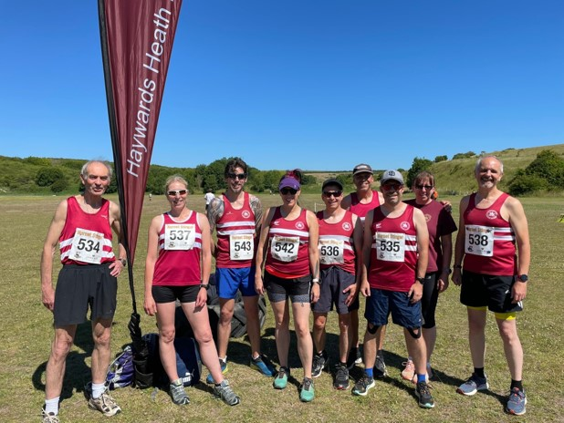

**HOSTED BY Hove Hornets the next run in the West Sussex Fun Run League took place on July 10th 2022 on the South Downs with a gloriously tough 10km run. With temperatures reaching 26 degrees, and no shade, this was going to be a challenging run.**

Athletics clubs from all over Sussex joined together raising their standards by the rugby club in preparation for the run which starts on the green before heading for a 5km run uphill to the top of the South Downs. The views from the top are inspiring as you turn and start coming back down through roads, footpaths and trails.

This is one of the most challenging runs in the WSFRL calendar, but worth doing for the experience and kudos of having achieved it.

There was some great running from Haywards Heath Harriers with Andy Hind first across the post for the club followed by Julian Boyer and Barry Tullett.

**Haywards Heath Harriers results**:  **Andy Hind**, 00:42:19; **Julian Boyer**, 00:47:11; **Barry Tullett**, 00:49:43; **James Smyth**, 00:58:57; **Sarah Hamilton**, 01:10:42; **Michael Parish** 01:10:57; **Carys Hind**, 01:16:33; **Richard Bates** 01:19:36; **Linda Tullett** 01:22:47.

**Race results**: 1st Liam Briscoe, Fittleworth Flyers, 00:38:44; 2nd Fraser Macnicoll, Lewes AC, 00:40:19; Alex Rawlinson, Portslade Hedgehoppers, 00:40:47.

**Parkrun round-up:**

Clair parkrun: 1st **Andy Hind** 19:07; 11th **Sam Atkin** 21:43; 28th **Daniel Mardle** 25:33; 45th **Sarah Ann Hamilton** 27:25; 64th **Katherine Woolhouse** 32:48.

Kingston parkrun: 90th **James Smyth** 24:48.

Peacehaven Parkrun: 10th **Jason Robinson** 22:59; 35th **Shelagh Robinson** 29:56.

Horsham parkrun: 28th **Steven Heath** 21:07.

Tilgate parkrun: 153rd **Jack Chivers** 28:19.

Hove Prom parkrun: 2nd **Arun Khursheed** 17:12 (pb); 420th **Linda Tullett** 31:54.

Dolgellau parkrun: 2nd **Will Grey** 17:47.

Lancing Beach parkrun: 26th **Carl Bicknell** 24:36.

Weedon Island Preserve parkrun: 4th **Andrew Wilson** 24:43.

Ifield Mill Pond parkrun: 2nd **Ben Duncan** 18:03.