Haywards Heath Harrier youngsters Shine at Sussex Primary Schools & Sussex Schools Cross Country Championships.

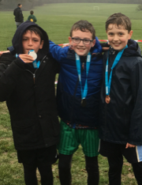

The Mid Sussex Primary Schools’ Cross Country was held last Wednesday at east court East Grinstead and the first 3 under 11 boys are all members of Haywards Heath Harriers. First to cross the line was new member Jacob Roderick closely followed by Arun Khursheed in second place and Oscar French in third. Well done boys.

Left to right: Arun Khursheed, Jacob Roderick and Oscar French.

YOUNG HARRIERS SHINE AT SUSSEX SCHOOLS CROSS-COUNTRY CHAMPS!
The Sussex Schools Cross Country Championships took place at the Waterhall grounds last Wednesday the 16th January at Brighton. Several Harriers were taking part in this tough competition with the best youngster in Sussex taking part. Adam Dray was top Harrier finisher in a superb 4th place in the Intermediate Boys race. Darja Knotkova-Hanley was the best placed of the girl’s races with fifth place in the Senior Girls race.

Results were:
Junior Girls race:
19th Harriet Dray 12:53, 65th Phoebe Whiting 14:34.
Inter Girls race:
30th Rosie Beckett16:07.
Junior Boys race:
37th Sam Fernley 17:32, 94th William Spensley 19:24, (?) Harry Russell 19:56.
Inter Boys race:
4th Adam Dray 21:13, 59th Harvey Alcock 26:40, 78th Tom Spensley 28:18.
Senior Girls race:
5th Darja Knotkova-Hanley 17:25, 8th Jasmine Mamoany 19:17.
Inter Boys race:
9th Joseph Martin 26.08.

SKINNER’S SUPERB 2ND PLACE AT SUSSEX MASTERS CROSS-COUNTRY AT COOMBE FARM.

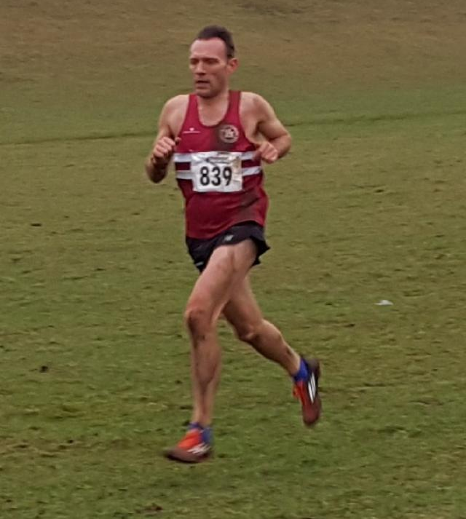
James Skinner: Silver medallist in the Over 40’s Men’s race.

The Sussex Masters Cross Country Championships were held at a new venue this year. Coombe Farm near Lancing produced a new challenge to the runners. On a hilly course, the Harriers came away with 1 individual medal and 2 team medals. James Skinner, who already has had a great cross-country season so far, added a superb silver medal to his medal haul this season. Both the Over 40 Men and the Over 50 Men’s team came away with bronze for each team. One of the best results for the club and the coaches as well as individual and team medals was the number of the Harriers who ran in the competition. There were even 3 scoring teams in the Men’s Over 50’s race. It was exciting to see so many take part in this event.

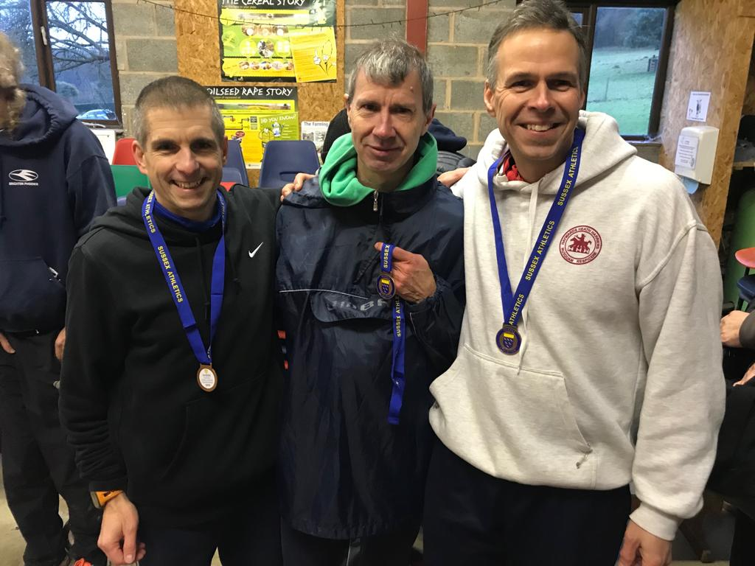
Over 50’s Bronze medal team: Left to right): Julian Boyer, Paul Cousins and Barry Tullett.

Cross-country results as follows:
Men’s Over 40’s race:
2nd James Skinner 27:08, 16th Ben Duncan 31:04, 17th Andy Hind 31:12, 33rd Jack Chivers 33:41, 36th Any Dray 34:27. (3rd Team).
Men’s Over 50’s race:
4th Paul Cousins 29:48, 10th Julian Boyer 31.11, 21st Barry Tullett 32:40, 36th Tim Hicks 35:07, 55th Phil Scott 37:31,57th Mark Sykes 37:41. 64th, Ian Dumbrell 38:59, 71st Graham Kenward 40:03, 73rd Carl Bicknell 40:38. (3rd Team, 11th Team and 13th Team).
Men’s Over 60’ race:
31st Richard Bates 50:55.

Women’s Over 35’s race:
12th Gemma Morgan 39:14,
Women’s Over 45’s race:
29th Jacqueline Barnes 42:45, 32nd Shelagh Robinson 44:55, 34th Sarah Hamilton 45:23, 36th Claire Annesley 45:47. (8th Team).
Women’s Over 55’s race:
23rd Jennifer Denyer 62:51.

