Kenton Runs The Two Oceans Classic Ultra Race.

Haywards Heath Harrier, Ian Kenton went down under to the southerly most tip of South Africa for this most popular and famous of ultra races. The Two Ocean Ultra 2023 race is held around Cape Town in South Africa and this year the race was held on 15 April.

Ian, had been preparing for this race for several months which included a marathon qualifying race.
This race has been called “the world's most beautiful marathon” and is Africa’s biggest running event and is run against a backdrop of spectacular scenery through the Cape Peninsula.
The race distance is over thirty-five miles and started at ten minutes past five in the morning (local time). The race is relatively flat for the first twenty six miles then the long climbs start and with the added rise in temperature it gives the race a unique set of challenges.
Ian said: “I went for it, and I thought I had it until somewhere around halfway. Things got very interesting after that was in a world of hell for the last fifteen miles. Not the sub four [hours] I was hoping for, but an amazing experience all the same!”
Ian finished the race in three hundred and tenth place out of five thousand seven hundred and thirty three runners, in a time of four hours and twenty three minutes and forty one seconds. (The first runner coming home in three hours and nine minutes!).

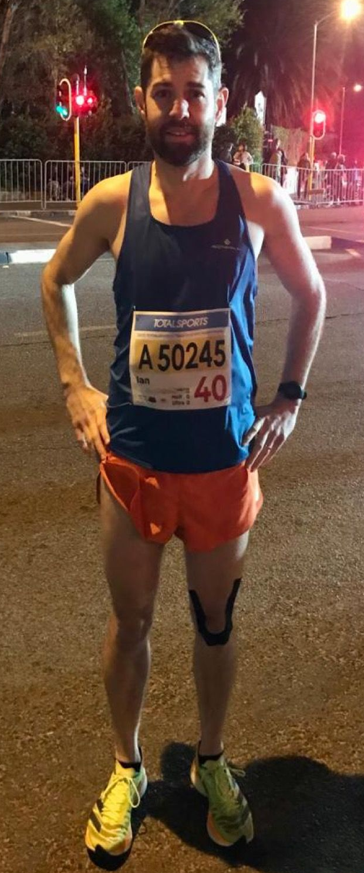
Ian Kenton

Sean Duff at the Rotterdam Marathon
Haywards Heath Harrier marathon results:
With the marathon season in full swing, this week we can bring you lots of results from the Haywards Heath Harriers.
On Sunday 23rd April was the London Marathon. The Harriers had only Chris Faulkner running this race. Chris finishing the race in three hours and forty seven minutes and fifty-one seconds in thirteen thousand seven hundredth and twenty second position.
At the Manchester Marathon on 16 April Harriers, three Haywards Heath Harriers took part. Sam Ridley was first home in three hours twenty-six minutes and seventeen seconds finishing as fourth veteran woman in the fifty-five to fifty nine age group. Oliver Farr who was on his ninety-eighth marathon, finished next in four hours ten minutes and five seconds. Emma Pryor brought up the rear finishing in four hours and forty-nine minutes and nineteen seconds for a super eleven minute personal best time!
At the Rotterdam Marathon on 16 April, Sean Duff ran a super personal best time of two hours and fifty six minutes and twenty two seconds.
Oliver Farr completed his ninety-ninth marathon at the Phoenix Not The London Marathon race held at Sunbury-on-Thames on 23 April. Oliver on his way to becoming a member of the elite One Hundred Marathon Club completed the race in four hours and twenty eight minutes. Oliver is looking to complete his hundredth at the Richmond Park Marathon in May.
Kim Lo ran in the Vienna Marathon on 23 April. In a hot marathon for the time of year, Kim finished in three hours and thirty-four minutes and thirty seven seconds.
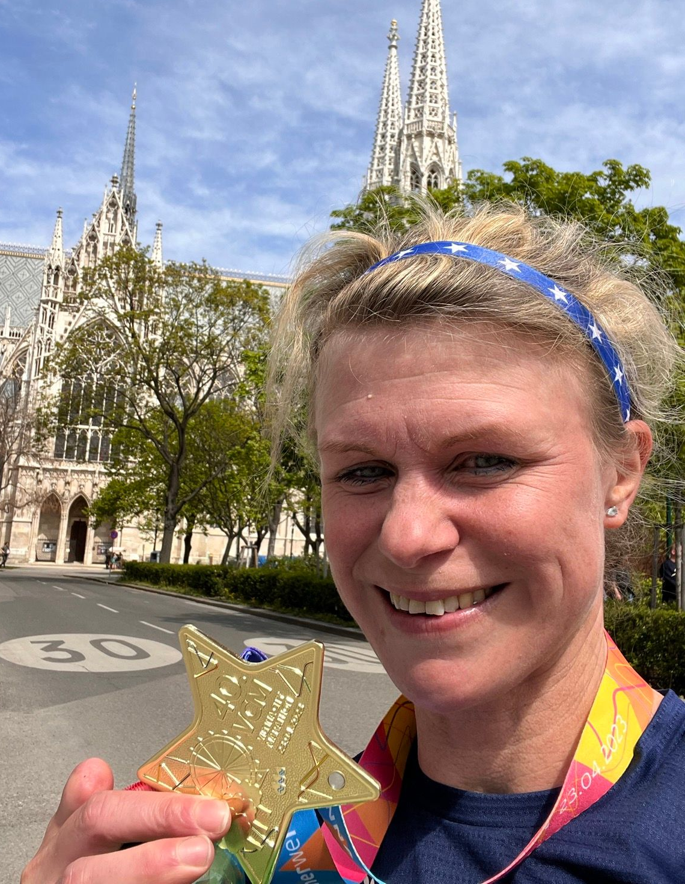

Other Harrier results:
At the Friday Night Under The Lights on 21 April, two Haywards Heath Harriers, Jamie Topping and Russ Mullen, took part in this fast five kilometres race series held at Battersea Park in London last Friday evening. The runners were set off in separate seeded races depending on ability. The course was composed of two and a bit laps around the park.
Jamie was first home in a personal best time of sixteen minutes and sixteen seconds. Russ finished sixteen minutes a thirty eight seconds (both running in the same race as each other).

