Lucie Shines at Kingston

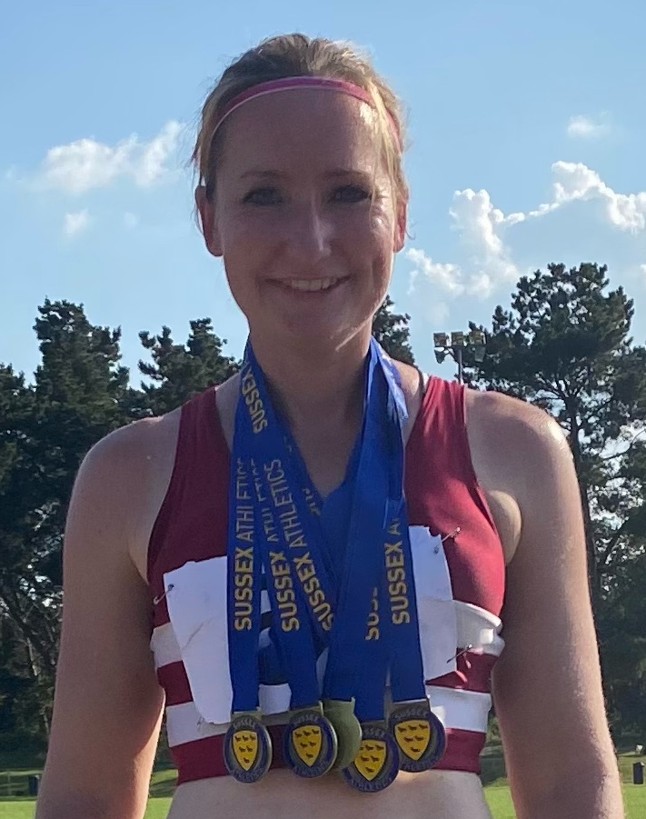
Spotlight on Lucie Venables:
Lucie is a seasoned track athlete who trains and competes for Haywards Heath Harriers in track and field competitions.

She competed recently at the Sussex Masters Athletics Champs at Kingston on 18 July.

She said to me (referring to her most recent competition), “I won 5 Gold medals on Sunday at Kingston at the Sussex Veterans Championships. This was all in the 35 to 40 age-

Lucie Venables

group.

These were in:
400m hurdles (82.28 seconds), a new club record beating the previous record held by Jenny Denyer (88.5 seconds) that stood since 1995.
Triple jump (8 metres 61 centimetres)
100 metres (14.77 seconds)
200 metres (31.34 seconds)
Long jump (4 metres 45 centimetres) also a new club record beating her previous club record effort by a massive 40 centimetres!).

I also the week before at the Southern Athletics League, Lucie had broken her own 100m hurdles club record with 21.0 seconds. “I didn’t do these hurdles at the weekend as thought six events was too much!”. Lucie also reflected on the late Bob Ruff, adding, “Sorry Paul I should have added - the long jump Bob (Bob Ruff) would definitely been over the moon and very pleased with so that was for him!”

Bob Ruff, sadly passed away last year and was the Harriers senior sprints coach for over 20 years.

Mike Bale recently competed in the BMAF Throws Pentathlon Championships, held on 27th June at Horspath, Oxford. It was his first outing in a Men Over 65’s competition. He managed six personal bests and six age 65 records club records. His results were as follows:

Hammer 31.97 metres (pb/cr).
Shot 7.88 metres (pb/cr).
Discus 27.08 metres (pb/cr).
Javelin 17.05 metres (pb/cr).
9.08 Weight 12.51 metres (pb/cr).
Throws Pentathlon score: 2575 points (pb/cr).

Mike also competed at the Sussex Masters County Champs at Kingston on 18th July. He competed in five events gaining three golds, one silver and one bronze:
Results were:
Hammer Gold (31.13 metres).
Discus Gold (25.71 metres).
Weight Gold (12.27 metres).
Shot Silver (7.73 metres).
Javelin Bronze (with a new personal best/club record of 17.70 metres).

Chris Russell also competed at The Sussex Masters Championships at Kingston. Competing in three events in the Vet men’s 60 age group, Chris came home with three county medals and set personal bests in three events. He struck Gold in the 400m (74.83 seconds), a silver in the 1500 metres (5 minutes 38.48 seconds) and as second silver in the 5000 metres (22 minutes 12.97 seconds.)

Carl Bicknell narrowly missed out on a medal in the Vet Men’s 55 age group in the 5000 metres race with a finishing time of 21 minutes and 51 seconds.

Left to Right: Julian Boyer, Peter Tullett, Barry Tullett and Paul Cousins

Three Harriers took part in the Caterham Half Marathon at Redhill Aerodrome on 18 July. In sweltering conditions, Julian Boyer finished in 1 hour 38 minutes and 44 seconds, Barry Tullett finished in 1 hour 41 minutes and 56 seconds (with his older brother, Pete (in yellow above running for Chelmsford AC) claiming silver in the Men’s over 60’s). Paul Cousins finished in 1 hour 41 minutes and 46 seconds. This race incorporated the British Masters Athletics Federation Half Marathon Championships.

Other Harriers results:

Phoenix 10 Kilometres race.

The Phoenix 10 kilometres race was held on Wednesday 14 July. This mid-week evening race was a run very humid and balmy evening down on Hove Prom. The runners completing an out-and-back course to Carat’s Café.

Harriers results were:
11th James Skinner 34:26, 19th Ben Duncan 35:59, 36th Phil Payne 37:12, 38th Jamie Topping 37:18, 45th Will Herbert 37:53, 77th Ryan Armstrong 40:45, 160th Phil Scott, 47:32, 168th Dave Harper 47:59, 209th Sarah King 51:38, 269th Amy Lovejoy 62:26.

The 21st Bewl 15 Mile race on 4th July

First home for the Harriers in 56th place was Andy Guy in 2 hours 4 mins 52 secs followed by Siobhan Amer in 63rd place in 2 hours 6 mins 35 secs. Next was Bryan Tiller in 77th pace in 2 hours 8 mins 51 secs, 215th was Andrew Wilson in 2 hours 32 mins 38 secs and lastly (but not least) was Andy Henry in 381st place with 3 hours 7 mins and 9 secs.

The Focus 10k race at Borde Hill on 4th July.

This race was run over the local countryside at Borde Hill with five Haywards Heath Harriers finishing in the top eleven places. James Moffat finished in a super second place in 40 minutes and 40 seconds. He was backed up by Tim Miller in 43:13 in fifth place. Pete Francis in sixth with 43:28, Steve Dallman was tenth with 44:52 and James Bennett twelfth with 45:07.

Other Harriers finishers were:
16th Sim Wishlade 46:09, 19th Isobel Russell 49:02, 31st Phil Scott 52:11, 36th Ian Tomkins 53:22, 70th Liz Earley 60:11

