CROSS COUNTRY

A week ago, on Saturday January 18th was the Sussex Masters Cross Country Championships, which were held at Coombe Farm, Lancing. On a tough course of about five miles, all of the age groups and both male and female competed the same distance. The hilly terrain also made up for the lack of mud of last year.

The Men 60 Vet age group celebrated with a team Silver medal, missing out from Gold by one point! The Harriers had sent a strong 60’s team made up of Chris Russell (who led the team home in fourth place in the V60 race), Tim Hicks (seventh), Mark Sykes (fifteenth) and Richard Haynes (twenty-first).

The Harriers ladies finished in fourth place in the Women’s Vet 45 age group and the Harriers men finished fourth in the Men Vet 40 and tenth in the Men’s Vet 50 age groups.

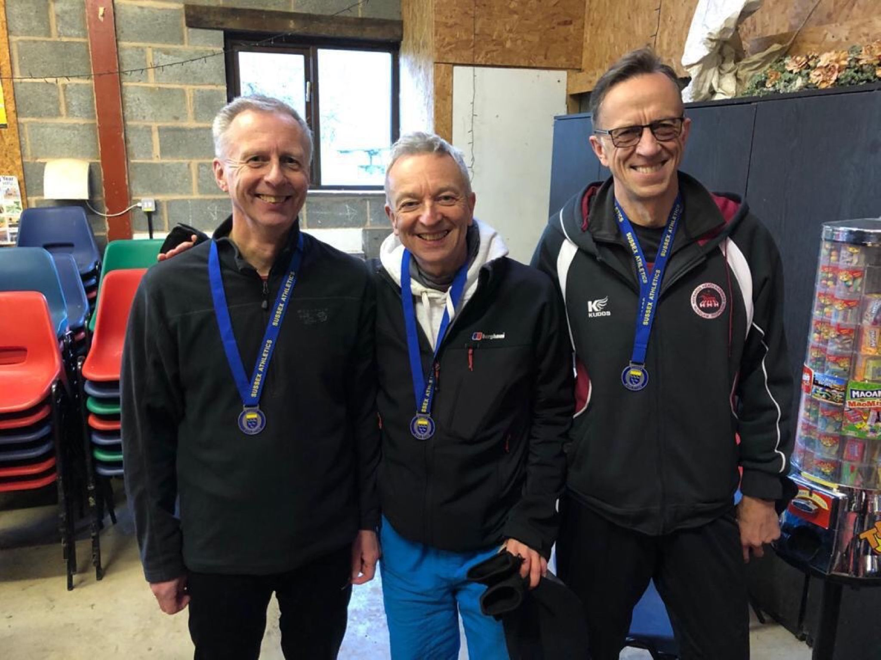
Left to right: Chris Russell, Mark Sykes and Tim Hicks.

Harriers results were as follows:

Men’s Vet 40 race: 6th Marcus Kimmins 29:06, 16th Rob Watts 31:01, 18th Andy Hind 31:06, 37th Andy Dray 34:58, 42nd Chris Faulkner 37:16.

Men’s Vet 50 race: 5th Paul Cousins 30:43, 47th Carl Bicknell 39:29, 48th Graham Kenward 39:47.

Men’s vet 60 race: 4th Chris Russell 33:08, 7th Tim Hicks 34:27, 15th Mark Sykes 36:59, 21st Richard Haynes 38:15.

Women’s Vet 35 race: 19th Gemma Morgan 40:46.

Women’s Vet 45 race: 12th Sam Ridley 36:50, 15th Jacqueline Barnes 39:26, 19th Katherine Buckeridge 41:14, 29th Sarah Hamilton 46:34.

Women’s Vet 55 race: 15th Teresa Mockridge 43.39.

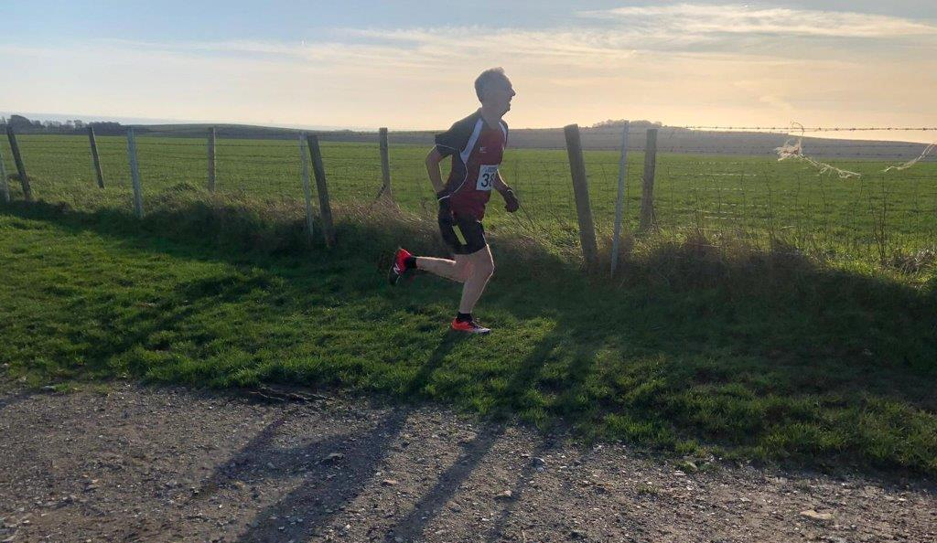
Chris Russell.

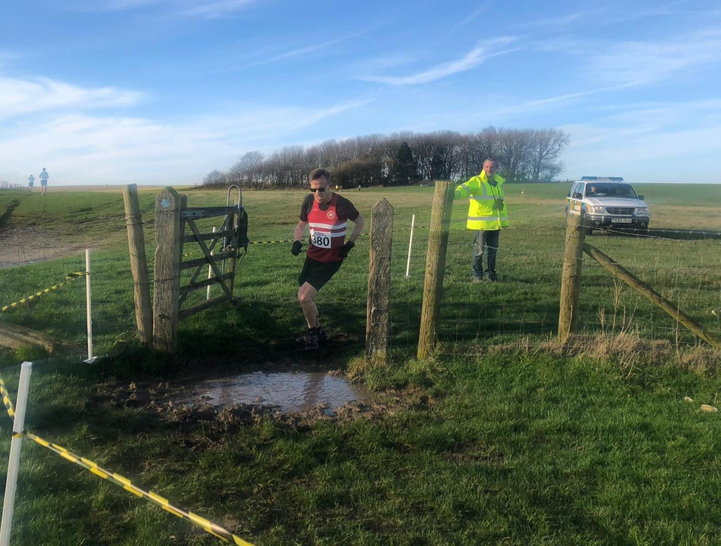
Tim Hicks.

SOUTH OF ENGLAND CHAMPS

Last Saturday 25 January was the South of England Cross Country Championships which were held at Parliament Hill Fields on Hamstead Heath in north west London. A cross country course with a difference!. The mud did not fail this year to test every runner of every age group taking part. Parliament Hill Fields lies on a sandy ridge over the clays of north London, so any rain that falls stays nicely saturating the ground ready for this epic annual cross country mud fest of races.

The afternoon was full of races from young kids races (under 13’s) and culminating in the senior men’s race which covered nine cruel miles, the ground already having being churned up from the previous races.

Haywards Heath Harrier, Darja Knotkova Hanley, had the best run of the day finishing in a superb nineteenth place is the under 20 women’s race. Darja, who has had a great cross country season already, made light of the muddy conditions.

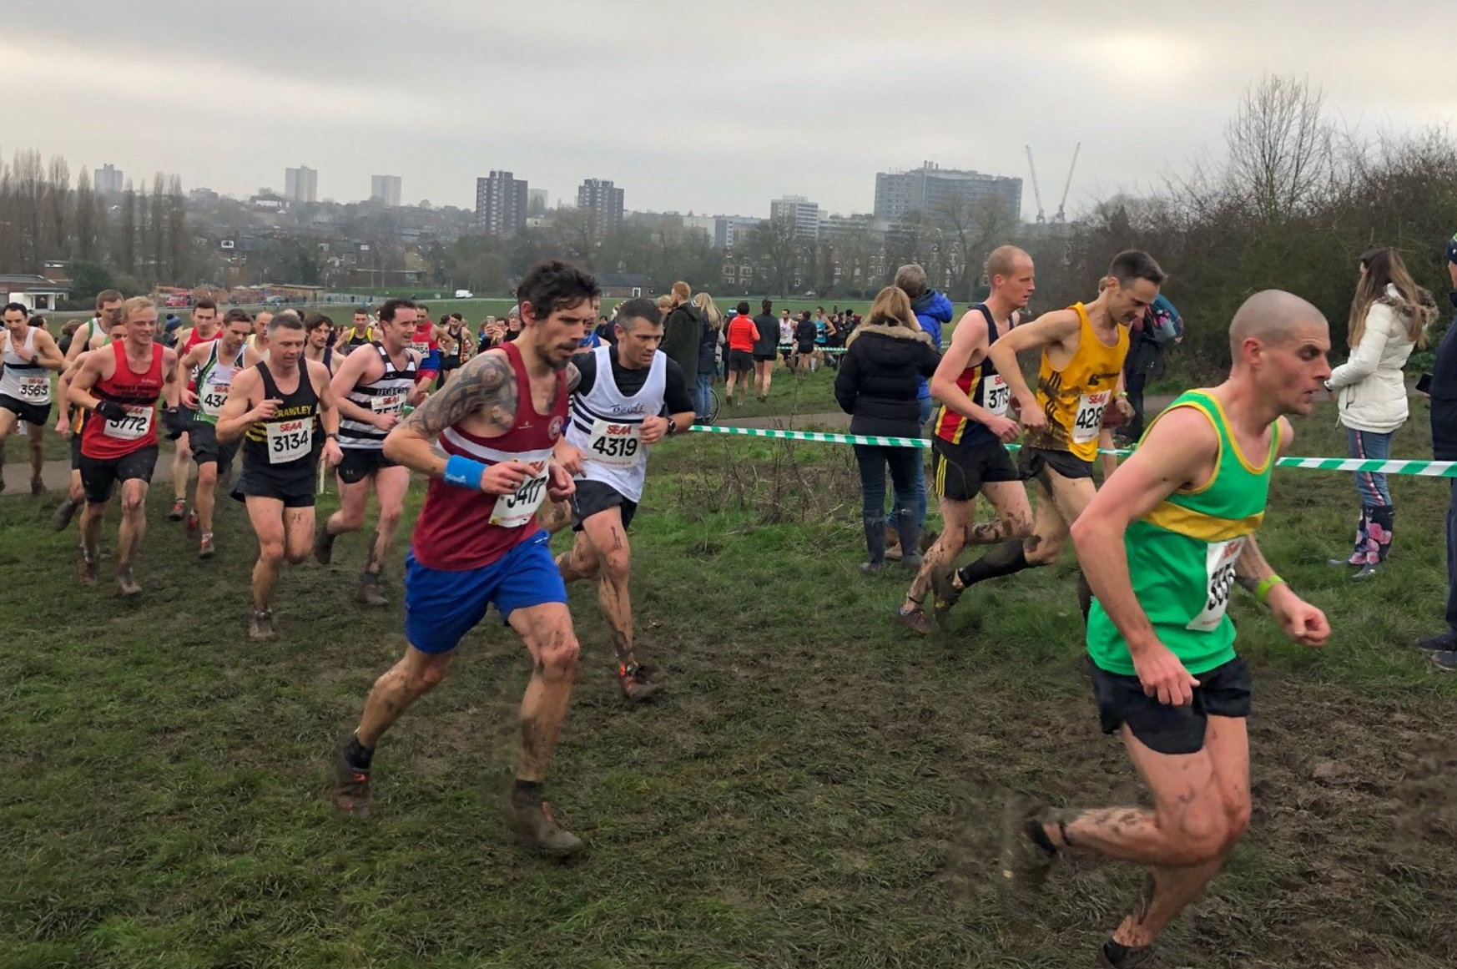
Andy Hind at Parliament Hill.

All Harriers results were as follows:

Under 13 Boy’s race: 65th Arun Khursheed 12:52, 101st Jacob Roderick 13:09, 130th Charlie Bonwick-Adams 13:26, 249th Oliver Downey 14:41, 252nd George Bonwick-Adams 14:43.

Under 15 Boy’s race: 178th Sam Fernley 17:25.

Under 20 Women’s race: 19th Darja Knotkova-Hanley 27:39.

Senior Women’s race: 397th Liz Earley 42:37, 398th Sam Ridley 42:37,483rd Katherine Buckridge 45:26, 562nd Teresa Mockridge 47:55, 589th Jenny Turner 49:37.

Senior Men’s race: 542nd Michael Burke 63:54, 586th Andy Hind 64:49, 790th Greg Hilton 69:36, 1090th Paul Turner 82:04, 1106 Carl Bicknell 83.00.

Other Harrier Results:

Simeon Cousins ran in the London Under 20/ Senior Games on 18 January and ran 55.22 seconds over the 400 metres on the indoor track at Lee Valley.

Kim Lo and Phil Payne took part in the Benfleet 15 mile race on 19 January. On a very muddy course, Kim finished 11th lady in 2 hours and 5 minutes and 31 seconds. Phil finished in 28th place overall in a time of 1 hour 46 minutes and 37 seconds.

Tim Hicks also ran in the Farnborough Winter Half Marathon race on 26 January 2020 and finished in one hour thirty three minutes and four seconds.

