By Michael Parish.

At the Barns Green Half Marathon

BARNS GREEN held it’s first half marathon in 1982 where runners just showed up on the day. The event attracted over one thousand entrants which took the committee by surprise as a seemingly endless line of cars rolled into the village. The run was due to start at 11:00 and at three minutes to, athletes were either still registering or warming up. With an anxious plea from organisers the athletes got into position and one thousand runners were ready to start just in time.

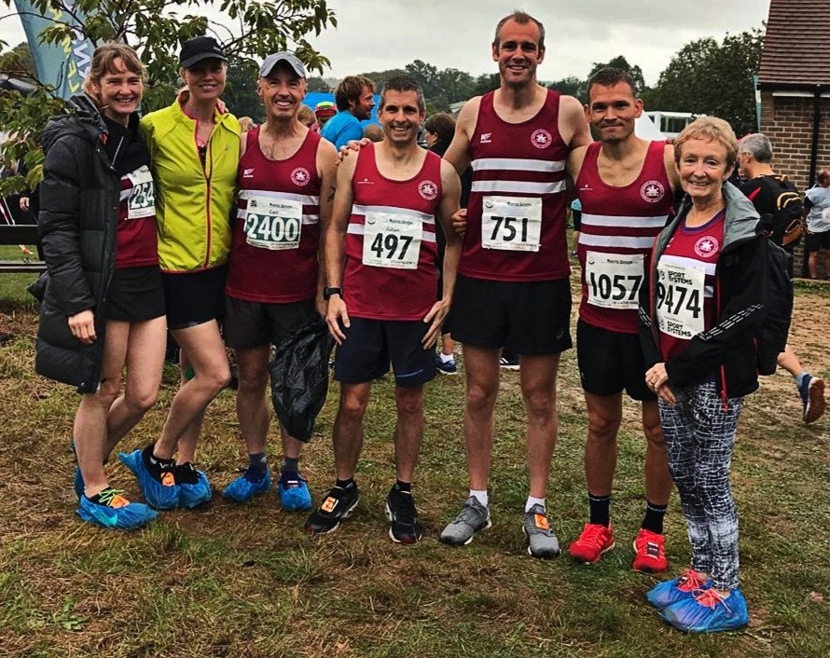
Harriers at Barns Green.

Forward to current times and Sunday 29th September saw Barns Green open its doors to the 2019 10k and half marathon event which is a part of the Bill Page awards. With a fully closed road route that runs two loops through the village and over the outlying West Sussex countryside, it’s best described as undulating and a good challenge for competing athletes.

There were some amazing results on the half marathon with Paul Navesey, Crawley AC coming in first at 01:08:25 and Ben Savill, Lewes AC at 01:09:53 and James Turner at 01:13:17.

The 10k followed the half marathon with exceptional runs from Maxwell Dumbrell, Horsham Blue Star Harriers coming in first at 31:59, Freddie Sherwood at 34:48, Richard Murphy, Denmead Striders at 35:55.

In the 10 km race the results were as follows:
4th Russ Mullen 37:29, 26th Matt Quinton 42:45, 58th Phil Scott 46:22, 69th Carl Bicknell 46:55, 103rd Karen Thompson 49:28, 124th Verity Coombes 50:45, 204th Chris Glandfield 55:05, 635th Jenny Denyer 78:35.

In the half marathon, the results were:
4th James Skinner 1 hr 14.01 secs, 26th Darren Bird 1 hr 26.10 secs, 27th Matt King 1 hr 26.21 secs, 47th Julian Boyer 1 hr 29.20 secs, 68th Ivan Catterwell 1 hr 31.27 secs, 97th Pete Francis 1 hr 34.29 secs,104th Greg Hilton, 1 hr 35.08 secs,127th Sam Ridley 1 hr 36.54 secs, 228th Steve Mitchell 1 hr 43.49 secs, 229th Mark Sykes 1 hr 43.50 secs, 263rd Ian Dumbrell 1 hr 46.13 secs, 284th Mike Scholes 1 hr 47.50 secs, 403rd Bryan Tiller 1 hr 53.36 secs, 523rd Mark Green 1 hr 58.20 secs, 856th Michael Parish 2 hrs 22.58 secs.

Tilgate Forest 5 miler.
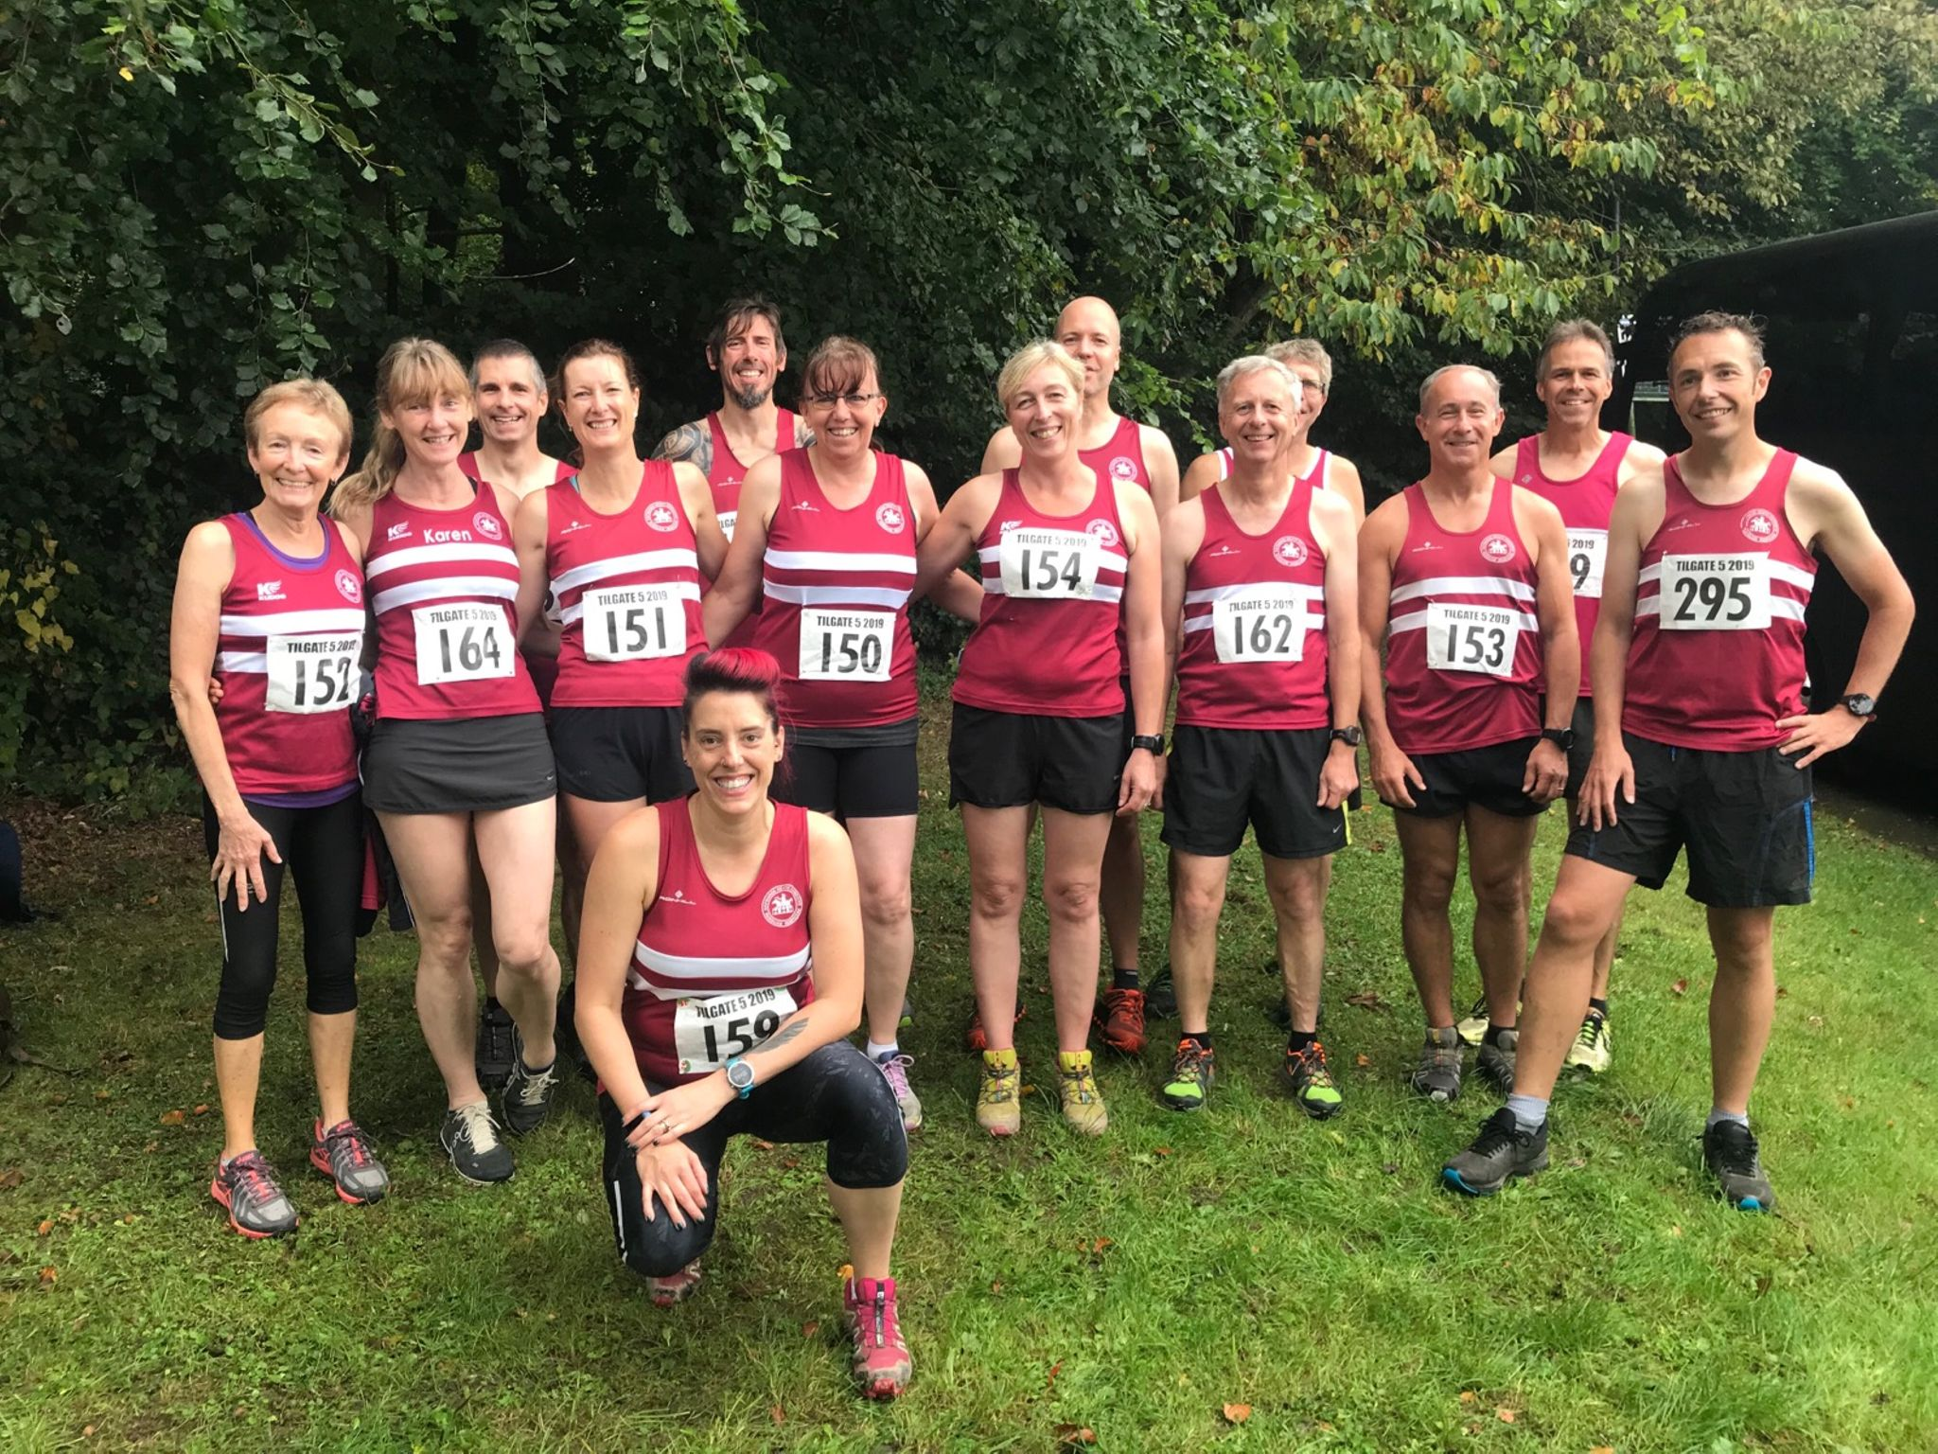

Harrier results from West Sussex Fun Run League at Tilgate Forest 5 mile race were:
14th Andy Hind 34:02, 17th Julian Boyer 34:19, 33rd Paul Cousins 36:43, 37th Ryan Armstrong 37:12, 44th Chris Russell, 37:41, 48th Greg Hilton 38:00, 60th Barry Tullett 39:19, 75th Mark Sykes 40:38, 88th Phil Scott 41:23, 90th Ian Dumbrell 41:26, 125th Jonathan Bromley 43:58, 141st Kath Buckeridge 45:13, 153rd Karen Thompson 46:01, 216th Marion Hemsworth 51:02, 225th Sarah Hamilton 52:20, 236th Carys Hind 53:58, 277th Richard Bates 59:16, 285th Linda Tullett 60:40.

Run and Talk
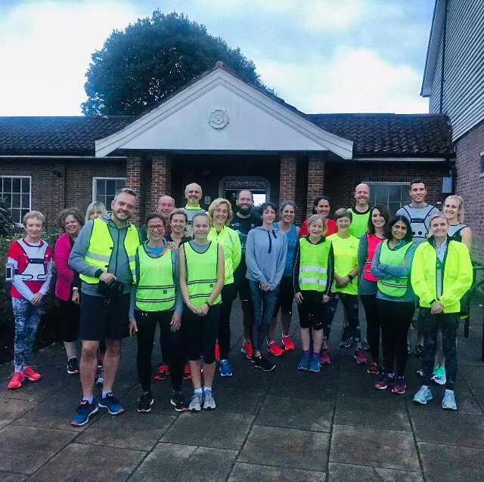

ENGLAND ATHLETICS with the Mental Health Charity MIND set up a week of #RunAndTalk sessions across the country. This was a chance for athletics clubs to hold an event focusing on the positive effects of running on mental health.

The theme for this year’s campaign was “men”. Suicide is the leading cause of death for men aged 20 to 34. The event gives an opportunity to feel good, talk issues through, build a support network and realise that you are not alone.

J and M Running, in conjunction with Haywards Heath Harriers, held their event on Wednesday 25th September. With a total of 24 runners from Mid Sussex and Crawley taking part, they completed a 5km course from Beech Hurst Park, down Paddockhall Road, past the Dolphin Leisure Centre and up Harlands Road. Then on through Bluntswood to the main Cuckfield Road and back to Beech Hurst for a coffee at The Harvester.

The run was about keeping to a conversational pace. The weather was kind and the chat flowed throughout the run and coffee afterwards. J and M Running and Haywards Heath Harriers would like to thank everybody for attending and hope to see you next year.

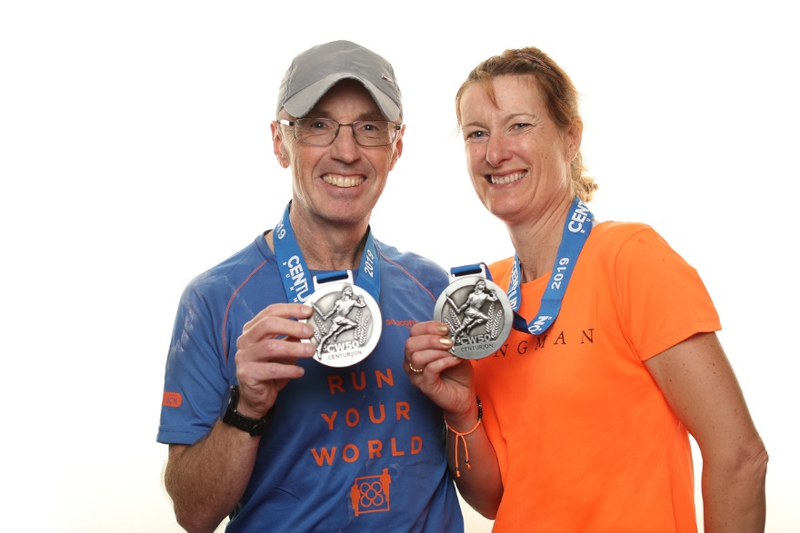
Carl Bicknell and Kath Buckridge.

On 14 September Harriers Carl Bicknell and Katherine Buckeridge successfully completed the Chiltern Wonderland 50 mile ultra
l​
Organised by Centurion Running, this race comprises a single loop around the beautiful but hilly Chiltern countryside, taking in 5600ft of elevation and including the windmill featuring in the film Chitty Chitty Bang Bang.
​
In hot weather both Harriers completed the course well within the 13-hour cut-off, Katherine finishing in a strong 11hrs 26mins, and Carl overcoming some mid-race stomach issues to finish in 12hrs 22 minutes.
​

