HARRIERS TAKE THE PLATE
With the track and field athletics coming to an end after a busy season and the final competitions being held. The Haywards Heath Harriers are celebrating team and individual successes with the youngsters.

At the Sussex Track and Field League Final at K2 sports, Crawley on 1st September,

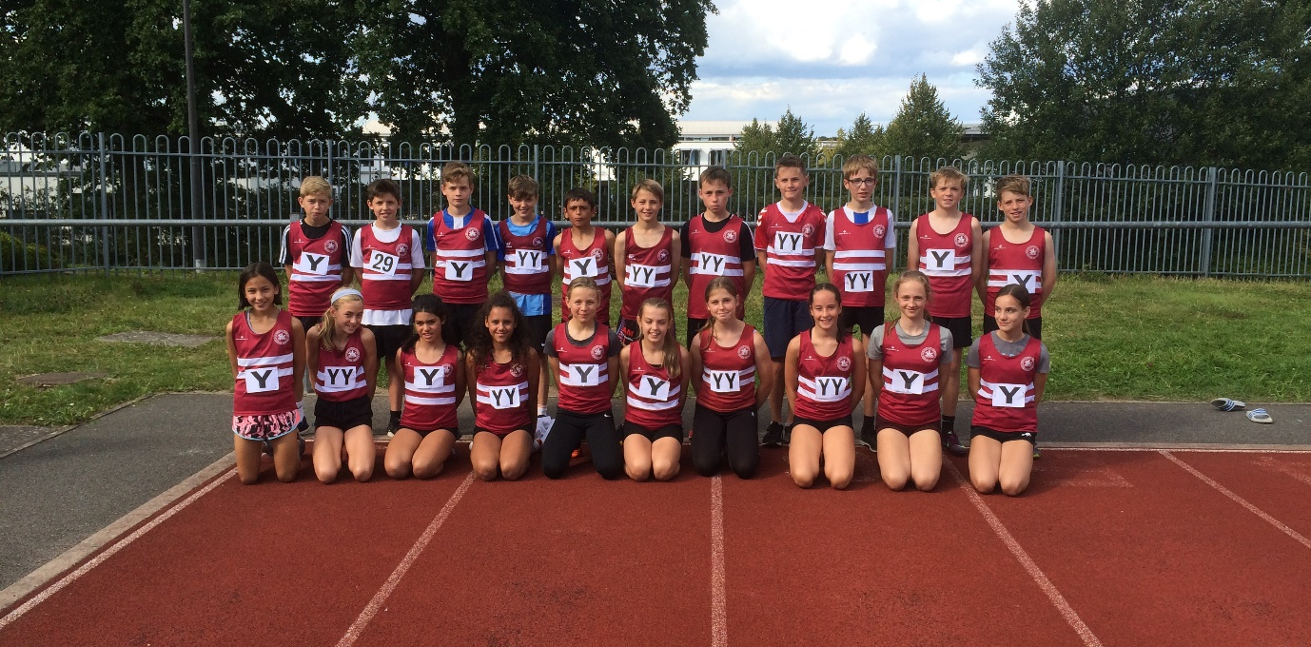
Under 13’s - Winners of the Sussex Under 13 League Plate Trophy.

Harriers sent out one of their strongest under 13 teams in recent years with a team of twenty one young athletes and came away with the Sussex Under 13 League Plate Trophy. The Haywards Heath Harriers team finished in fourth place out of ten teams from all over Sussex (only three and a half points behind Chichester who were third!).

Results were:

Boys:
Charlie Bonwick-Adams: 6th 75m ‘A string 11.1 secs, 7th 150m ‘A’ string 21.56 secs.
Nye Sim: 4th 75m ‘B’ string 11.8 secs.
Arlo Marchant: 4th 150m ‘B’ string 22.60 secs, 3rd 600m ‘B’ string 1:54.48 secs.
Oscar French: 5th 600m ‘A’ string 1:53.53 secs, 3rd Shot Putt ‘B’ string 4m45.
Arun Khursheed: 1st 1000m ‘A’ string 3:12.15 secs, 5th 75m Hurdles ‘A’ string 15.42 secs.
Jonathan Beckett: 3rd 1000m ‘B’ string 3:28.29 secs, equal 5th High Jump ‘B’ string 1m10.
Thomas Pearce: 3rd 75m Hurdles ‘B’ string 16.78 secs, 4th Long Jump ‘B’ string 3m58.
Jonathan Parkin: 6th High Jump ‘A’ string 1m25, 5th Long Jump ‘A’ string 4m08.
Noah Perrett: 7th Shot Putt ‘A’ string 4m56.
George Bonwick-Adams: 3rd Discus ‘A’ string 14m68, 7th Javelin ‘A’ string 19m11.
Johnny Rutherford: 3rd Discus ‘B’ string 13m49, 3rd Javelin ‘B’ string 18m48.
4 x 100m relay: 5th HHH 59.12 secs.

Girls:
Siobhan McMahon: 5th 75m ‘A’ string 11.1 secs, 3rd Long Jump ‘B’ string 4m19.
Lucy Barker: 2nd 75m ‘B’ string 11.3 secs, 6th High Jump ‘B’ string 1m05.
Holly Wilkinson: 9th 150m ‘A’ string 24.16 secs, 5th Shot Putt ‘B’ string 5m14.
Magdalena Goodman: 7th 150m ‘B’ string 24.78 secs, 8th 70m Hurdles ‘A’ string 18.69 secs.
Megan Eyre: 7th 600m ‘A’ string 2:05.0 secs, 5th Javelin ‘B’ string 9m42.
Kitty Gandarez: 5th 600m ‘B’ string 2:18.2 secs, 3rd Discus ‘B’ string 10m99.
Grace Dobson: 6th 1000m ‘A’ string 3:40.25 secs, 3rd 70m Hurdles ‘B’ string 15.75 secs.
Maya Dell’Aira Bromley: 4th ‘B’ string 1000m 3:58.21 secs, 7th Javelin ‘A’ string 9m48.
Mae Robinson: 8th High Jump ‘A’ string 1m10, 6th Long Jump ‘B’ string 2m95.
Erin Gaston: 2nd Shot Putt ‘A’ string 6m69, 8th Discus ‘A’ string 13m05.
4 x 100m relay: 6th HHH 61.08 secs.

Non-scoring:
Nye Sim: Long Jump 3m22.
Noah Perrett: Long Jump 2m81.
HHH: 4x100m relay: 67.36 secs.

Also, the under 15 age group had their final track and field match of the season at the Withdean stadium in Brighton on the 30th August where there were a host of personal bests.

Results for the under 15’s were:
Rory Dalgliesh: 4th 300m ‘A’ string 45.2 secs, 3rd 1500m ‘B’ string 4:53.2 secs.
Sam Fernley: 4th 1500m ‘A’ string 4:44.7 secs.
Alex Booth: 7th High Jump ‘A’ string 1.35m, 5th Javelin ‘A’ string 20.86m.
Ellis Buckeridge: 3rd Javelin ‘B’ string 12.83m.
4 x 100mRelay: 8th HHH 59.3 secs.

Other Harrier results:

Oli Farr completed his 41st marathon. Running at the Phoenix Excalibur Marathon on Saturday 31st August, her finished in a time of 4 hours and 32 minutes.

At the Crawley Open Meeting on 26 August, Adam Dray ran a personal best time in the 800 metres in a time of 2 minutes and 02.98 seconds. Other harrier results were:
Arun Khursheed: 1500m in 4 mins 50.33 secs, 75mH 16.66 secs, LJ 3m74.
Sam Fernley: 4 mins 52.87 secs.
Oscar French: 75mH 16.75 secs, LJ 3m42.
Jonathan Parkin: HJ 1m35, Javelin 27m18.

On 1st September at the Fittleworth 5, which is a race that is part of the West Sussex Fun Run League, the results were as follows:
15th Andy Hind 33:08. 58th Ryan Armstrong 37:59, 142nd Kath Buckeridge 43:07, 175th Carl Bicknell 45:47, 239th Carys Hind 52:06, 246th Richard Bates 58:07.

Also, on 1st September was the Sussex 3000 metres track championships at K2 Crawley. Young Adam Dray finished fourth in the main race and was first in the under 17 age group in a new personal best time of 9 minutes 08.6 seconds. In the under 15’s boy’s race Sam Fernley finished in sixth place in a tough race. He also set a new personal best time of 10 minutes and 32.05 seconds. In the women’s race, Darja Knotkova-Hanley finished in 10 minutes and 44.0 seconds and Jasmine Mamoany in 13 minutes and 26.7 seconds – both finishing in first and second in the under 20’s age groups and in the under 15’s girl’s race, Amy Rutherford finished in fifth place in a personal best time of 12 minutes 37.86 seconds.

The Hellingly 10 kilometres race on last Sunday. Three harriers took part. First home was Rob Watts in 18th place in a time of 38 minutes and 42.64 seconds. He was followed by Jack Chivers in 39th place in a time of 41 minutes 17.65 seconds. Pete Cobbett was last home for Harriers in 212th place in a time of 58 minutes and 43.38 seconds. Well done Pete!

