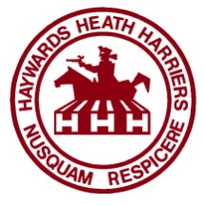 | Haywards Heath Harriers

Welfare/Child Protection Officer

MRS LINDA TULLETT
10 LANGRIDGE WAY
BURGESS HILL
WEST SUSSEX
RH15 8TN

TEL: 01444 870788
MOBILE: 07719 717936

Assistant Welfare/Child Protection Officer

MR GRAHAM KENWARD

EMAIL; graham27email@gmail.com

MOBILE: 07919 162782

Last updated: January 2022

